#2446 More Weekday Dinners – Done! recipe cards  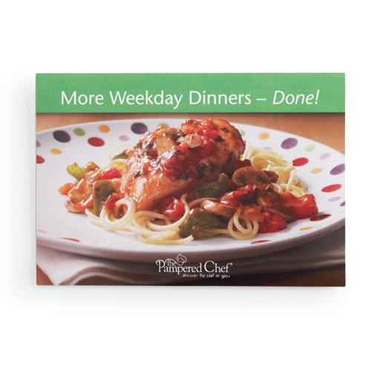  $7.00 | 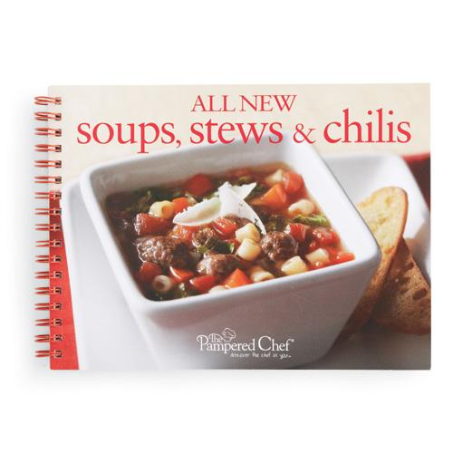  #2447 All New Soups, Stews & Chilis recipe collection  $8.00
#2449 Dinner in Your Deep Covered Baker recipe collection    $8.00 | 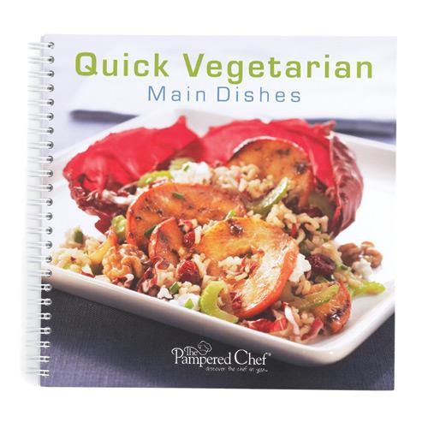  #2451 Quick Vegetarian Main Dishes recipe collection  $13.00
  #2453 Make It Fresh, Make It Healthy recipe collection  $15.00 | 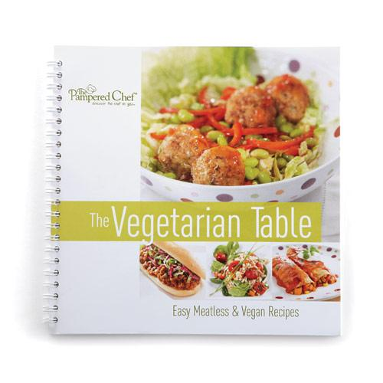  #2454 The Vegetarian Table cookbook  $15.00
  #2455 Corn Cob Nobs™  $4.50 | 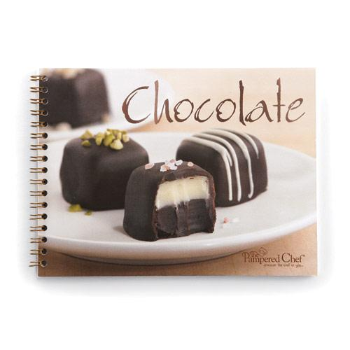  #2456 Chocolate recipe collection  $8.00
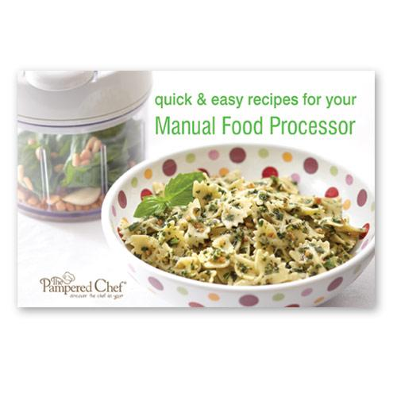  #2457 Quick & Easy Recipes for Your Manual Food Processor recipe cards  $7.00 | #2459 Great Grilling Recipes cookbook    $15.00

