#2443 TPC Weekday Dinners – Done! recipe cards  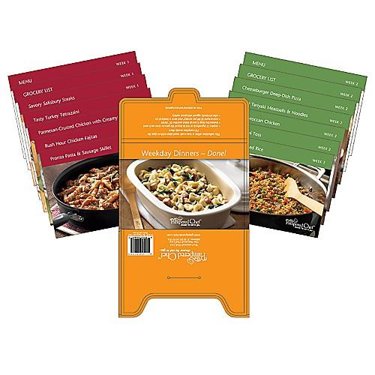  $7.00 |  | #2444 TPC Simply Sweet cookbook  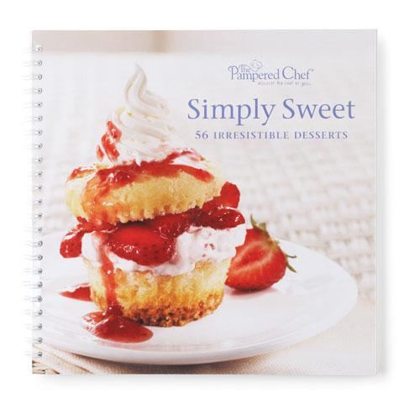  $15.00
#2446 TPC More Weekday Dinners – Done! recipe cards  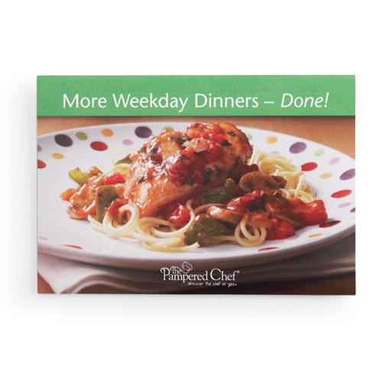  $7.00 |  | #2447 TPC All New Soups, Stews & Chilis recipe collection  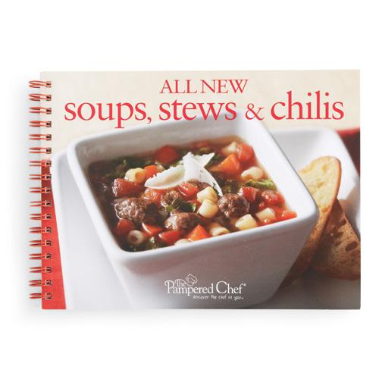  $8.00
#2449 TPC Dinner in Your Deep Covered Baker recipe collection  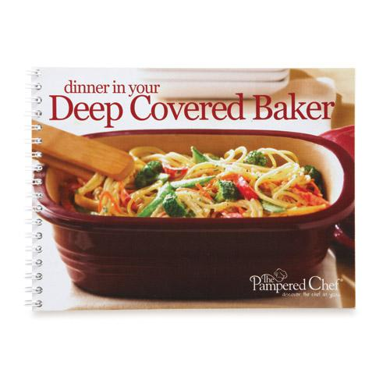  $8.00 |  | 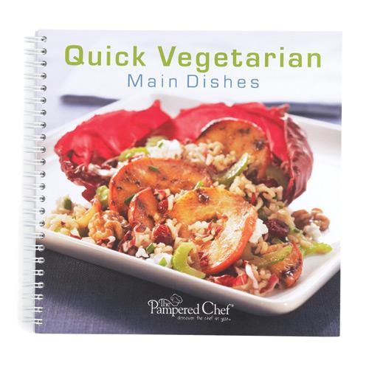  #2451 TPC Quick Vegetarian Main Dishes recipe collection  $13.00
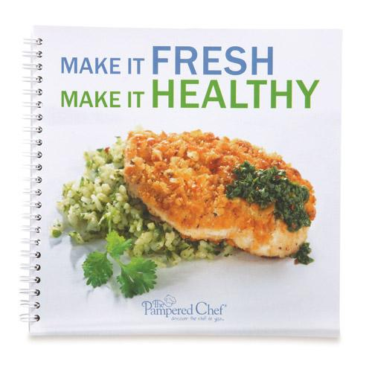  #2453 TPC Make It Fresh, Make It Healthy recipe collection  $15.00 |  | #2454 TPC The Vegetarian Table cookbook  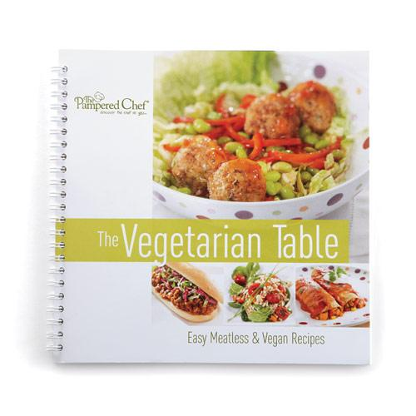  $15.00
#2455 Corn Cob Nobs™  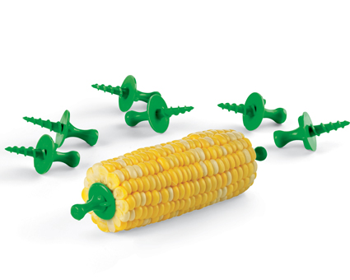  $4.50 |  | #2456 TPC Chocolate recipe collection  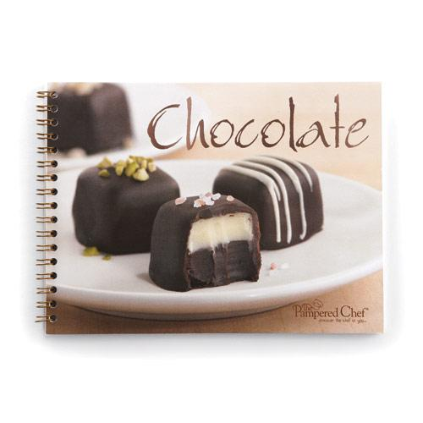  $8.00

