#2427 Apple Wedger  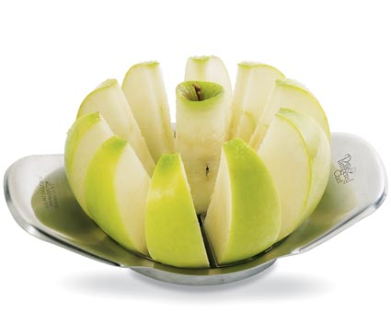  $13.50 | #2430 Apple Peeler/Corer/Slicer  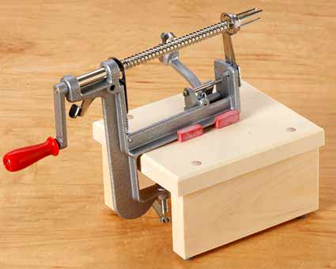  $32.00
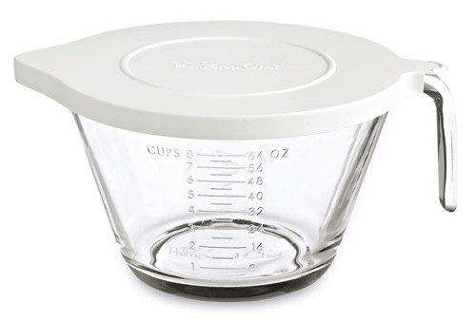  #2431 Classic Batter Bowl  $17.50 | #2432 Small Batter Bowl  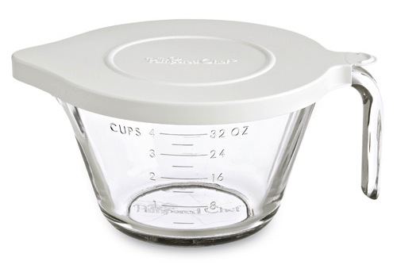  $15.00
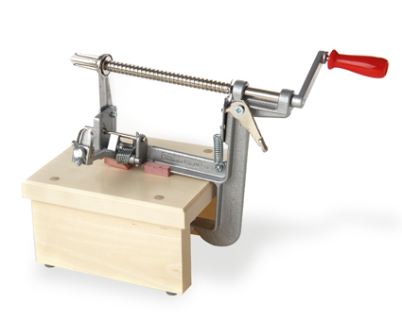  #2435 Apple Peeler/Corer/Slicer Stand  $18.50 | 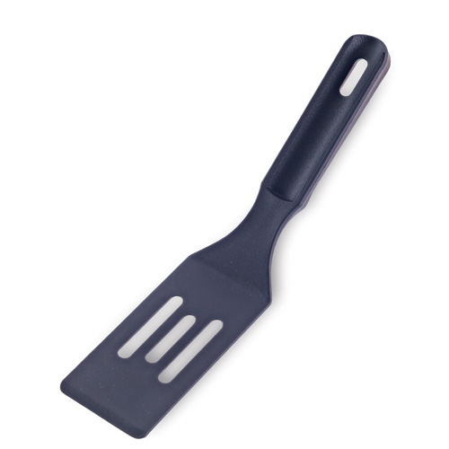  #2438 Mini Nylon Serving Spatula  $4.00
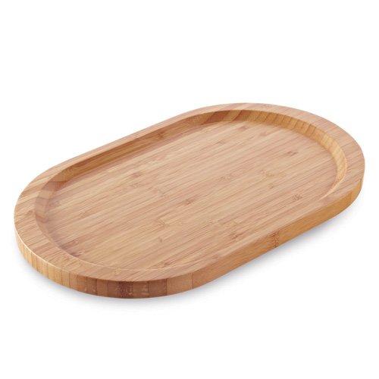  #2439 Bamboo Appetizer Platter  $24.00 | 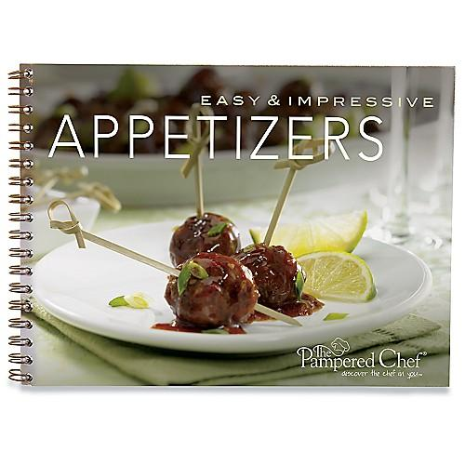  #2441 Easy & Impressive Appetizers recipe collection  $8.00
#2443 Weekday Dinners – Done! recipe cards  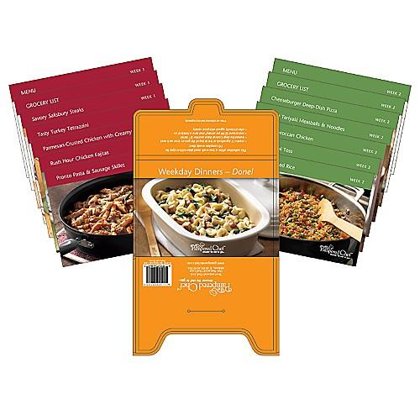  $7.00 | #2444 Simply Sweet cookbook  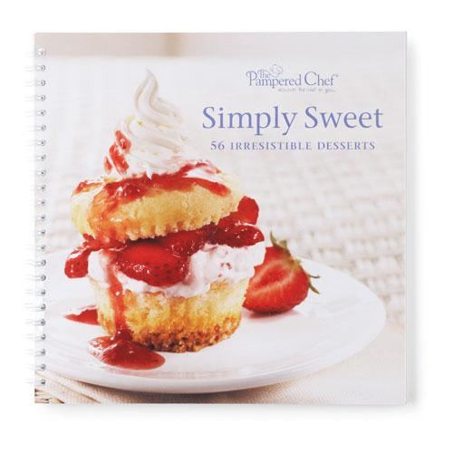  $15.00

