#2419 French Fry Cutter  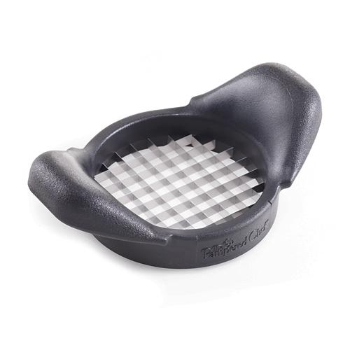  $17.00 |  | #2421 Silicone Prep Bowls  (set of 3)  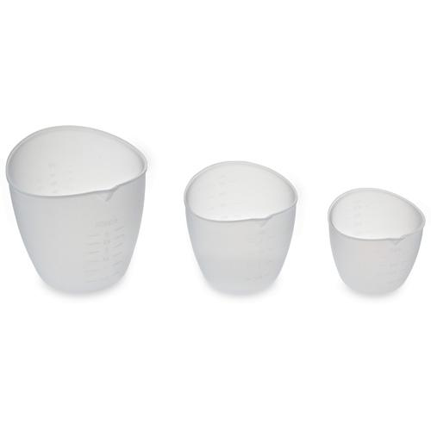  $19.50
#2422 Boil Over No More  - Small  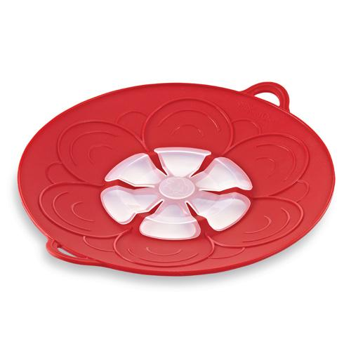  $24.50 |  | #2423 Boil Over No More  - Large  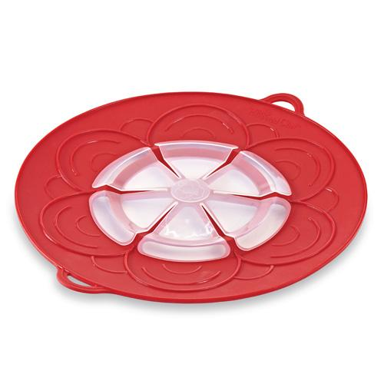  $29.50
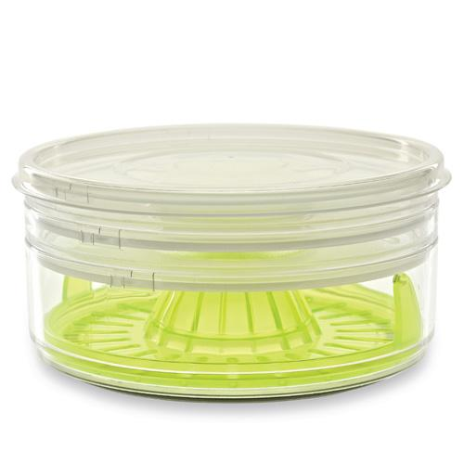  #2424 Drink Rimmer Set  $19.50 |  | #2426 Sauce It Up Gift Set  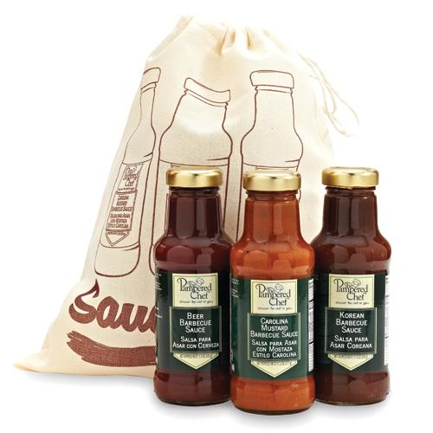  $34.50
#2427 Apple Wedger  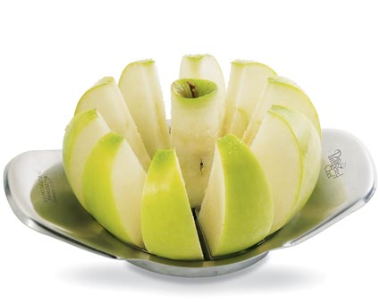  $13.50 |  | 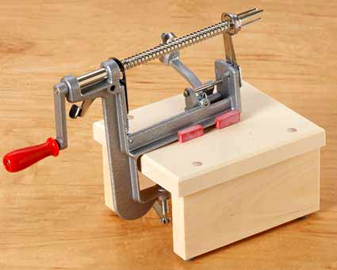  #2430 Apple Peeler/Corer/Slicer  $32.00
#2435 Apple Peeler/Corer/Slicer Stand  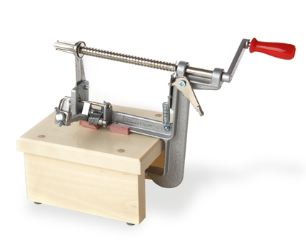  $18.50 |  | 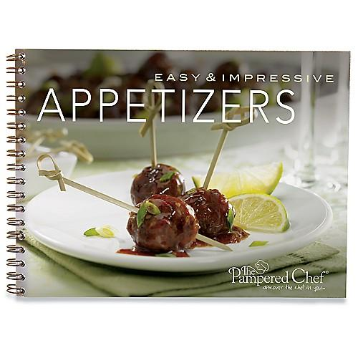  #2441 TPC Easy & Impressive Appetizers recipe collection  $8.00

