#2408 Double Boiler  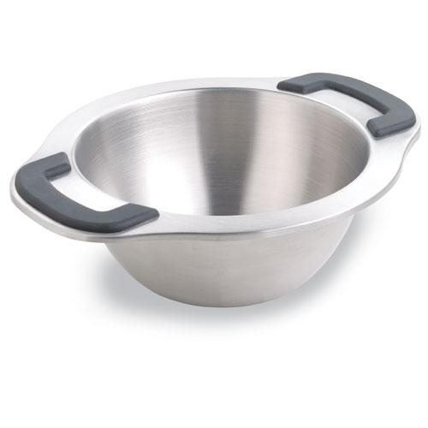  $21.00 | 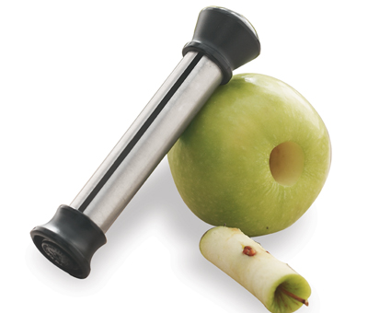  #2415 The Corer™  $11.00
#2416 Pineapple Wedger  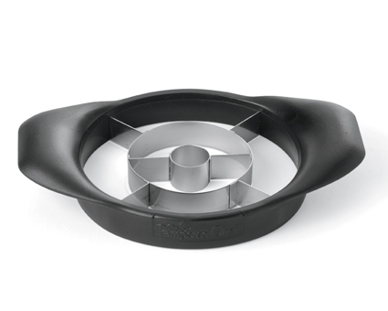  $19.00 | #2417 Veggie Wedger  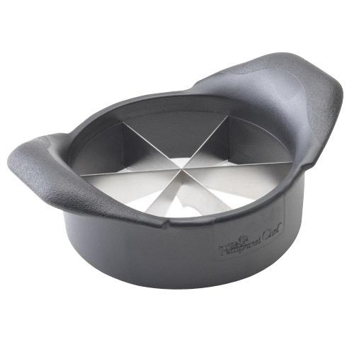  $18.50
#2418 Mango Wedger  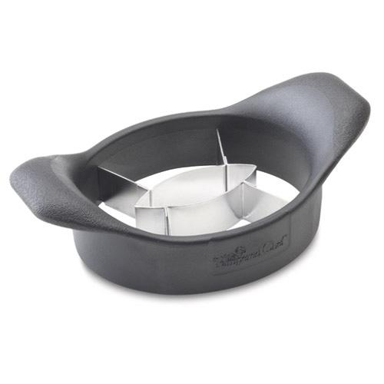  $15.00 | #2419 French Fry Cutter  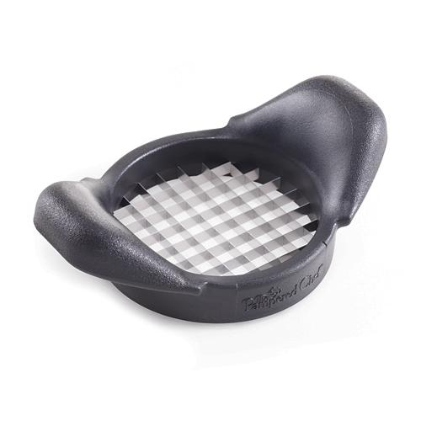  $17.00
#2421 Silicone Prep Bowls (set of 3)  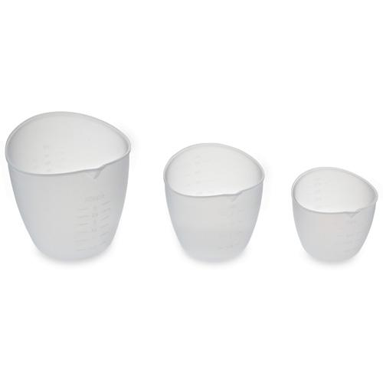  $19.50 | #2422 Boil Over No More – Small  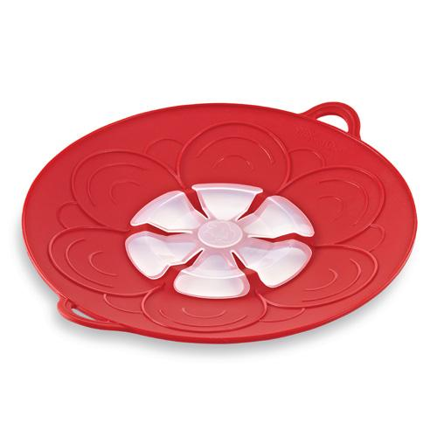  $24.50
#2423 Boil Over No More – Large  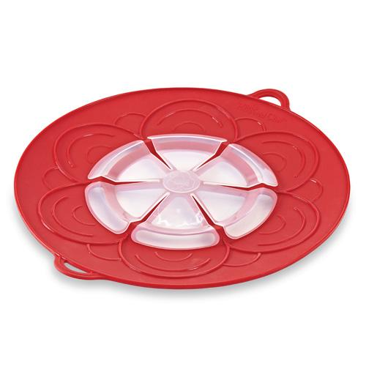  $29.50 | 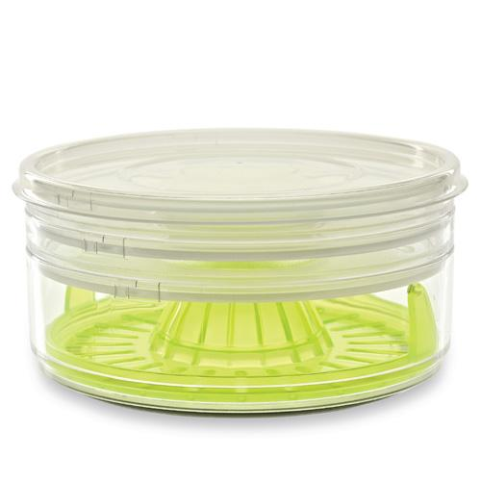  #2424 Drink Rimmer Set  $19.50

