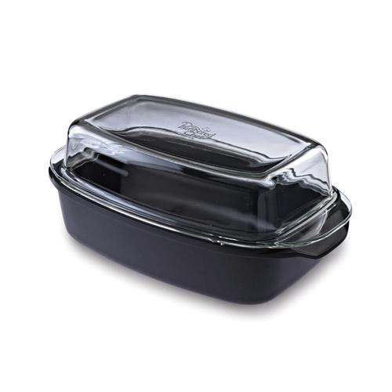  #2401 Covered Roaster  $99.50 |  | 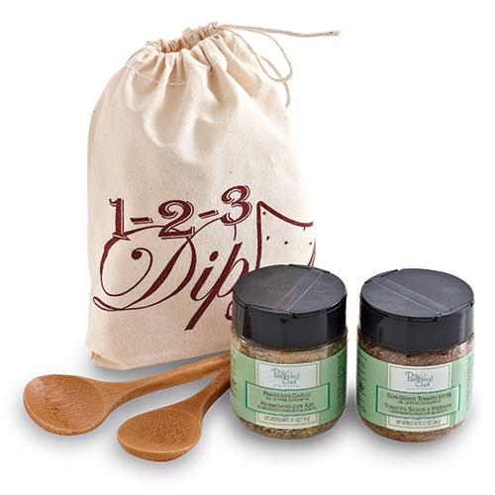  #2402 1-2-3 Dip! Set  $19.00
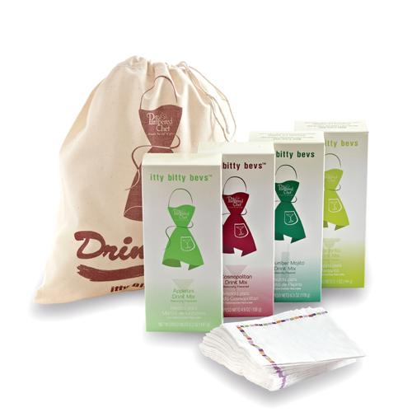  #2403 Drink It Up!  Itty Bitty Bevs Gift Set  $34.50 |  | 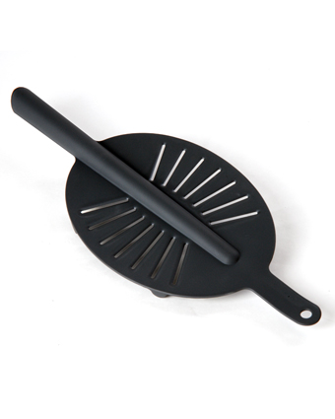  #2406 Drainer  $12.00
#2407 Splatter Screen  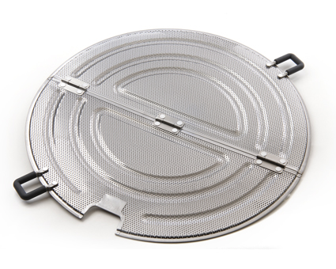  $24.00 |  | #2408 Double Boiler  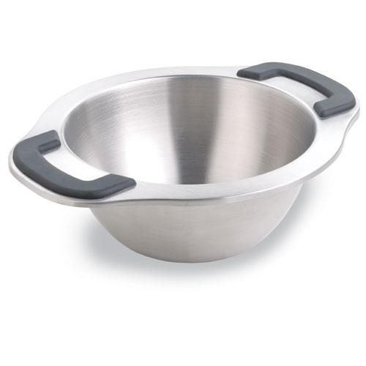  $21.00
#2415 The Corer™  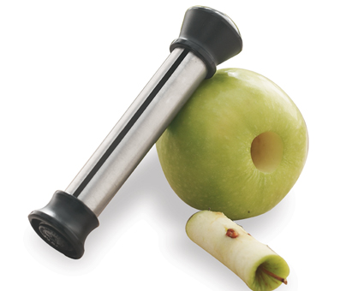  $11.00 |  | #2416 Pineapple Wedger  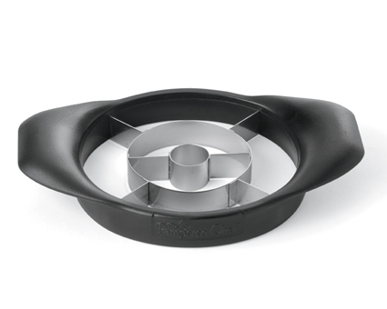  $19.00
#2417 Veggie Wedger  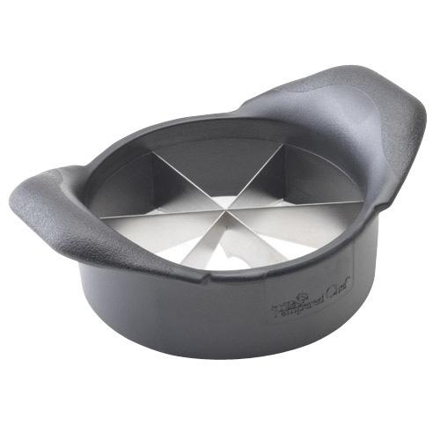  $18.50 |  | #2418 Mango Wedger  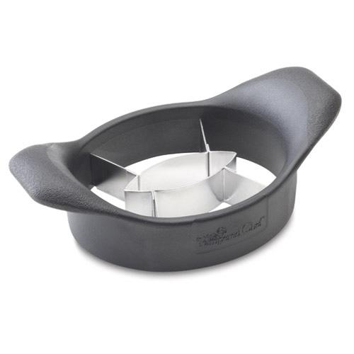  $15.00

