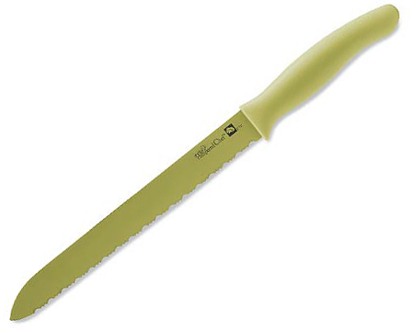  #1069 Color Coated Bread Knife  $20.00 | 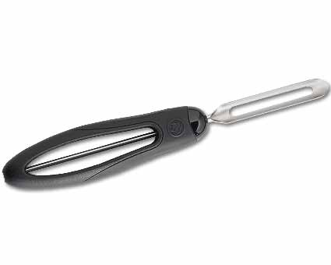  #1071 Vegetable Peeler  $9.00
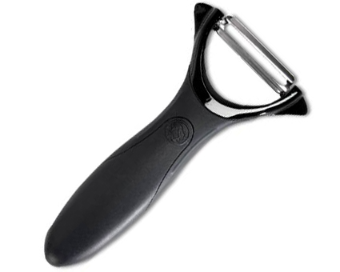  #1072 Serrated Peeler  $8.50 | #1073 J ulienne Peeler  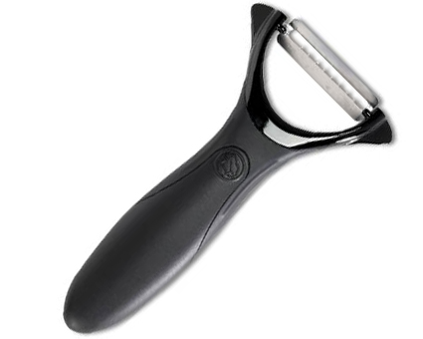  $10.50
#1074 Color Coated Paring Knife  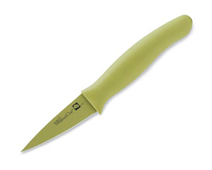  $13.50 | 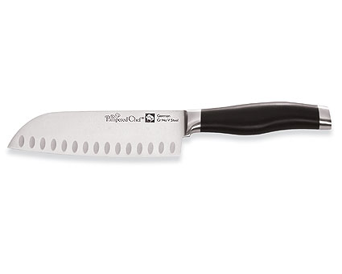  #1079 Forged Cutlery –  5” Santoku Knife  $52.00
#1081 Bamboo Knife Block  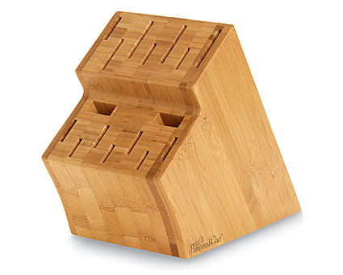  $60.00 | #1088 Professional Shears  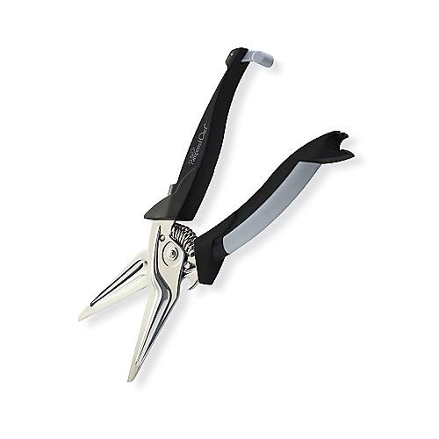  $25.00
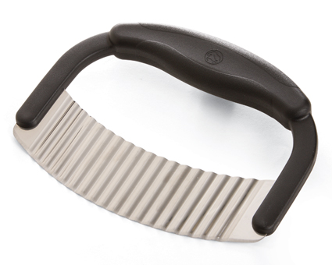  #1089 Crinkle Cutter  $11.00 | #1091 Forged Cutlery –  4.5” Serrated Knife  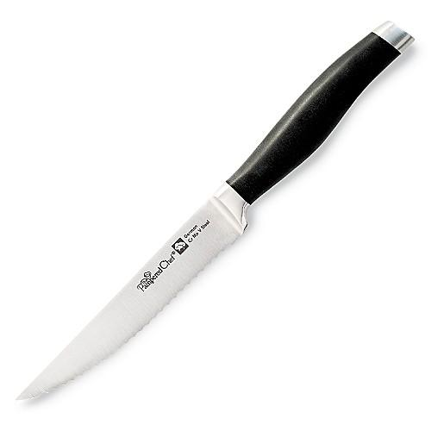  $38.00

