#2354 Digital Kitchen Scale  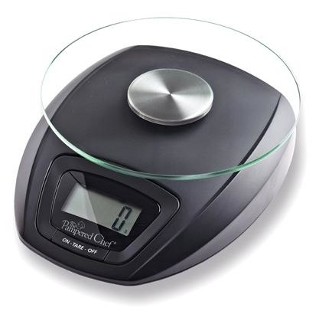  $39.50 | #2356 Spoon  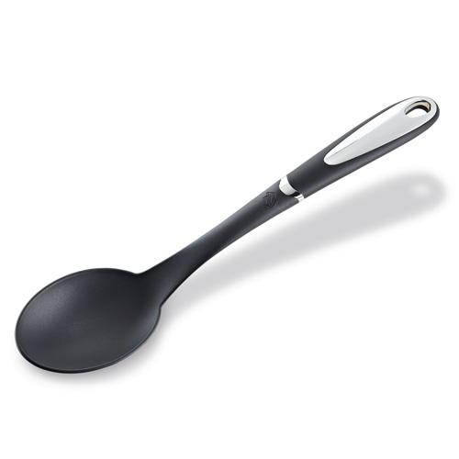  $12.50
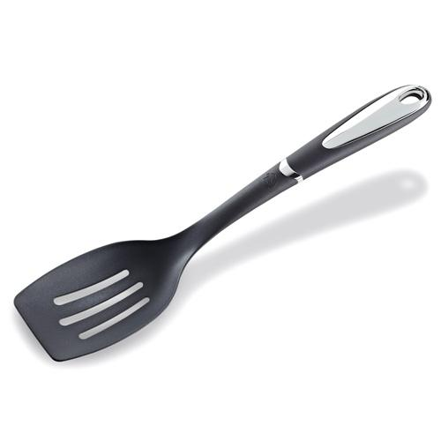  #2357 Slotted Spoon  $12.50 | 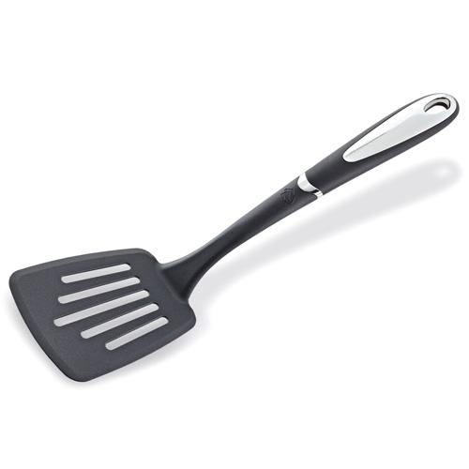  #2358 Slotted Turner  $12.50
#2359 Small Slotted Turner  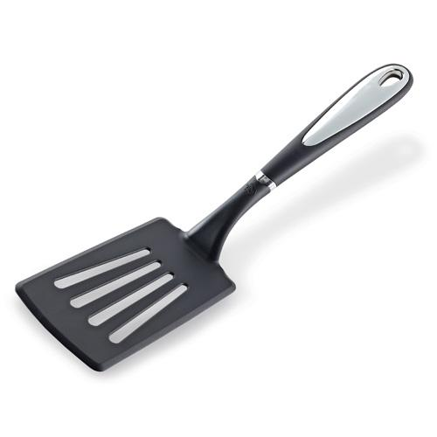  $11.00 | 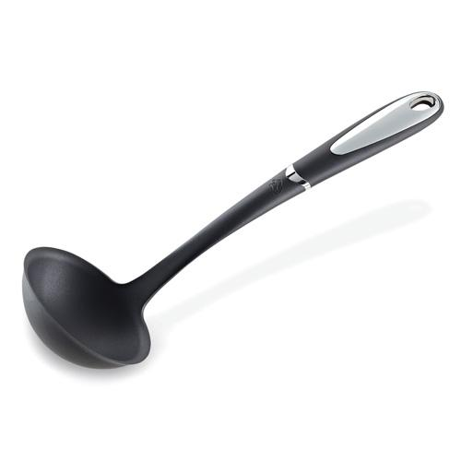  #2395 Ladle  $12.50
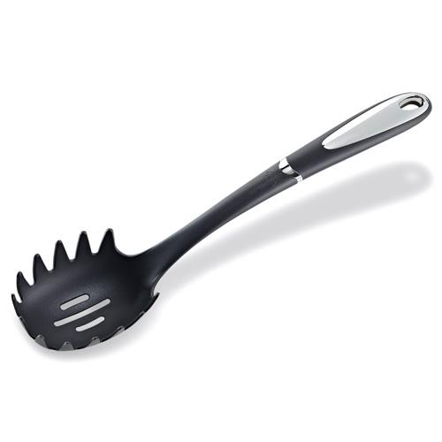  #2396 Pasta Fork  $12.50 | 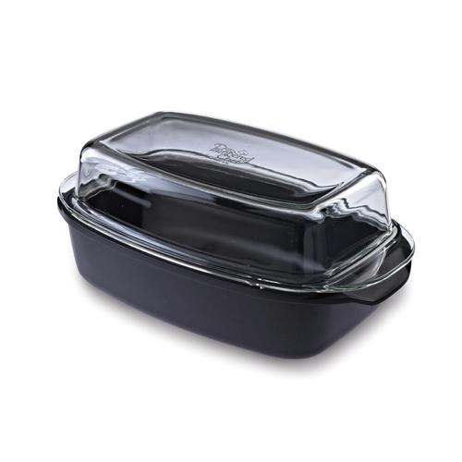  #2401 Covered Roaster  $99.50
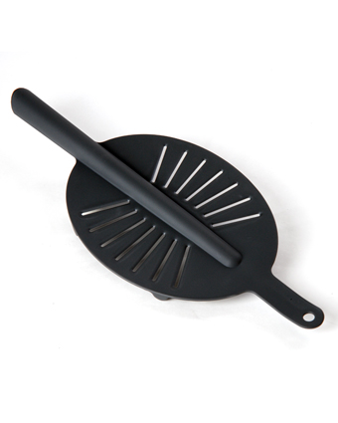  #2406 Drainer  $12.00 | #2407 Splatter Screen  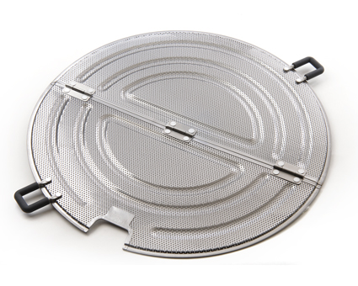  $24.00

