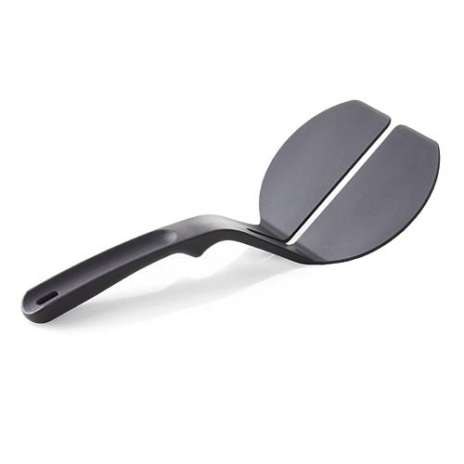  #2352 Nylon Panini Spatula  $8.00 |  | #2354 Digital Kitchen Scale  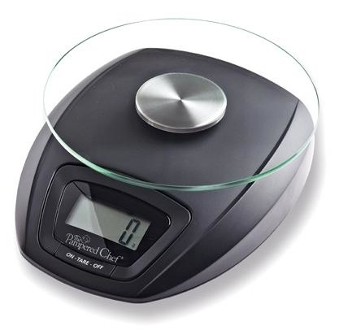  $39.50
#2356 Spoon  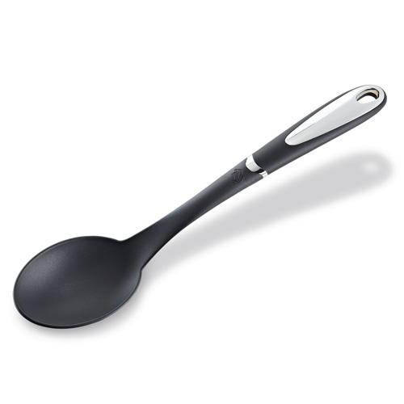  $12.50 |  | 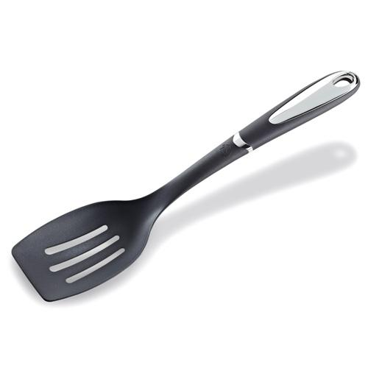  #2357 Slotted Spoon  $12.50
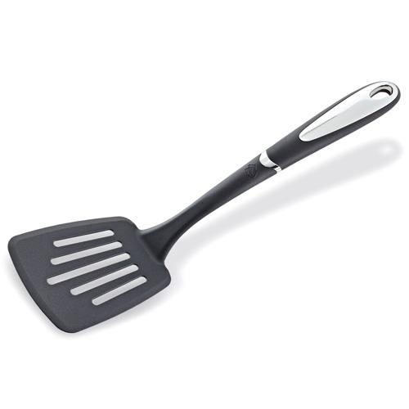  #2358 Slotted Turner  $12.50 |  | #2383 Great Grilling! Seasoning & Recipe Collection  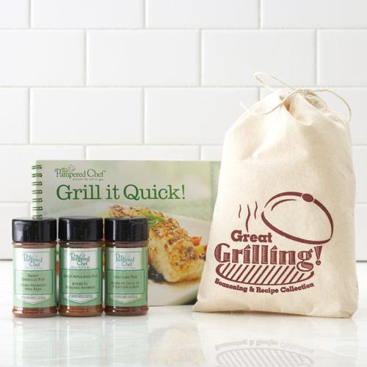  $19.00
#2389 Pizza Party Set  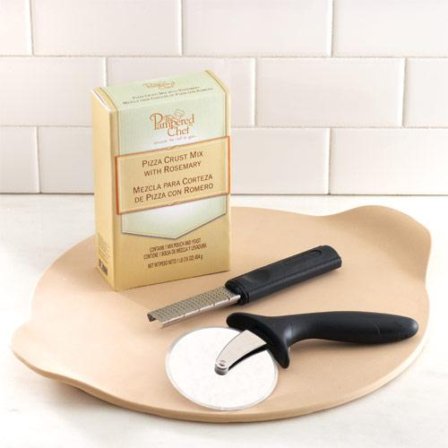  $59.50 |  | #2394 Grill I t! BBQ Pizza Set  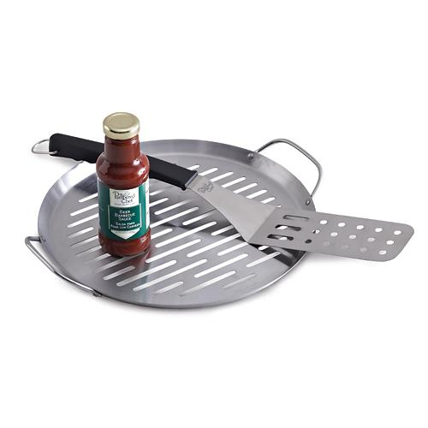  $49.00
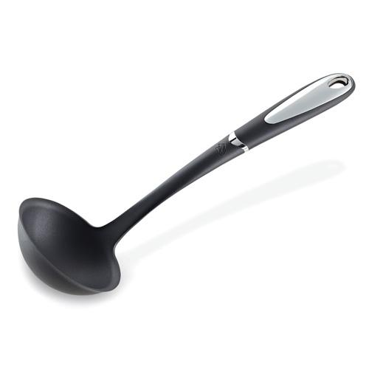  #2395 Ladle  $12.50 |  | 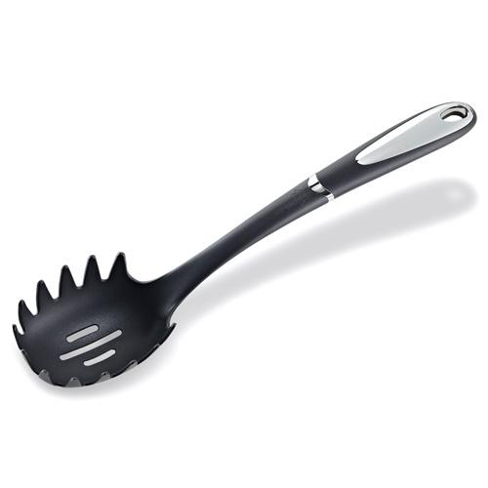  #2396 Pasta Fork  $12.50

