#2332 Small Frosted Dots Beverage Glasses (set of 4)  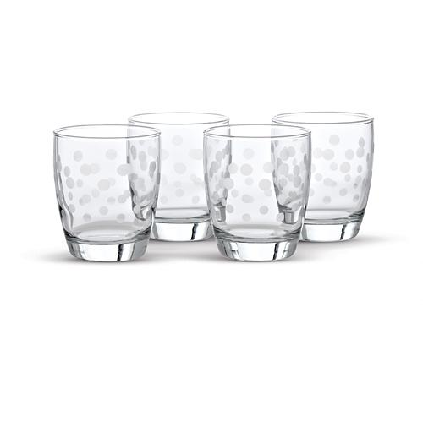  $23.00 | 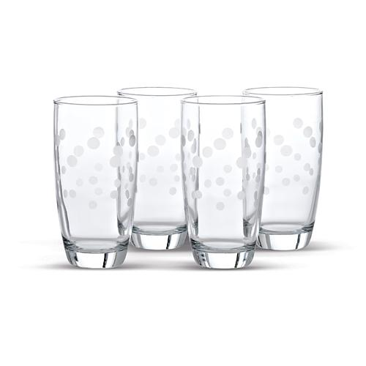  #2333 Large Frosted Dots Beverage Glasses  (set of 4)  $25.00
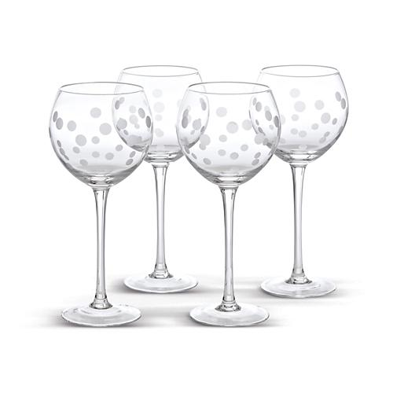  #2334 Frosted Dots Stemware (set of 4)  $44.50 | #2335 Nylon Ladle  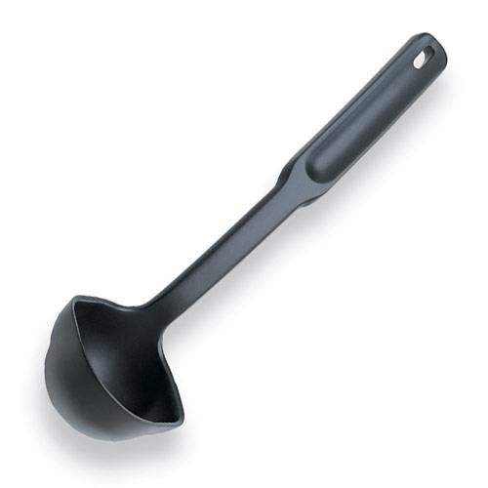  $6.50
#2336 Nylon Slotted Spoon  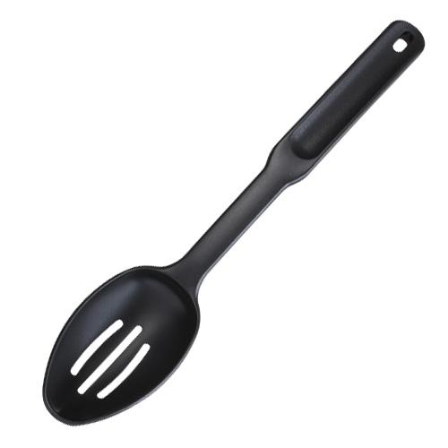  $5.50 | #2340 Small Nylon Turner  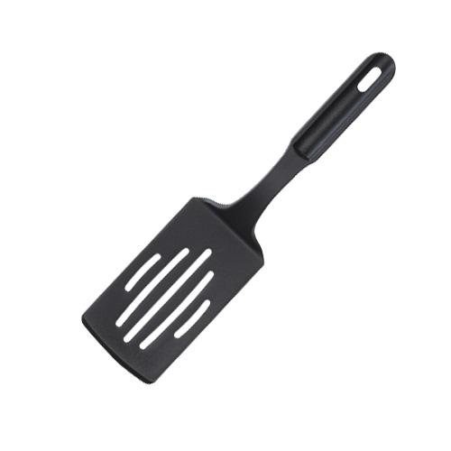  $5.00
#2348 Chef’s Tools – Skimmer  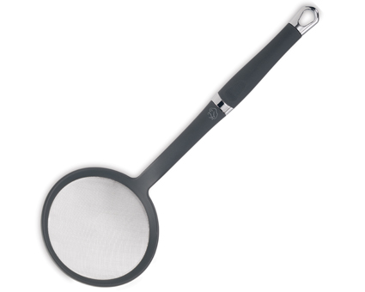  $14.00 | #2349 Nylon Spoon  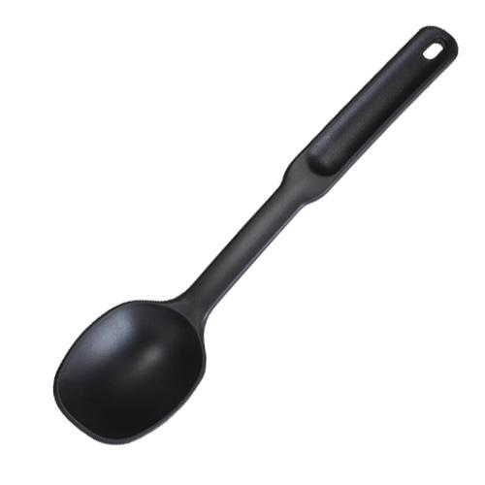  $5.50
#2351 Nylon Turner  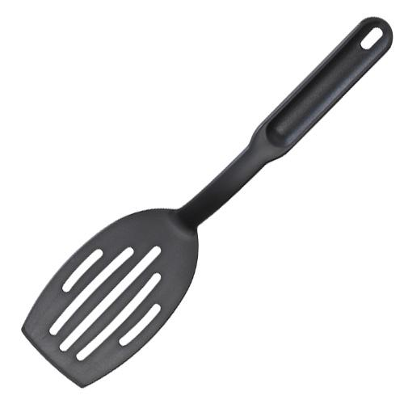  $5.50 | 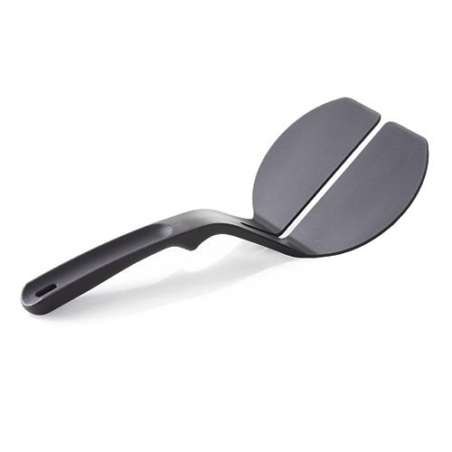  #2352 Nylon Panini Spatula  $8.00

