#2316 Salad Bowl Lid  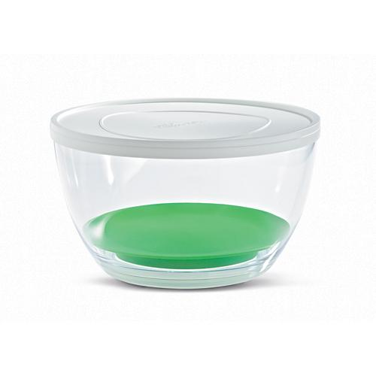  $5.50 | 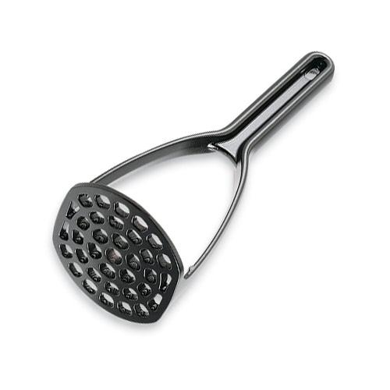  #2317 Nylon Masher  $6.50
#2319 Nylon Slotted Server  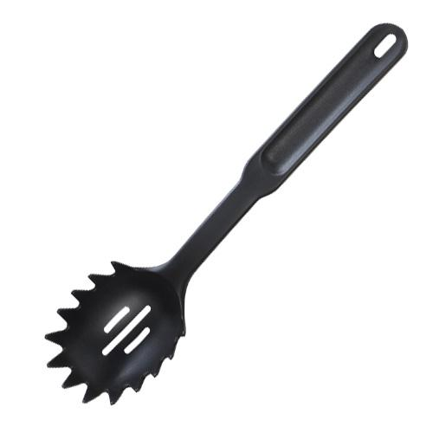  $6.50 | 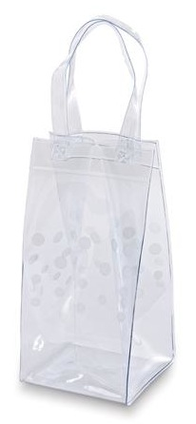  #2322 Bevs to Go –  Bottle Bag  $8.50
#2324 Easy Read Measuring Colander  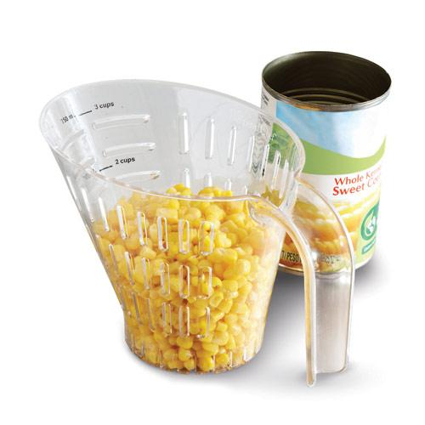  $10.00 | #2325 Basic Nylon Tool Set  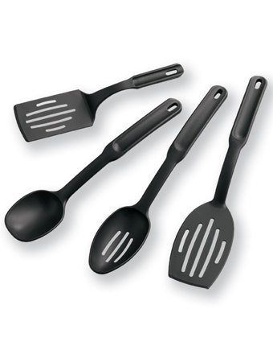  $19.50
#2326 Specialty Nylon Tool Set  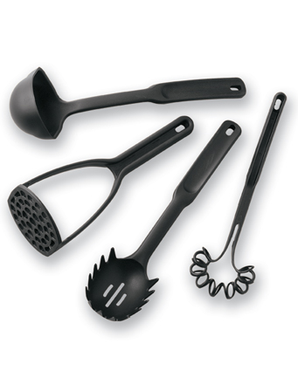  $24.50 | #2328 Double Wall Tumbler  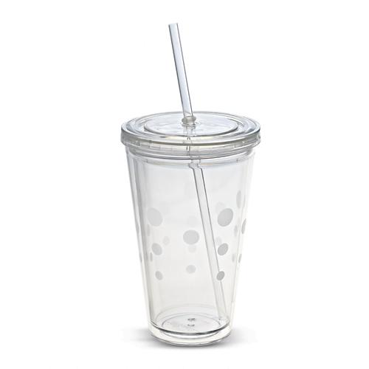  $10.00
#2329 Baking Soda Holder  with Thermometer  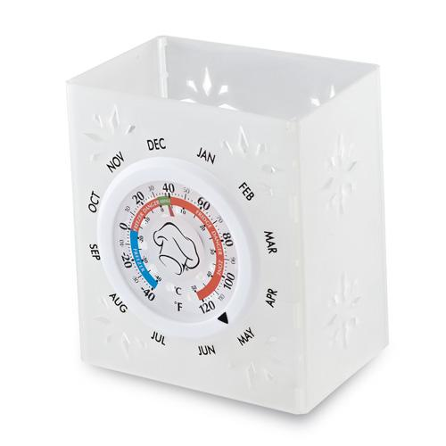  $15.00 | #2330 Nylon Spiral Whisk  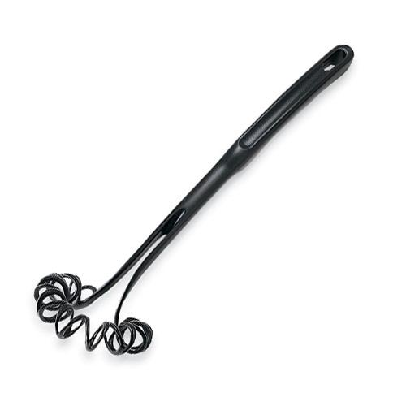  $8.00

