#2312 Bar Tongs  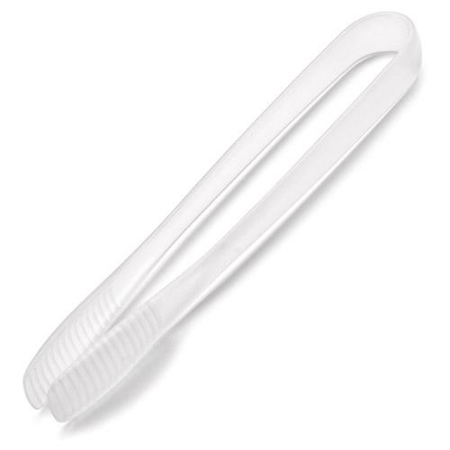  $5.50 |  | #2313 Outdoor Mini Spoons & Tongs Set  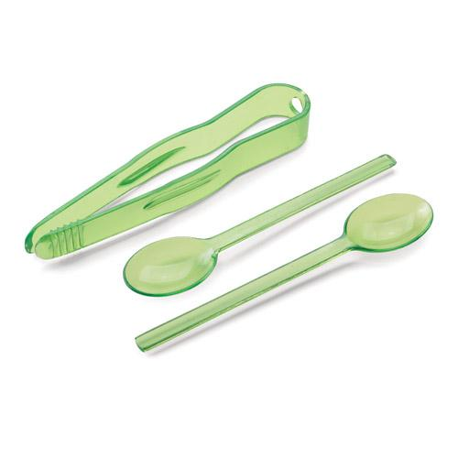  $5.00
#2316 Salad Bowl Lid  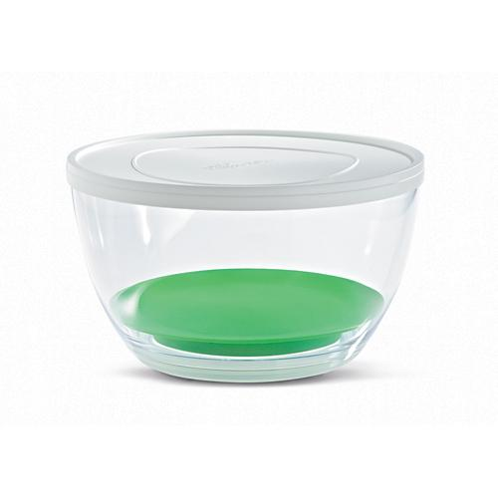  $5.50 |  | 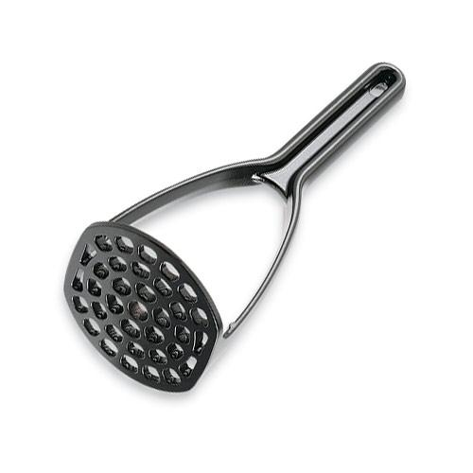  #2317 Nylon Masher  $6.50
#2319 Nylon Slotted Server  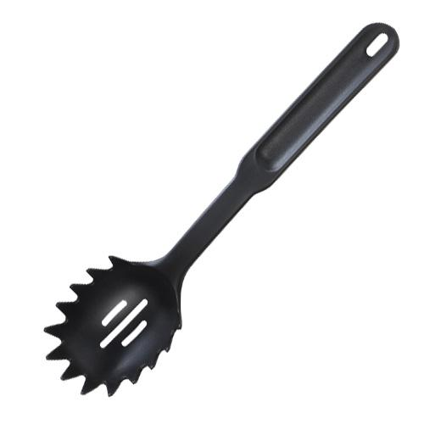  $6.50 |  | #2324 Easy Read Measuring Colander  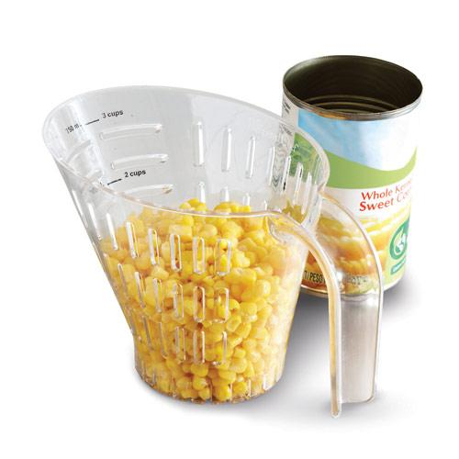  $10.00
#2325 Basic Nylon Tool Set  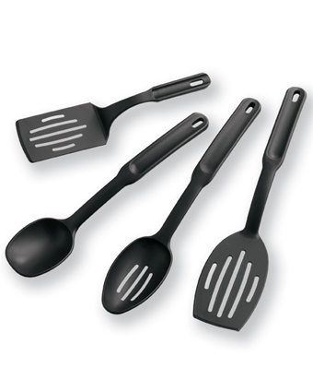  $19.50 |  | #2326 Specialty Nylon Tool Set  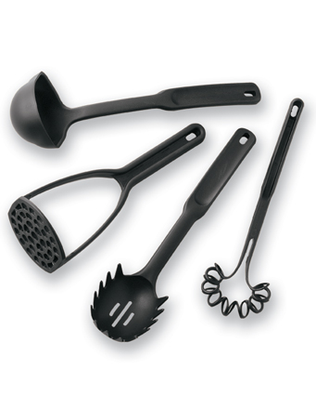  $24.50
#2328 Double Wall Tumbler  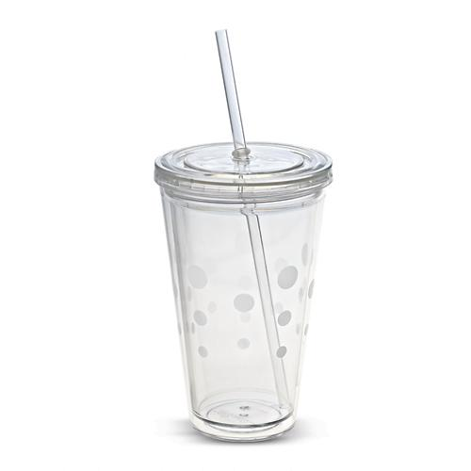  $10.00 |  | #2329 Baking Soda Holder  with Thermometer  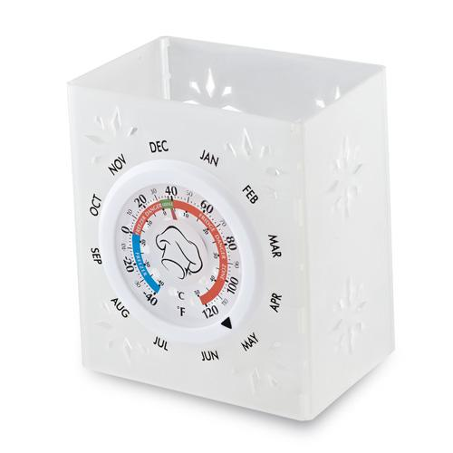  $15.00

