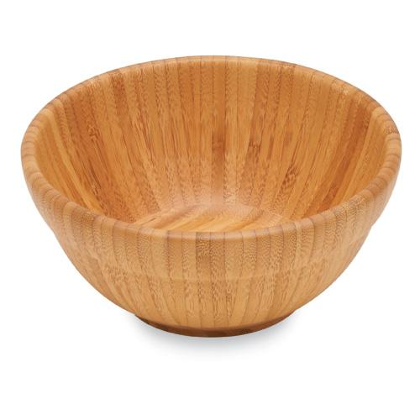  #2302 Medium Bamboo Round Bowl  $30.00 | #2303 Large Bamboo Round Bowl  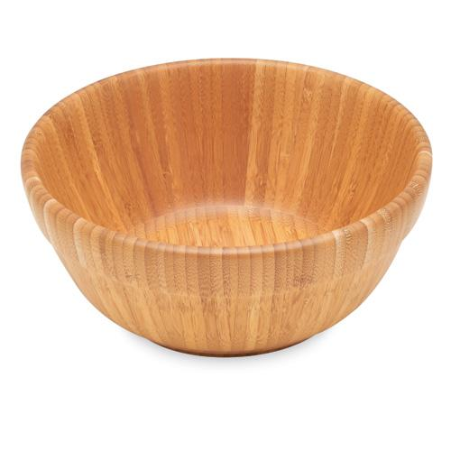  $40.00
#2304 Mini Scoop & Measure  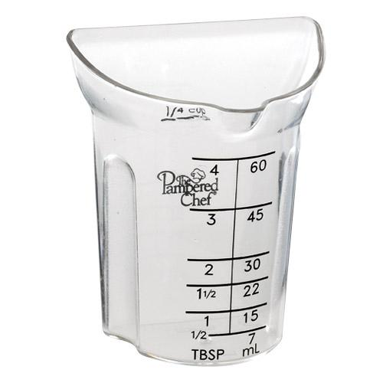  $5.50 | 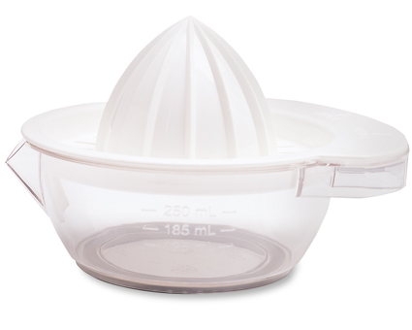  #2305 J uicer  $13.00
#2306 Bamboo Kitchen Towel  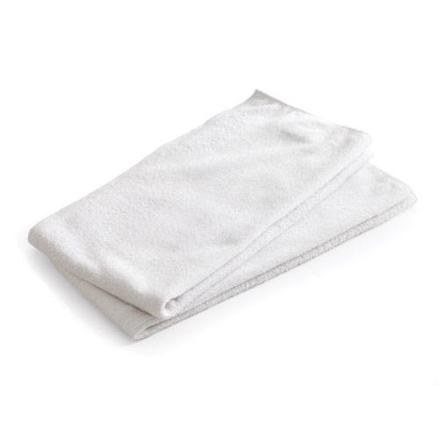  $14.00 | #2307 Petite Bamboo Spoon Set  (set of 2)  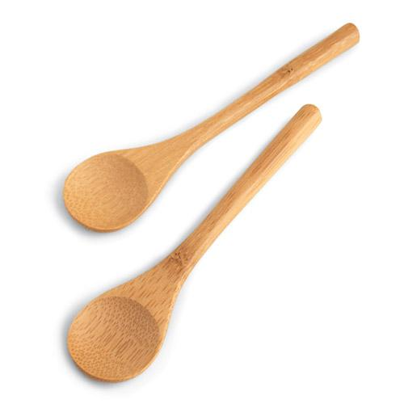  $4.50
#2308 Measuring Spoon Set  (set of 6)  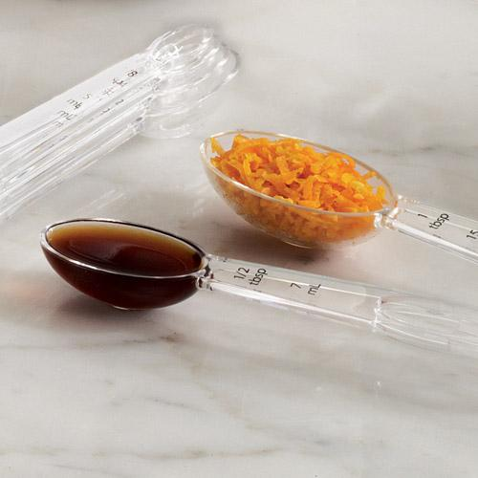  $8.50 | 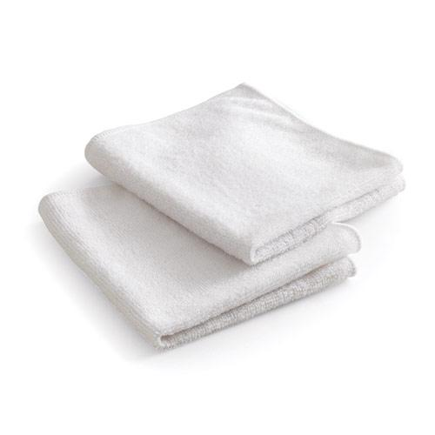  #2311 Bamboo Dishcloths  (set of 2)  $8.50
#2312 Bar Tongs  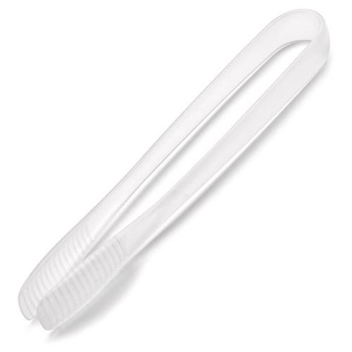  $5.50 | #2313 Outdoor Mini Spoons & Tongs Set  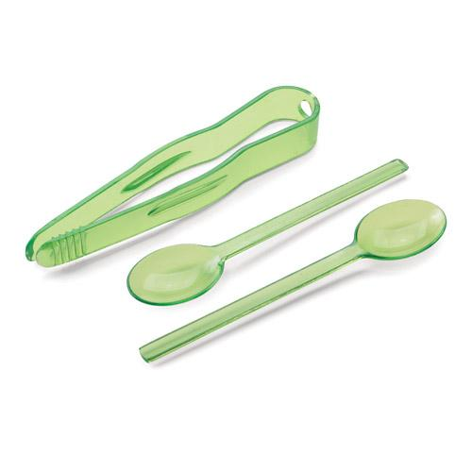  $5.00

