#2298 Ice Bucket & Scoop Set  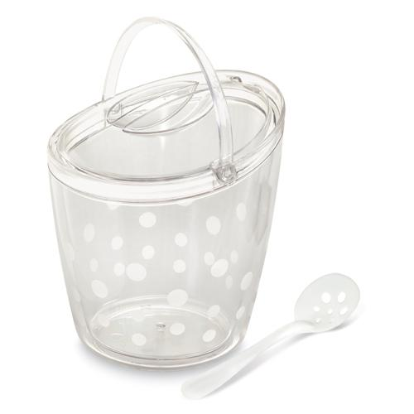  $41.50 |  | #2299 Small Bamboo Round Bowls (set of 2)  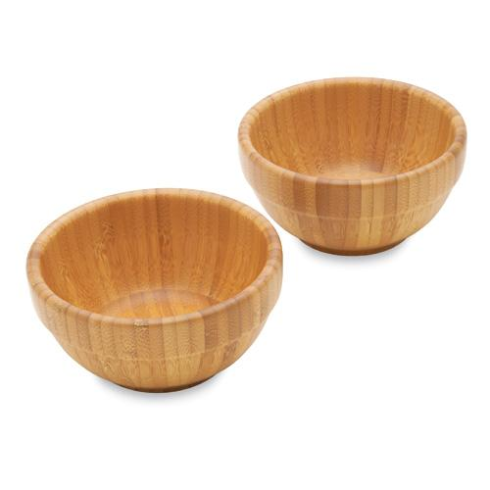  $26.00
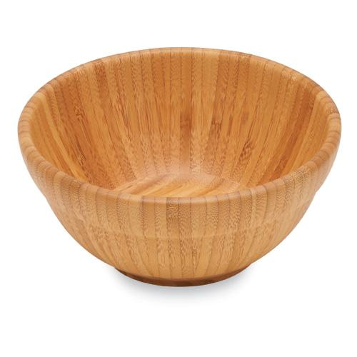  #2302 Medium Bamboo Round Bowl  $30.00 |  | #2303 Large Bamboo Round Bowl  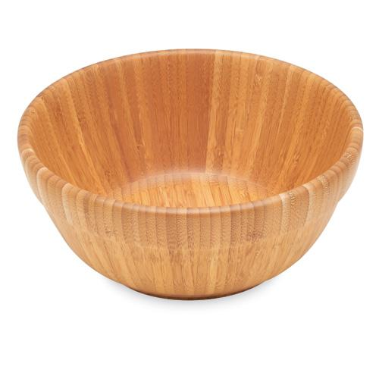  $40.00
#2304 Mini Scoop & Measure  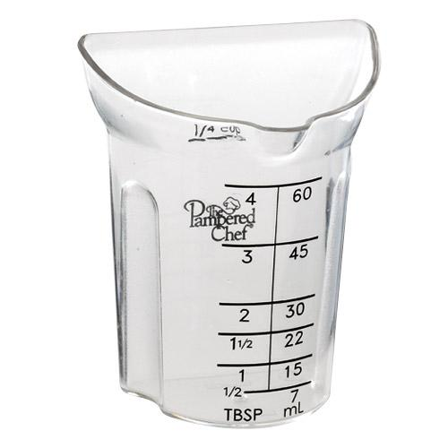  $5.50 |  | #2305 J uicer  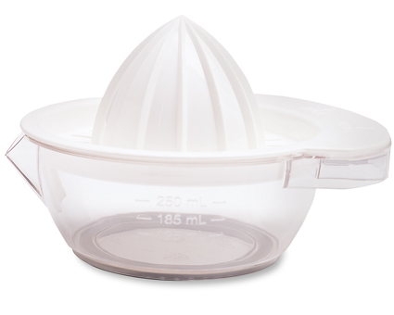  $13.00
#2306 Bamboo Kitchen Towel  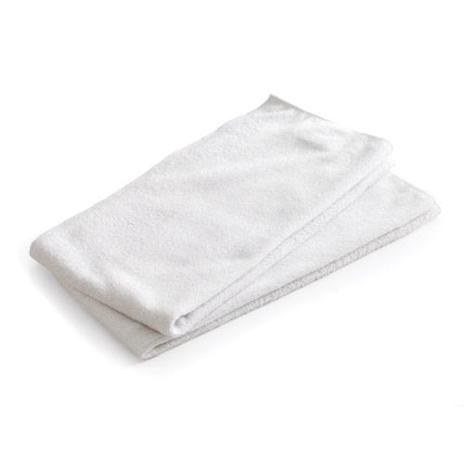  $14.00 |  | #2307 Petite Bamboo Spoon Set  (set of 2)  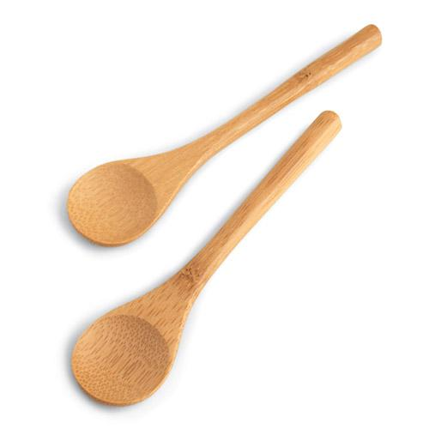  $4.50
#2308 Measuring Spoon Set (set of 6)  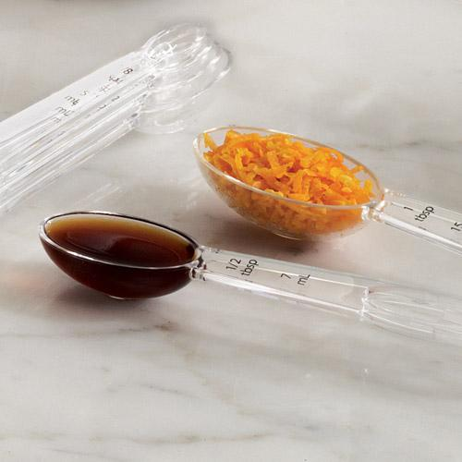  $8.50 |  | #2311 Bamboo Dishcloths (set of 2)  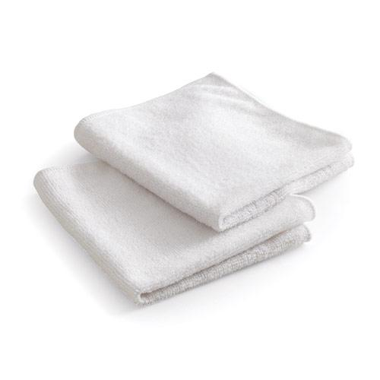  $8.50

