#2265 Measure, Mix & Pour™  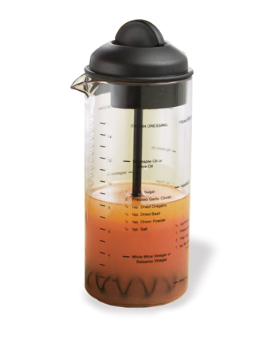  $12.50 | #2272 Quick-Stir® Pitcher (2 qts.)  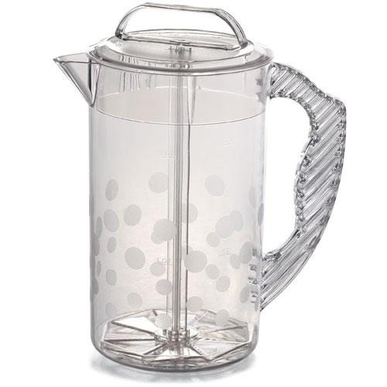  $17.50
#2274 Family-Size Quick-Stir® Pitcher (1 gal.)  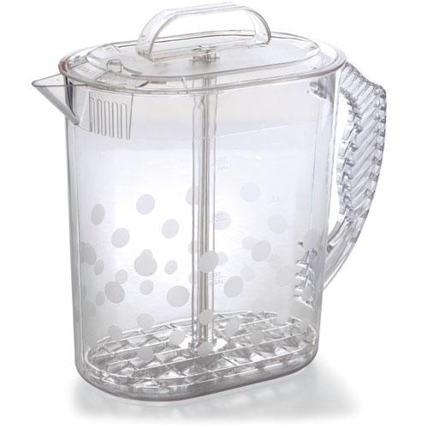  $23.50 | #2282 Shaker  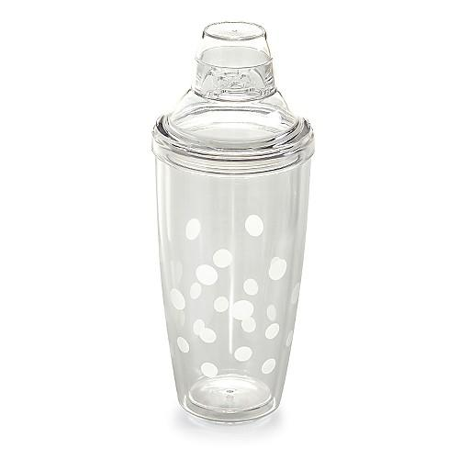  $21.50
#2284 Ice Bucket & Shaker Set  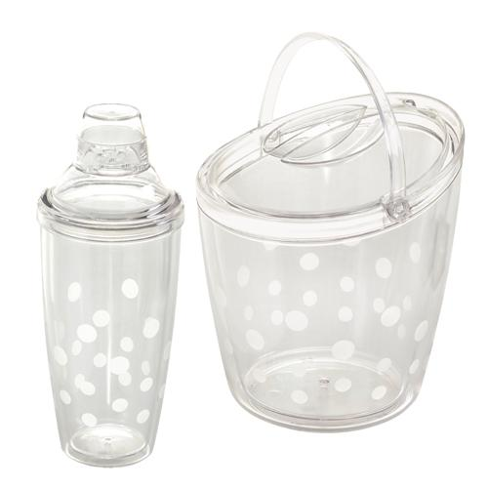  $54.50 | #2292 Cool & Serve Square Tray  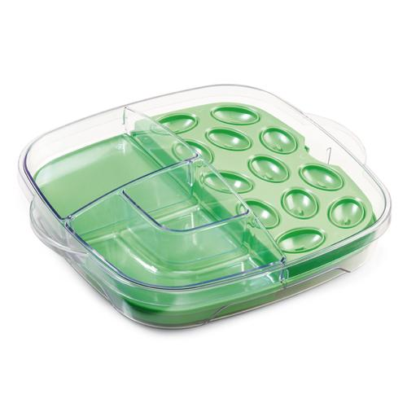  $46.50
#2296 Small Bamboo Snack Bowls (set of 2)  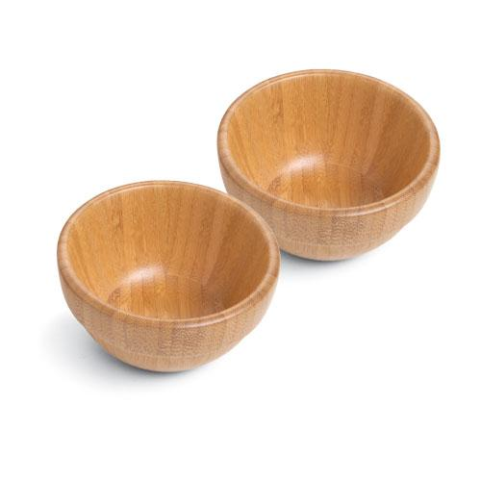  $19.50 | #2297 Bamboo Serving Tongs  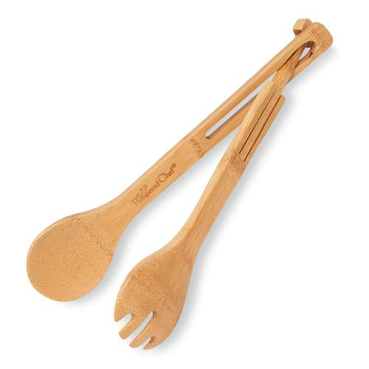  $12.50
#2298 Ice Bucket & Scoop Set  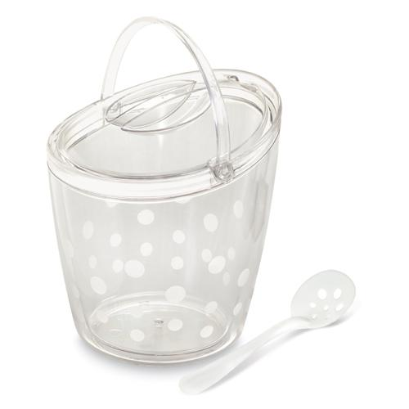  $41.50 | #2299 Small Bamboo Round Bowls (set of 2)  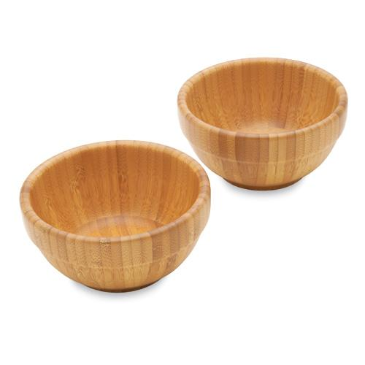  $26.00

