#2263 TPC 29 Minutes to Dinner, Volume 2 cookbook  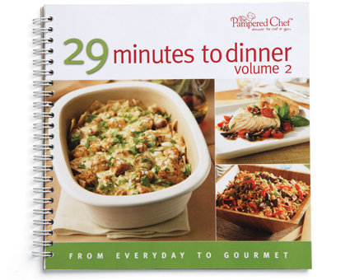  $15.00 |  | #2265 Measure, Mix & Pour™  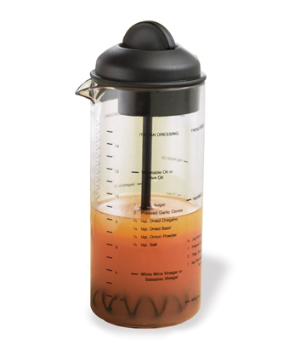  $12.50
#2272 Quick-Stir® Pitcher (2 qts.)  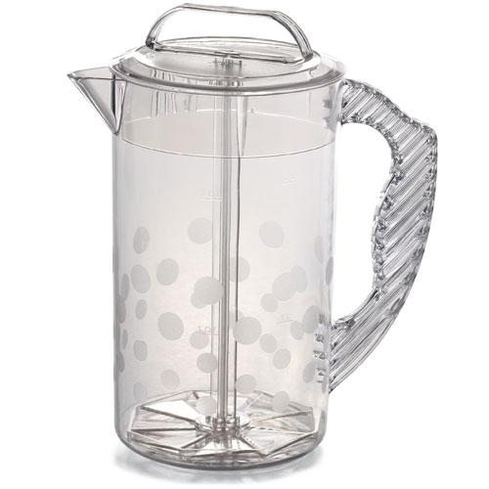  $17.50 |  | #2274 Family-Size Quick-Stir® Pitcher (1 gal.)  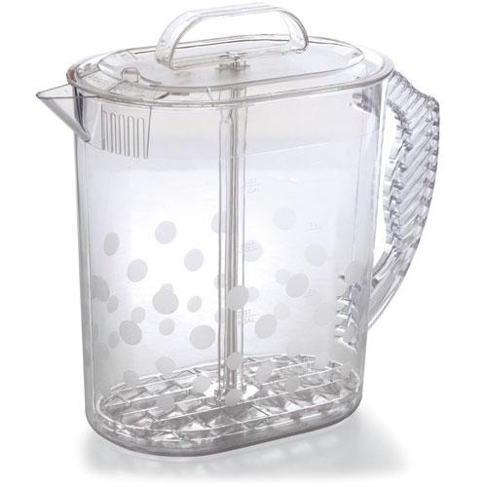  $23.50
#2282 Shaker  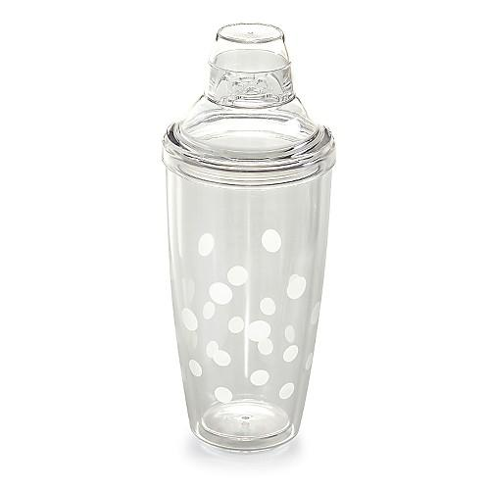  $21.50 |  | #2284 Ice Bucket & Shaker Set  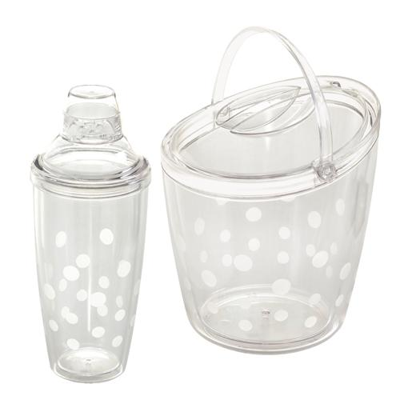  $54.50
#2288 Bamboo Salad Claws  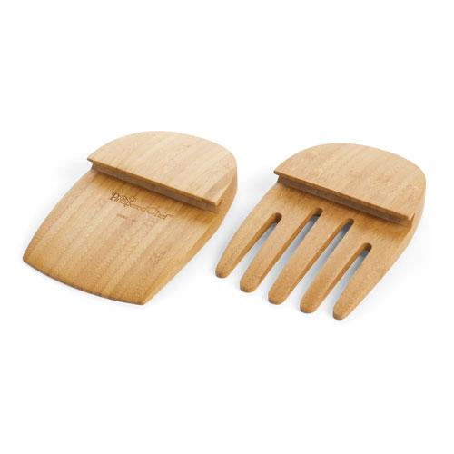  $16.00 |  | #2292 Cool & Serve Square Tray  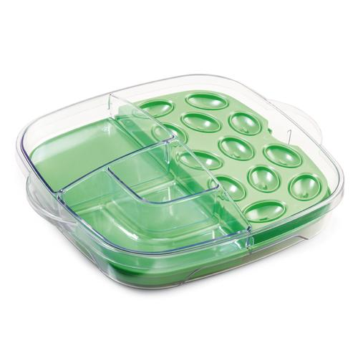  $46.50
#2296 Small Bamboo Snack Bowls (set of 2)  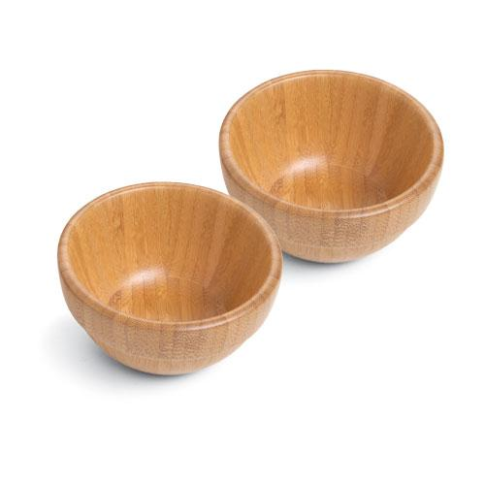  $19.50 |  | #2297 Bamboo Serving Tongs  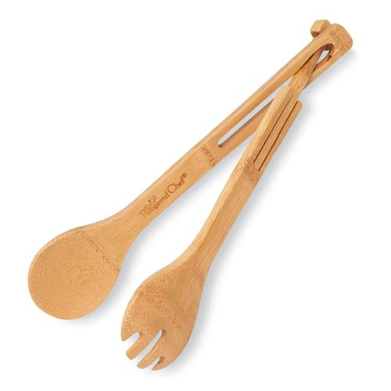  $12.50

