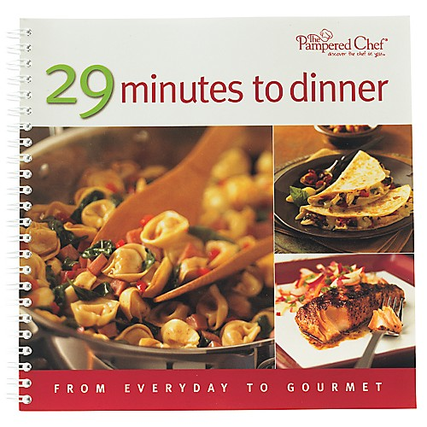  #2227 TPC 29 Minutes to Dinner cookbook  $15.00 | #2236 Mini Measure-All® Cup  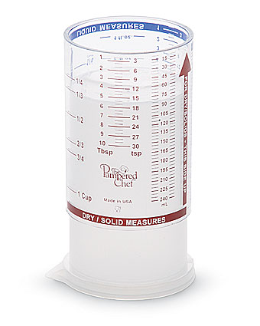  $6.50
#2244 Candy Thermometer  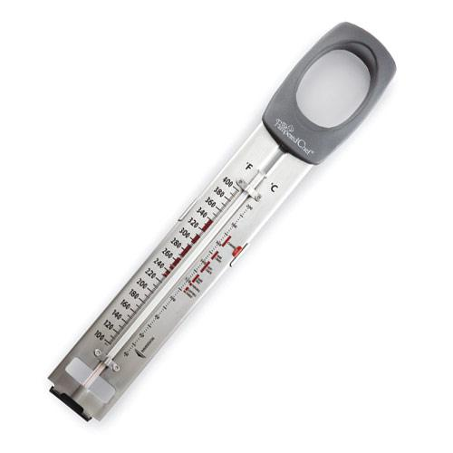  $22.50 | 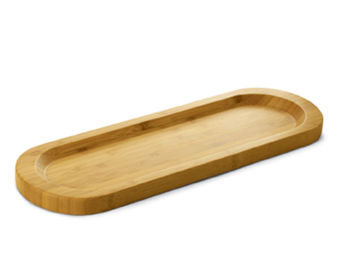  #2247 Bamboo Cracker Tray  $16.50
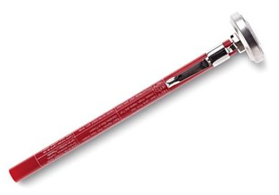  #2248 Pocket Thermometer  $12.50 | #2253 Petite Bamboo Snack Bowls (set of 4)  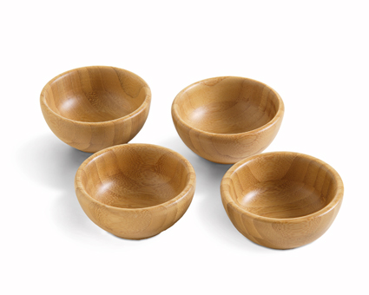  $25.00
#2256 Easy Conversions Magnet  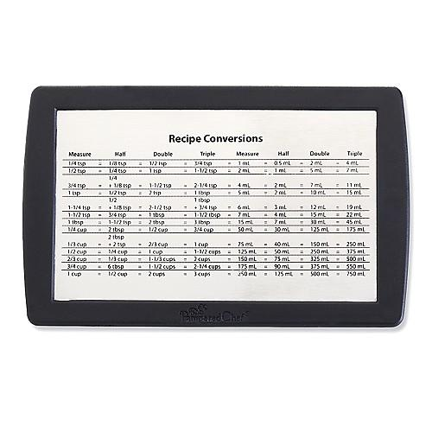  $8.50 | #2257 Measuring Cup Set  (set of 6)  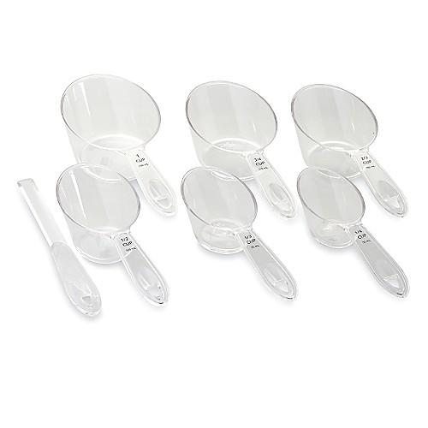  $16.00
#2258 Adjustable Measuring Spoons  (set of 2)  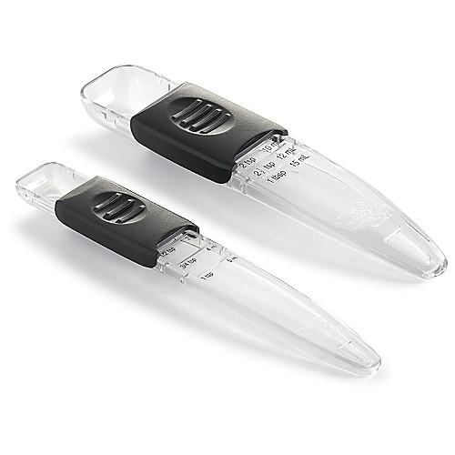  $8.50 | #2263 29 Minutes to Dinner, Volume 2 cookbook  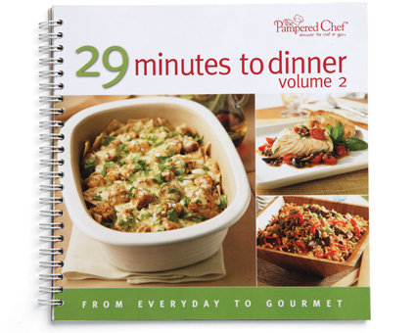  $15.00

