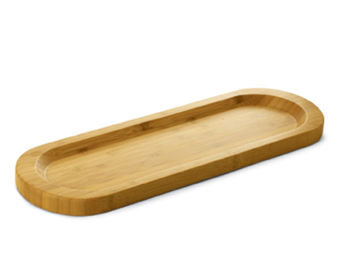  #2247 Bamboo Cracker Tray  $16.50 |  | 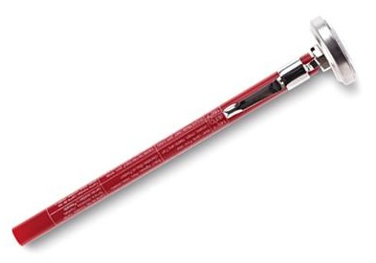  #2248 Pocket Thermometer  $12.50
#2249 Medium Square Bamboo Bowl  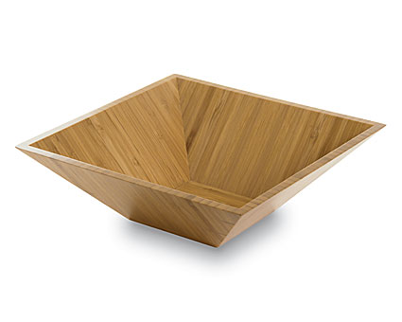  $20.00 |  | 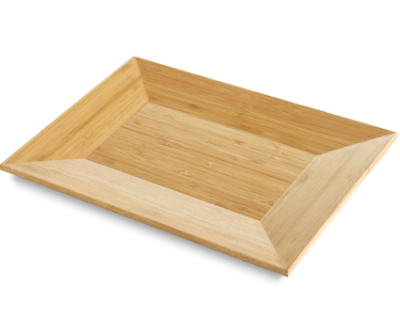  #2251 Medium Bamboo Platter  $30.00
#2252 Large Bamboo Platter  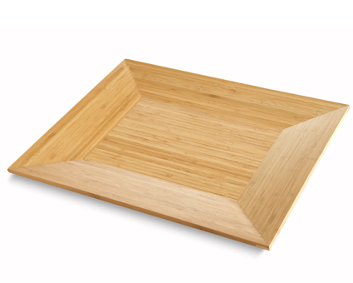  $40.00 |  | #2253 Petite Bamboo Snack Bowls (set of 4)  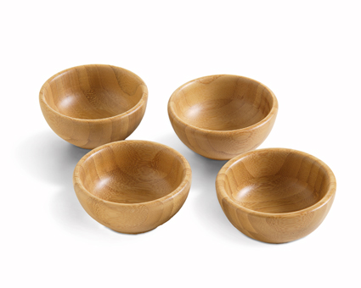  $25.00
#2254 Large Bamboo Square Bowl  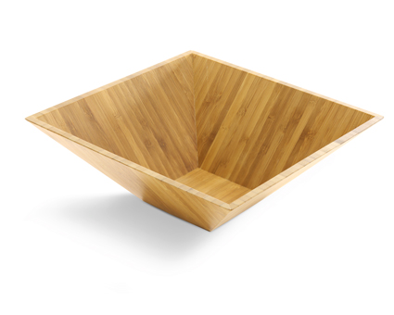  $30.00 |  | #2256 Easy Conversions Magnet  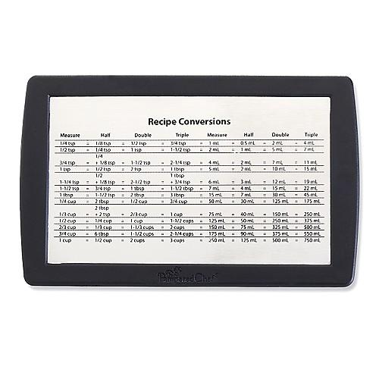  $8.50
#2257 Measuring Cup Set (set of 6)  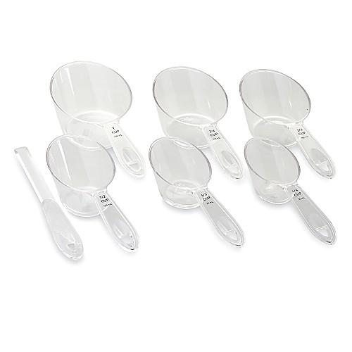  $16.00 |  | #2258 Adjustable Measuring Spoons (set of 2)  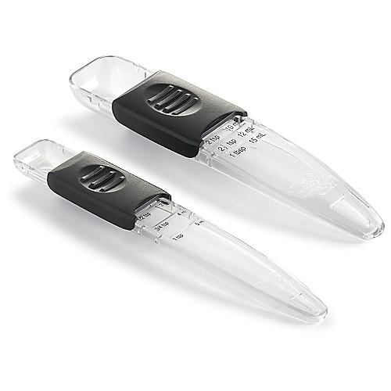  $8.50

