#2177 Easy Read Mini Measuring Cup  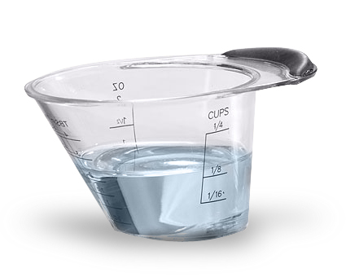  $6.25 | 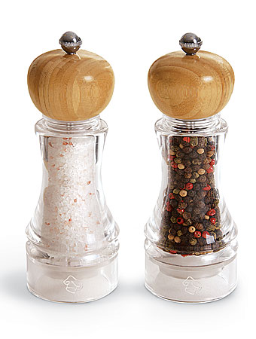  #2195 Grinder Set  (set of 2)  $44.00
#2196 Grinder  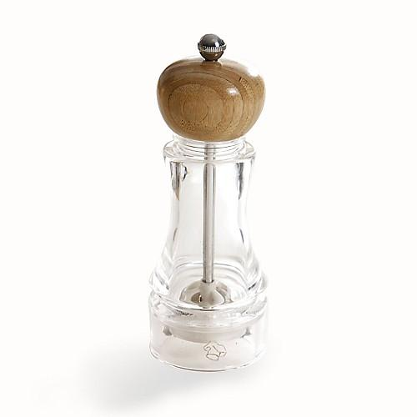  $23.50 | 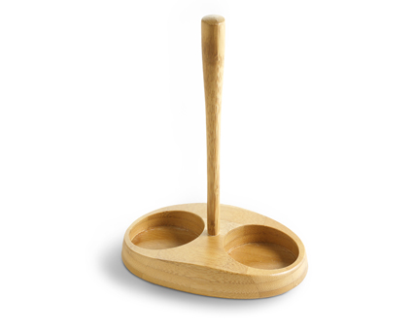  #2197 Bamboo Grinder Stand  $16.50
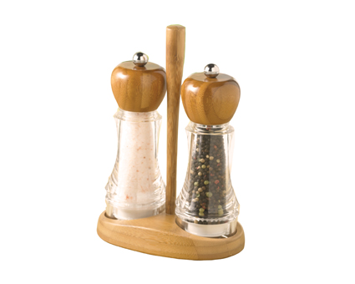  #2198 Bamboo Grinder Stand Set  $59.00 | 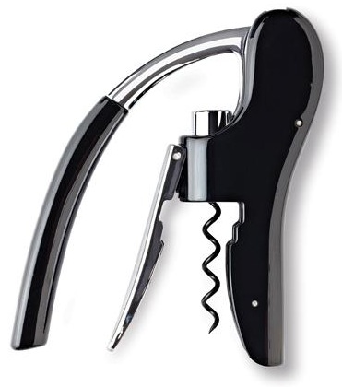  #2199 Wine Bottle Opener  $34.00
#2214 TPC All the Best cookbook  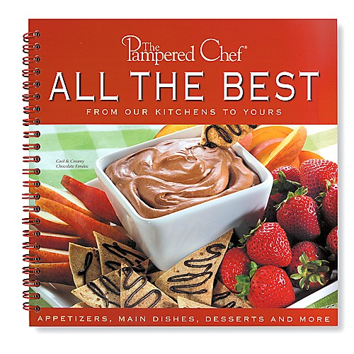  $15.00 | #2216 TPC Festive Holiday Desserts recipe collection  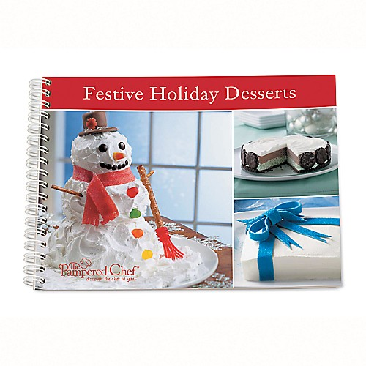  $8.00
#2223 TPC Stoneware  I nspirations cookbook  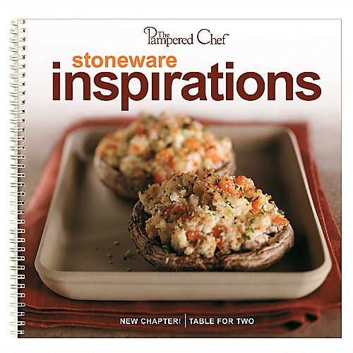  $15.00 | #2225 Measure-All® Cup  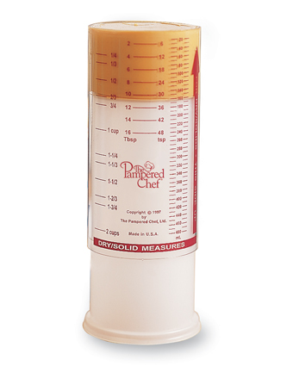  $10.50

