#2216 TPC Festive Holiday Desserts recipe collection  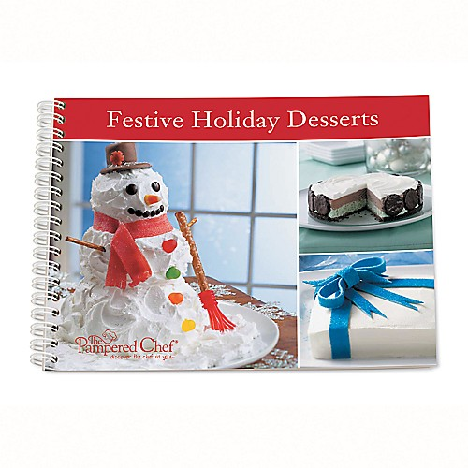  $8.00 |  | #2223 TPC Stoneware I nspirations cookbook  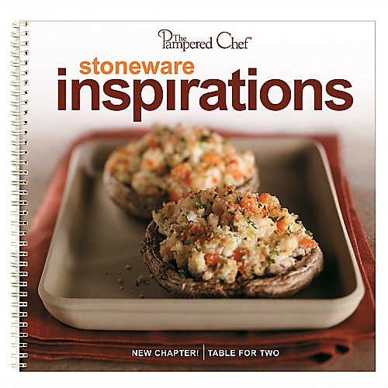  $15.00
#2224 TPC Cooking for Two & More cookbook  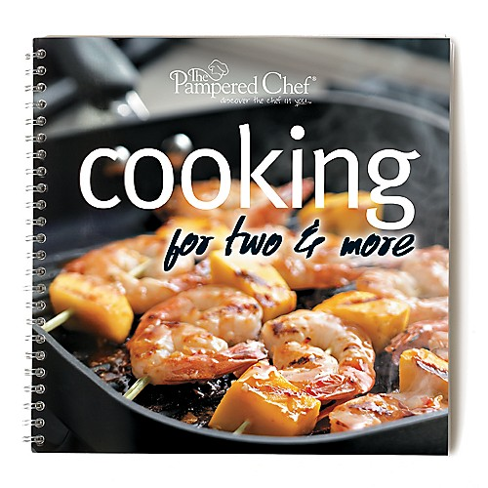  $15.00 |  | #2225 Measure-All® Cup  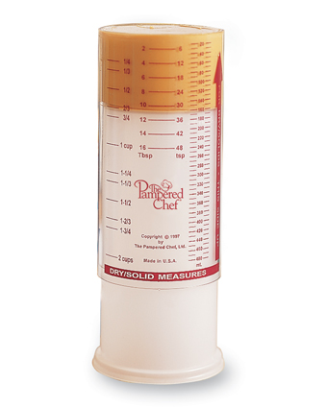  $10.50
#2227 TPC 29 Minutes to Dinner cookbook  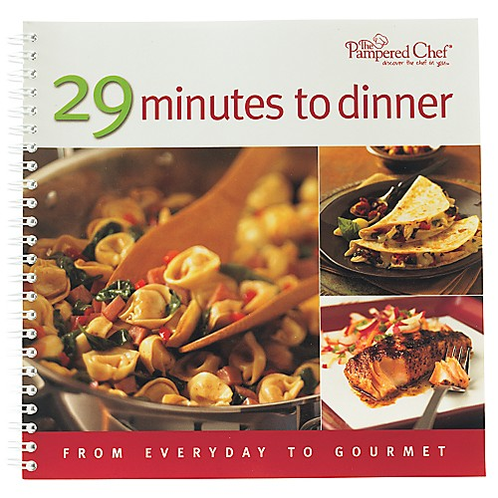  $15.00 |  | #2230 Classic Batter Bowl  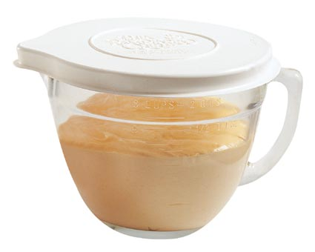  $16.00
#2233 Small Batter Bowl  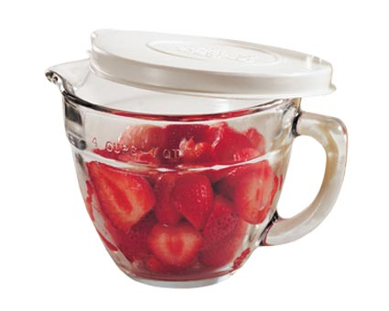  $12.50 |  | 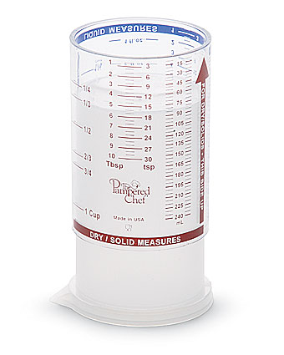  #2236 Mini Measure-All® Cup  $6.50
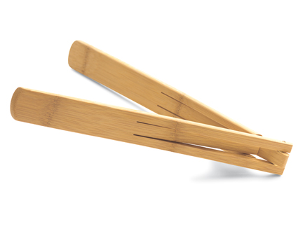  #2239 Bamboo Salad Tongs  $12.50 |  | #2244 Candy Thermometer  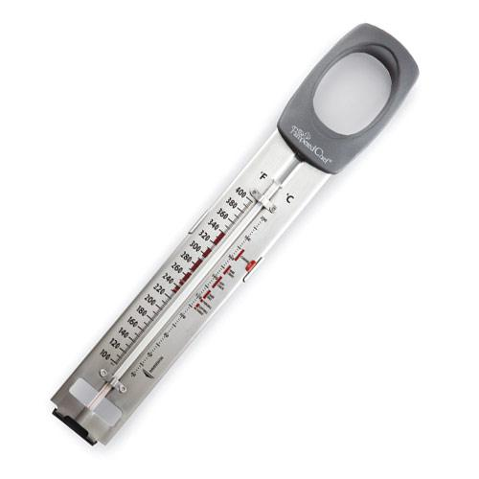  $22.50

