#2047 Small Bamboo Spoon Set  (set of 2)  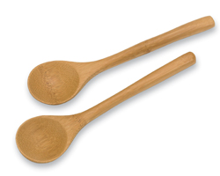  $6.00 | #2048 Bamboo Serving Set  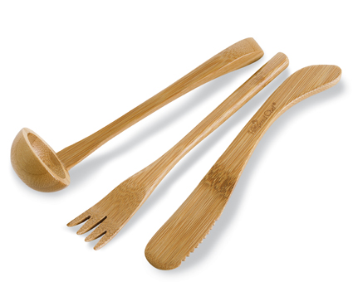  $12.50
#2049 Bamboo Slotted Spoon Set  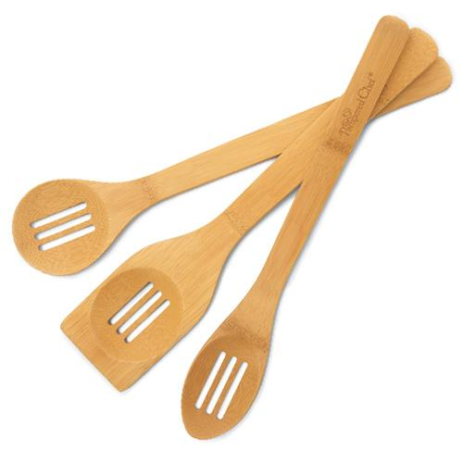  $11.00 | #2071 Small Spreader  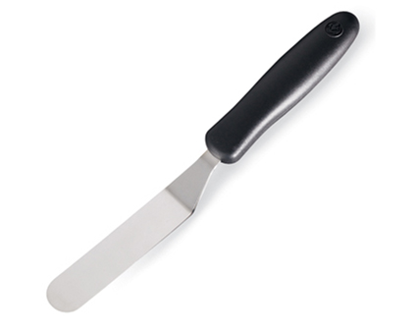  $6.00
#2126 Mega Lifter  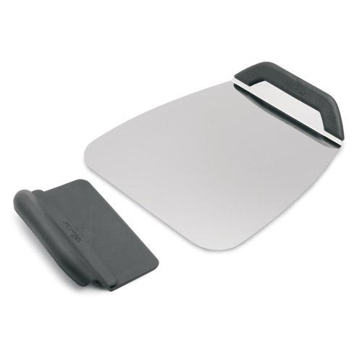  $20.00 | #2156 Hot Pad/Trivet – Cranberry  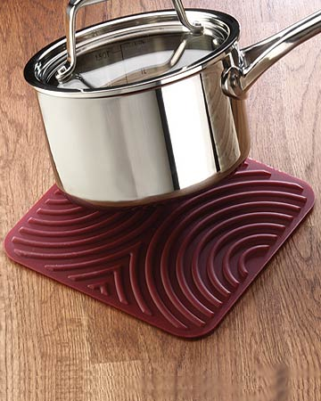  $11.00
#2158 Dripless Pourer/Stopper  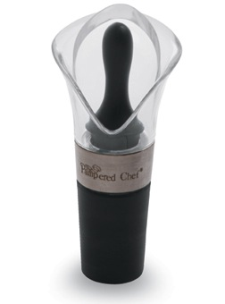  $11.00 | #2171 Tool Turn-About  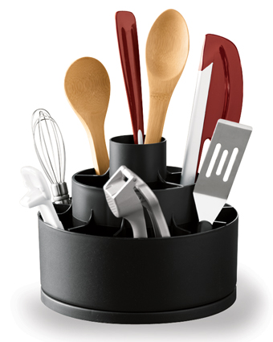  $19.00
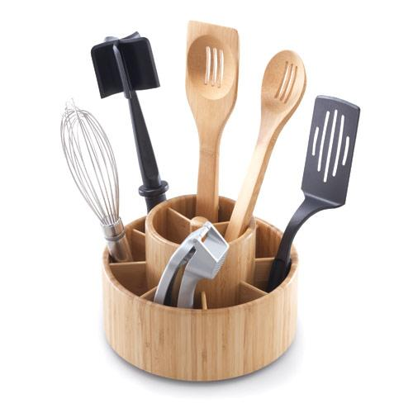  #2172 Bamboo Tool Turn-About  $39.50 | #2175 Easy Read Measuring Cups  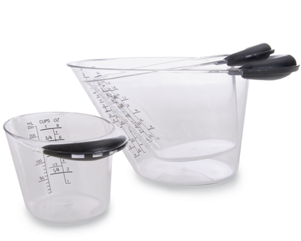  $23.50

