#2171 Tool Turn-About  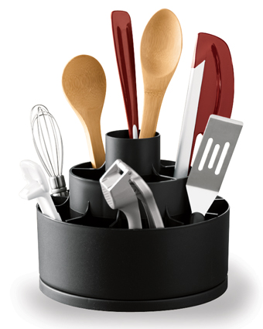  $19.00 |  | #2172 Bamboo Tool Turn-About  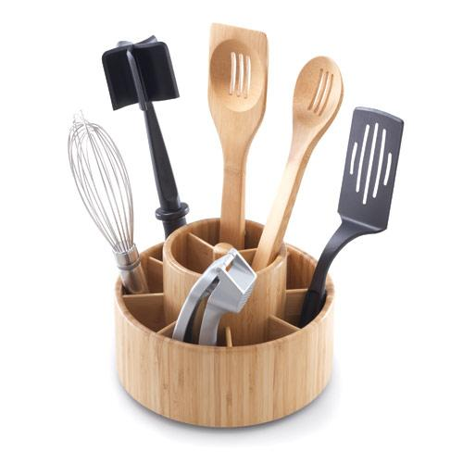  $39.50
#2175 Easy Read Measuring Cups  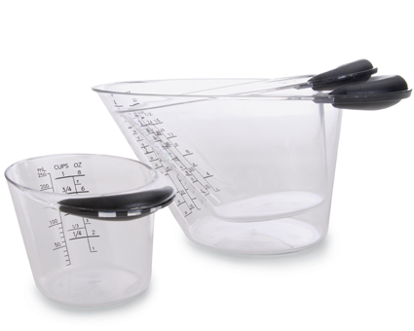  $23.50 |  | #2177 Easy Read Mini Measuring Cup  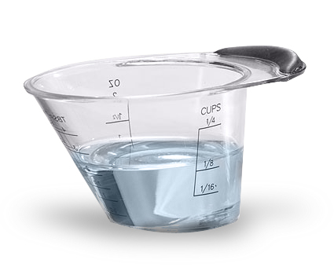  $6.25
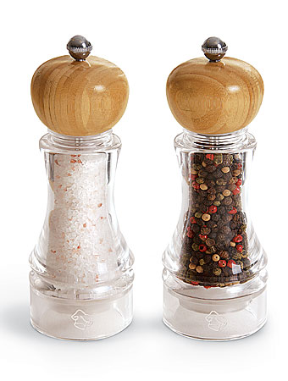  #2195 Grinder Set  (set of 2)  $44.00 |  | #2196 Grinder  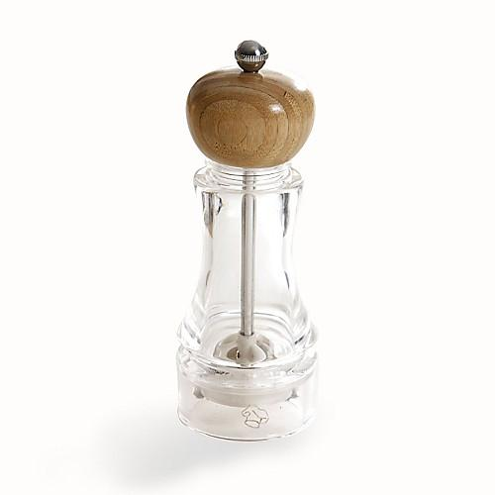  $23.50
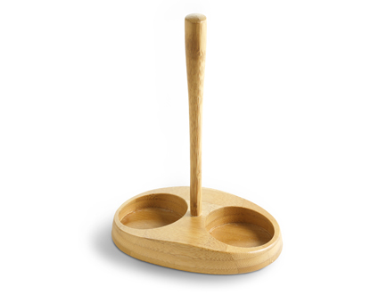  #2197 Bamboo Grinder Stand  $16.50 |  | 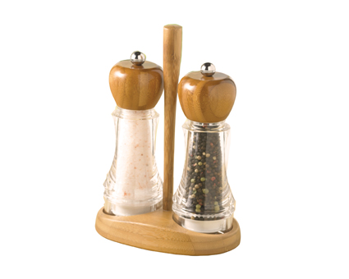  #2198 Bamboo Grinder Stand Set  $59.00
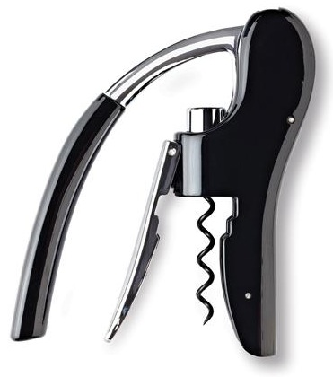  #2199 Wine Bottle Opener  $34.00 |  | #2214 TPC All the Best cookbook  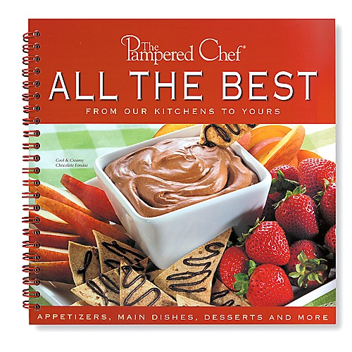  $15.00

