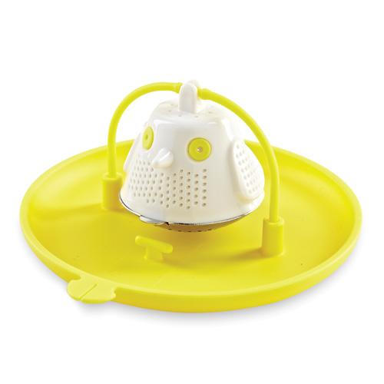  #1791 Tea-Bird Infuser  $12.50 | 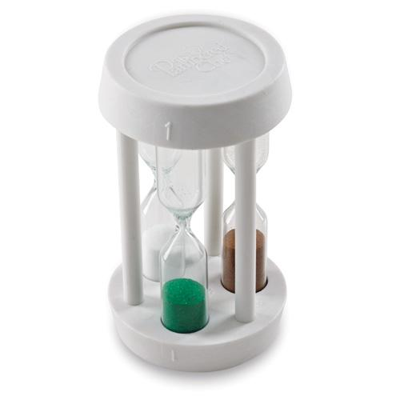  #1792 Minute Timer  $10.50
#1795 Tie-I t (set of 15)  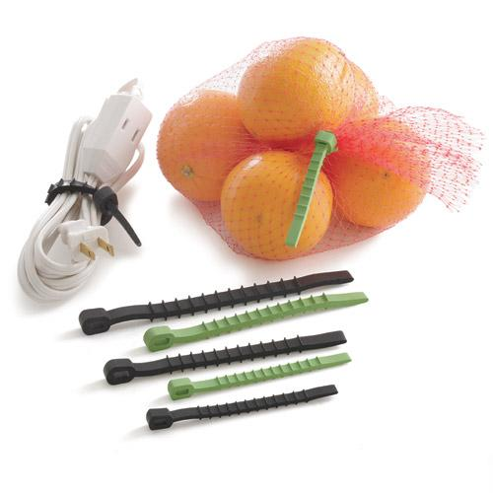  $7.00 | #1825 1-cup Prep Bowl Set  (set of 6)  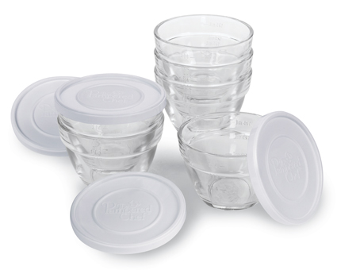  $21.50
#1900 Clock/Timer  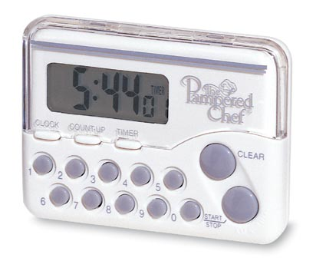  $16.50 | #1958 Shimmering Glass Adjustable Tiered Tower  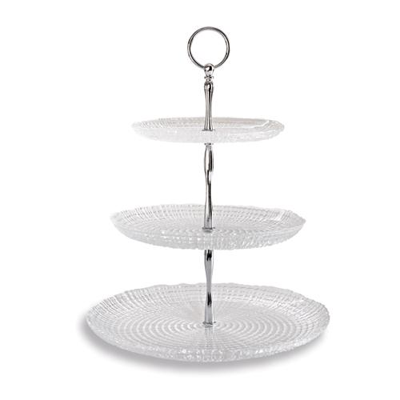  $49.50
#1966 Season’s Best® Recipe Collection (Fall/Winter 2013)  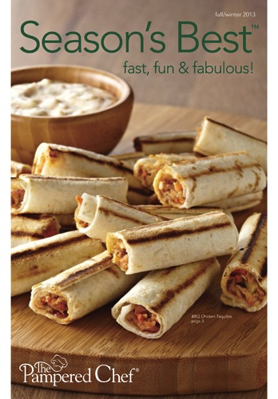  $2.00 | 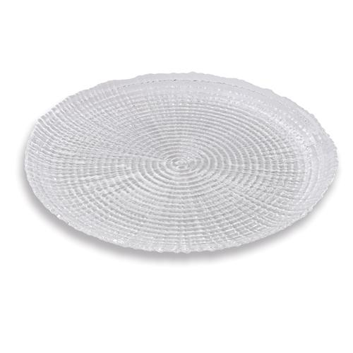  #2001 Shimmering Glass Round Platter  $34.50
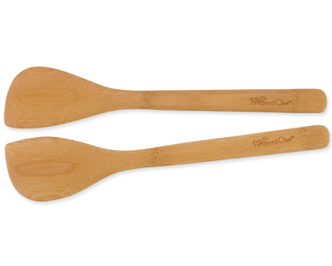  #2042 Bamboo Spatula Set  $9.00 | #2044 Bamboo Specialty Cooking Set  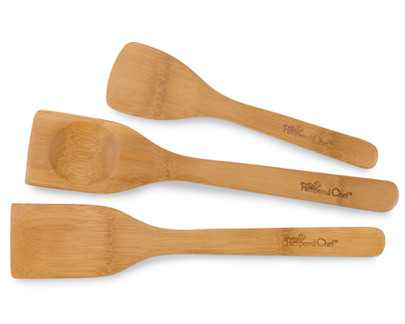  $10.50

