#2044 Bamboo Specialty Cooking Set  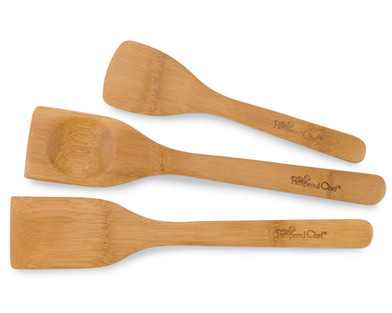  $10.50 |  | #2046 Bamboo Tongs  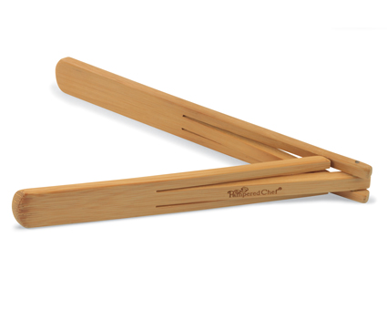  $8.00
#2047 Small Bamboo Spoon Set (set of 2)  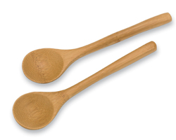  $6.00 |  | #2048 Bamboo Serving Set  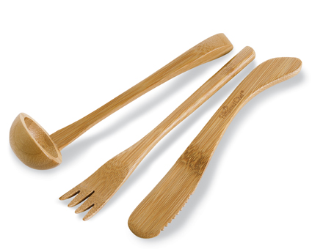  $12.50
#2049 Bamboo Slotted Spoon Set  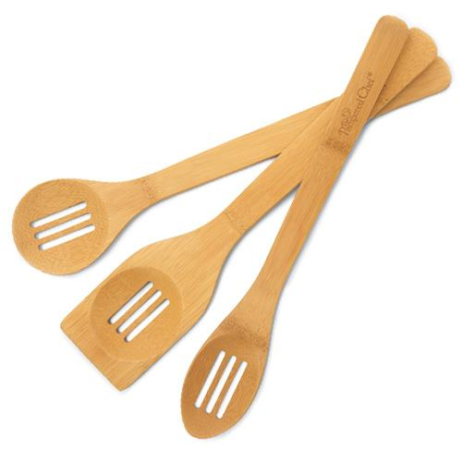  $11.00 |  | #2071 Small Spreader  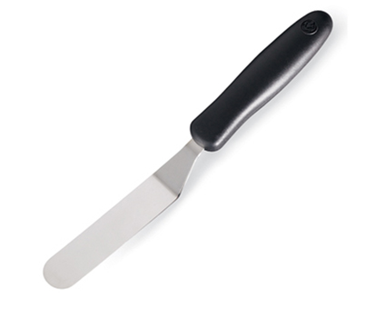  $6.00
#2072 Appetizer Plate Stand  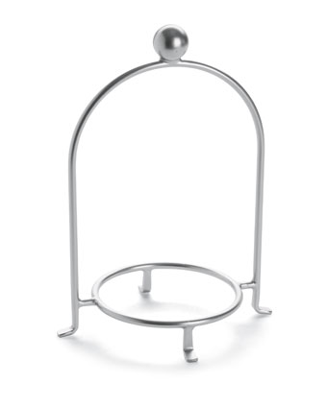  $17.50 |  | #2126 Mega Lifter  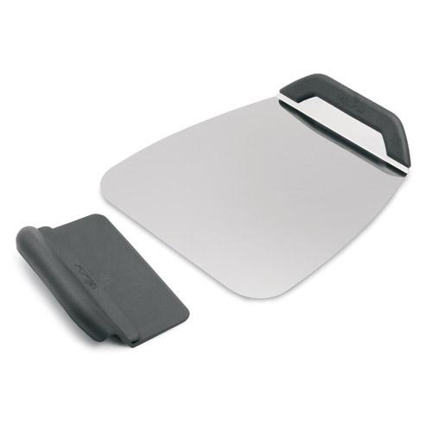  $20.00
#2156 Hot Pad/Trivet – Cranberry  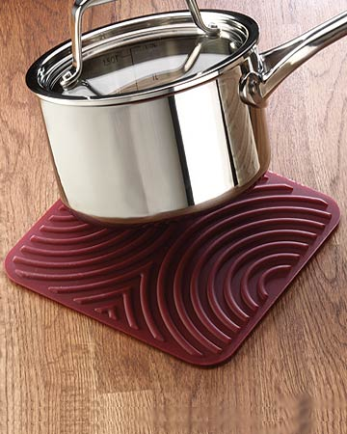  $11.00 |  | 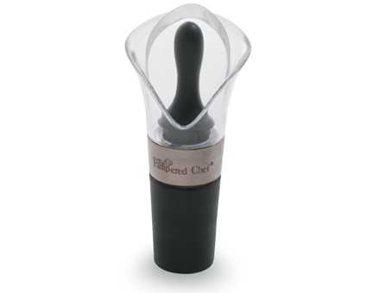  #2158 Dripless Pourer/Stopper  $11.00

