#1744 Bamboo Fiber Mixing Bowl Set - Natural  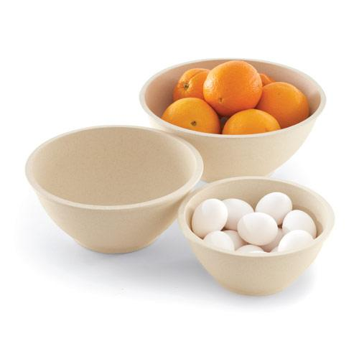  $39.50 | #1746 Flexible Funnels  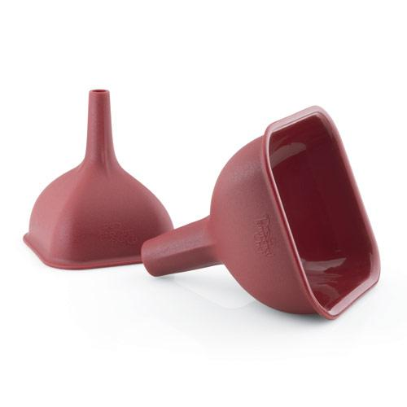  $12.00
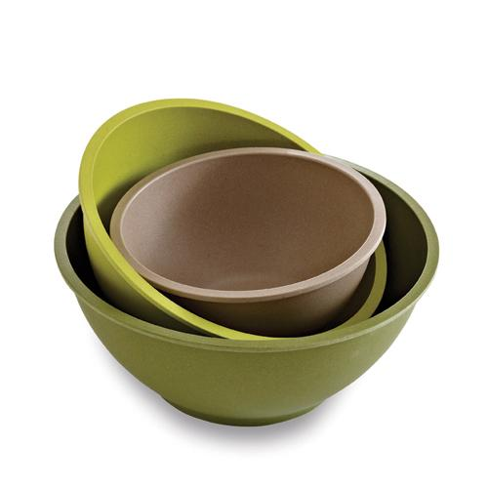  #1747 Bamboo Fiber  Mixing Bowl Set –  Multicolor  $39.50 | #1755 Chef’s Silicone Basting Brush  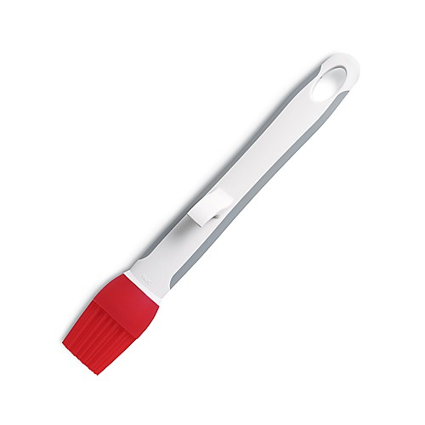  $9.50
#1778 Easy Accent® Decorator  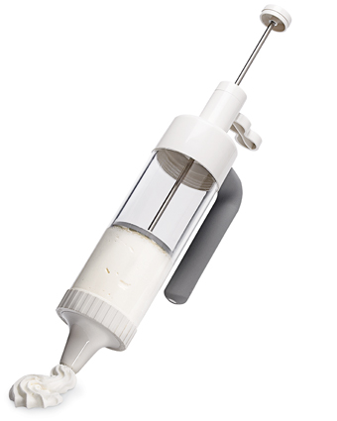  $24.00 | #1785 Salad & Berry Spinner  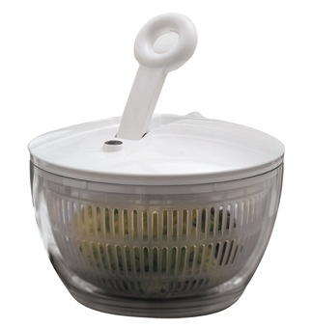  $60.00
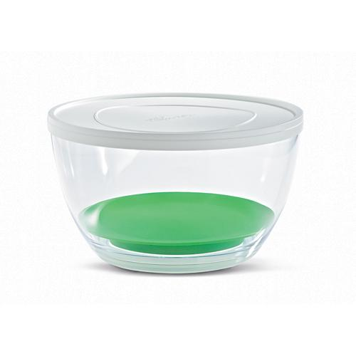  #1786 Cooling  I nsert  $13.00 | #1788 Herb Infuser  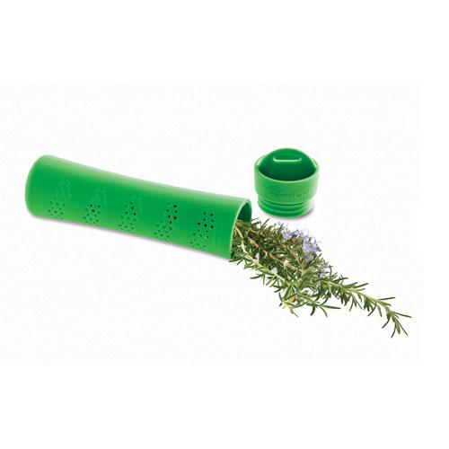  $9.50
#1789 Herb Keeper  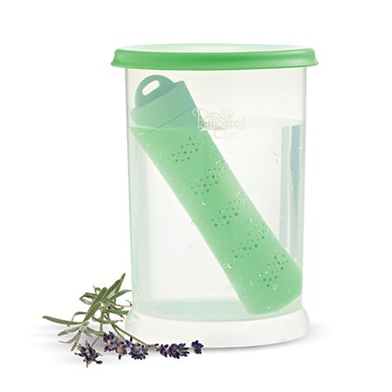  $16.00 | #1790 Large Scoop  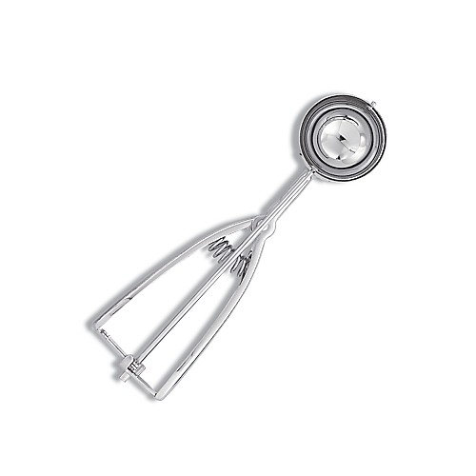  $17.50

