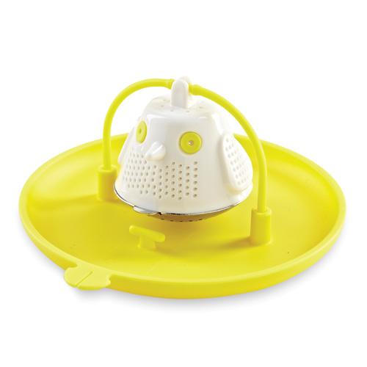  #1791 Tea-Bird Infuser  $12.50 |  | 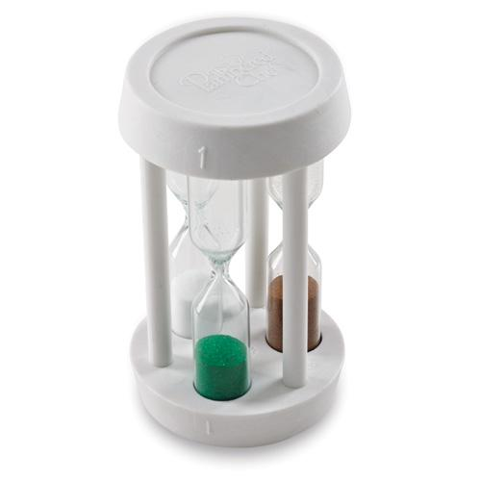  #1792 Minute Timer  $10.50
#1795 Tie-I t (set of 15)  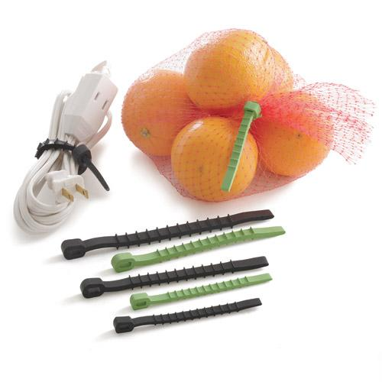  $7.00 |  | #1825 1-cup Prep Bowl Set  (set of 6)  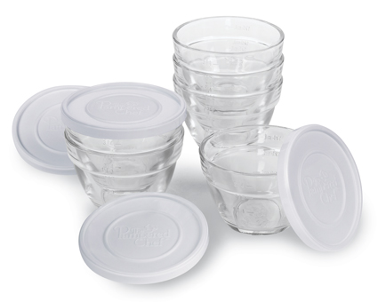  $21.50
#1900 Clock/Timer  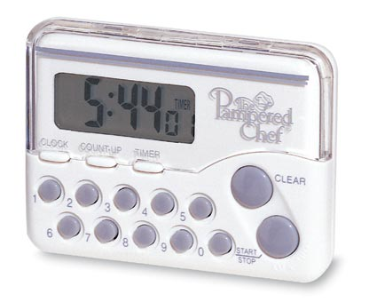  $16.50 |  | #1946 Small Bowl Caddy  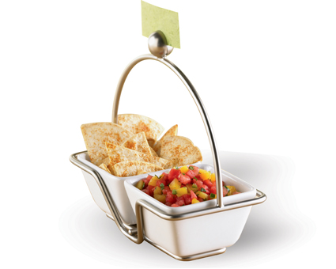  $15.00
#1958 Shimmering Glass Adjustable Tiered Tower  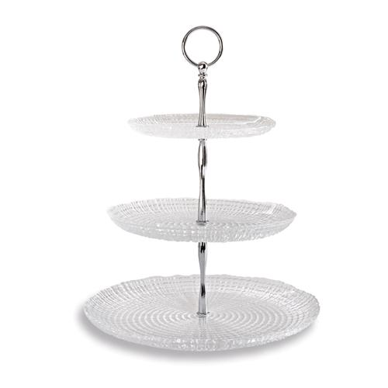  $49.50 |  | #1962 TPC Season’s Best® Recipe Collection (Spring/Summer 2013)  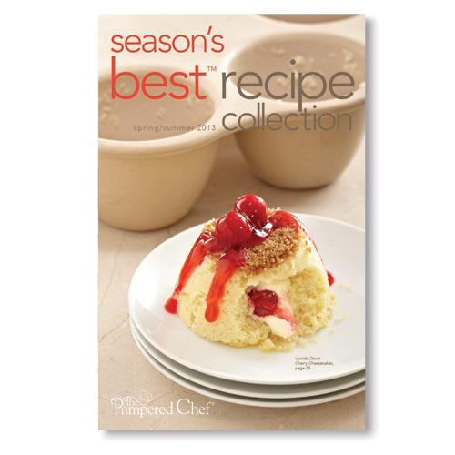  $2.00
#2001 Shimmering Glass Round Platter  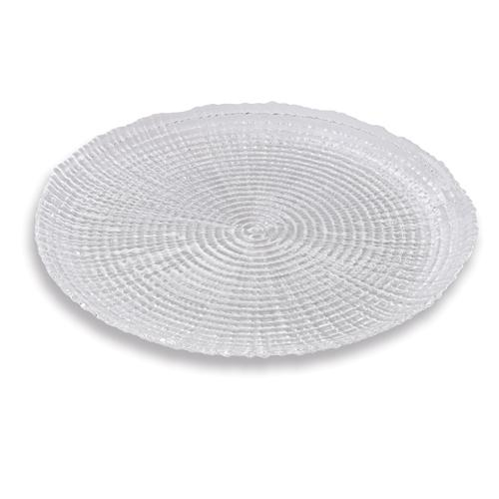  $34.50 |  | 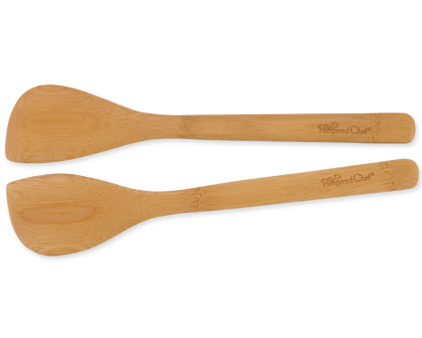  #2042 Bamboo Spatula Set  $9.00

