#1053 Forged Cutlery –  7” Santoku Knife  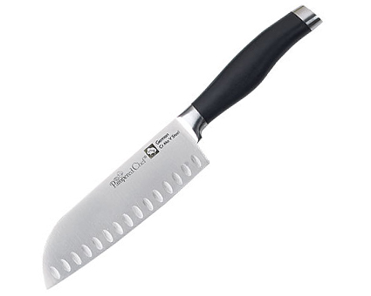  $72.00 | 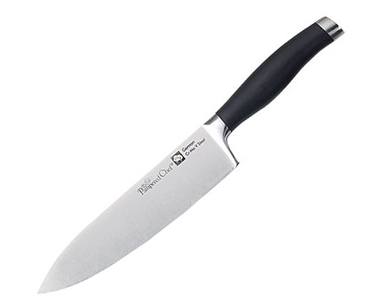  #1054 Forged Cutlery –  8” Chef’s Knife  $78.00
#1055 Forged Cutlery –  9” Bread Knife  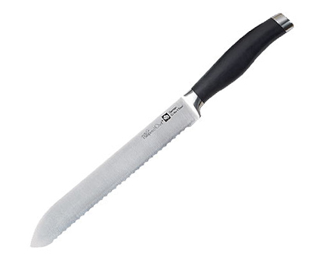  $68.00 | #1056 Forged Cutlery – Carving Set  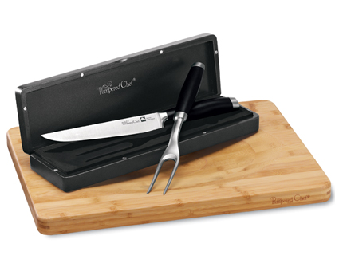  $118.00
#1057 Forged Cutlery Honing Tool  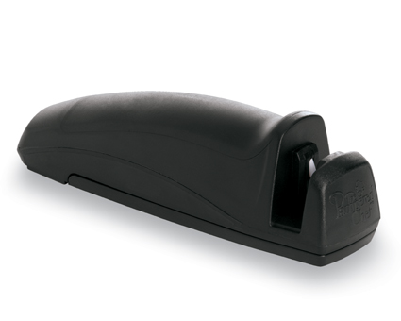  $21.50 | #1058 Forged Cutlery – Steak Knife Set  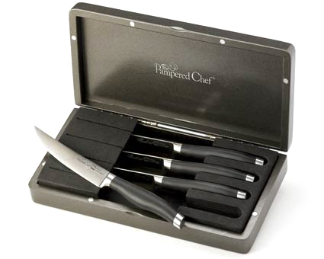  $112.00
#1059 Color Coated Santoku Knife  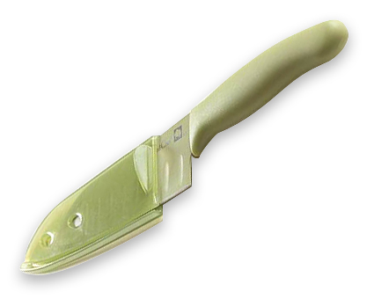  $18.00 | 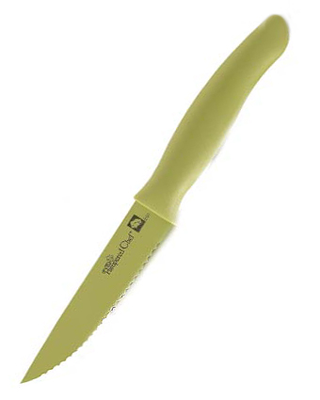  #1064 Color Coated Tomato Knife  $15.50
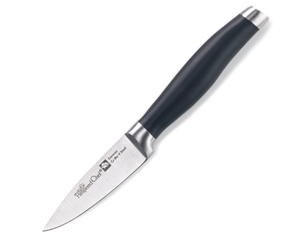  #1067 Forged Cutlery  – 3” Petite Paring Knife  $26.00 | 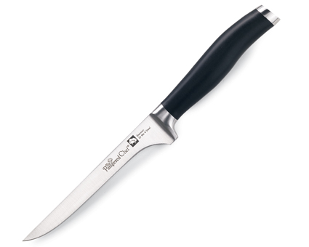  #1068 Forged Cutlery  – 5” Boning Knife  $52.00

