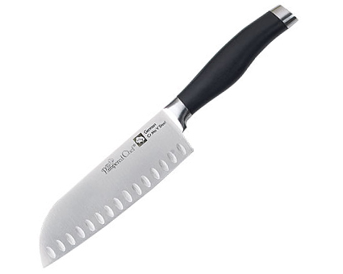  #1053 Forged Cutlery – 7” Santoku Knife  $72.00 |  | 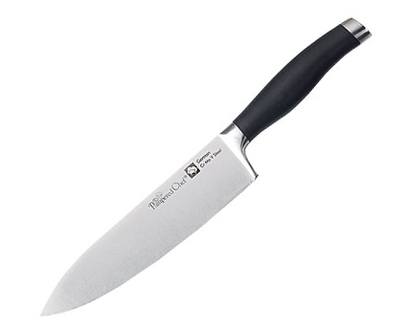  #1054 Forged Cutlery – 8” Chef’s Knife  $78.00
#1055 Forged Cutlery – 9” Bread Knife  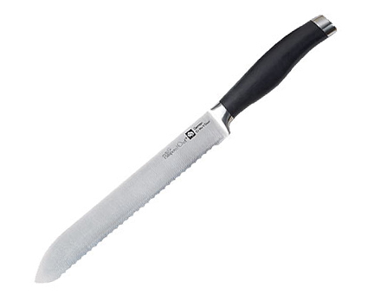  $68.00 |  | #1056 Forged Cutlery – Carving Set  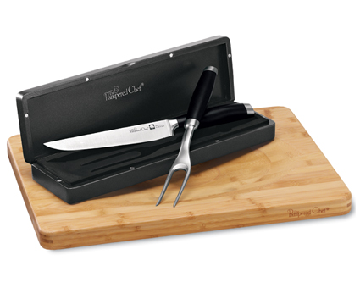  $118.00
#1057 Forged Cutlery Honing Tool  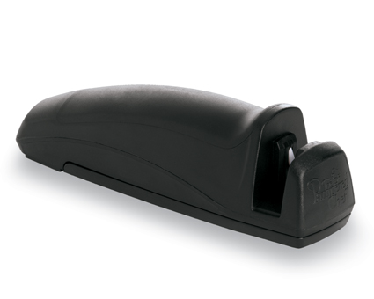  $21.50 |  | #1058 Forged Cutlery – Steak Knife Set  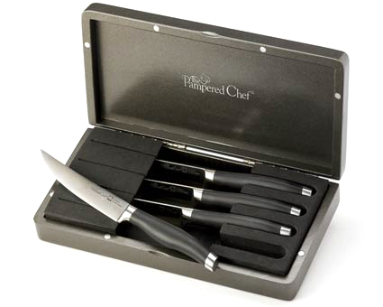  $112.00
#1059 Color Coated Santoku Knife  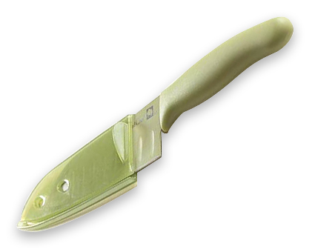  $18.00 |  | 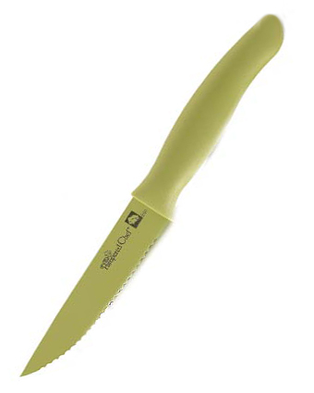  #1064 Color Coated Tomato Knife  $15.50
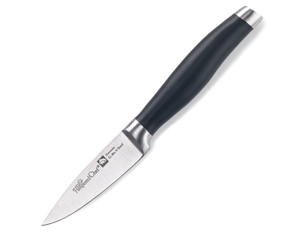  #1067 Forged Cutlery  – 3” Petite Paring Knife  $26.00 |  | #1068 Forged Cutlery – 5” Boning Knife  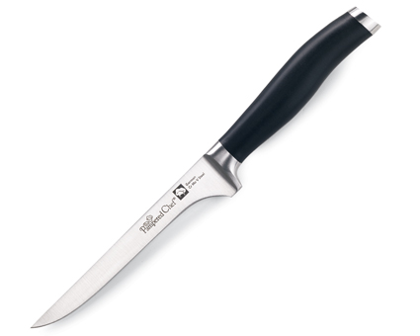  $52.00

