#1744 Bamboo Fiber Mixing Bowl Set - Natural  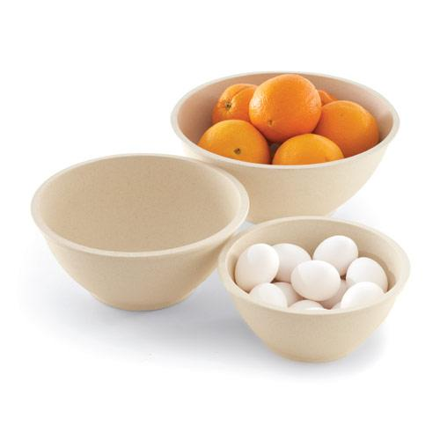  $39.50 |  | #1746 Flexible Funnels  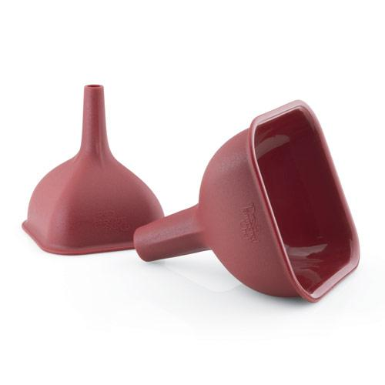  $12.00
#1747 Bamboo Fiber  Mixing Bowl Set –  Multicolor  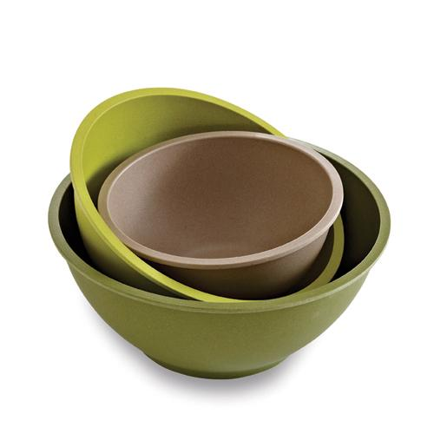  $39.50 |  | #1755 Chef’s Silicone Basting Brush  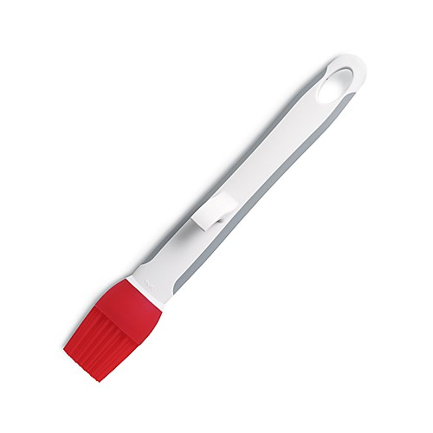  $9.50
#1778 East Accent® Decorator  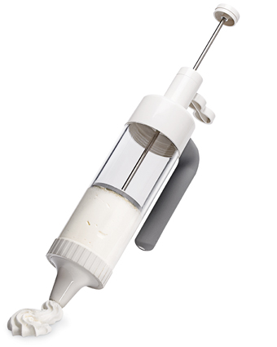  $24.00 |  | #1785 Salad & Berry Spinner  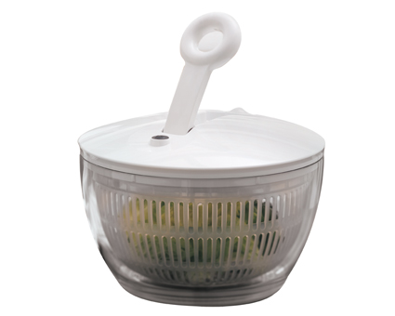  $60.00
#1786 Cooling I nsert  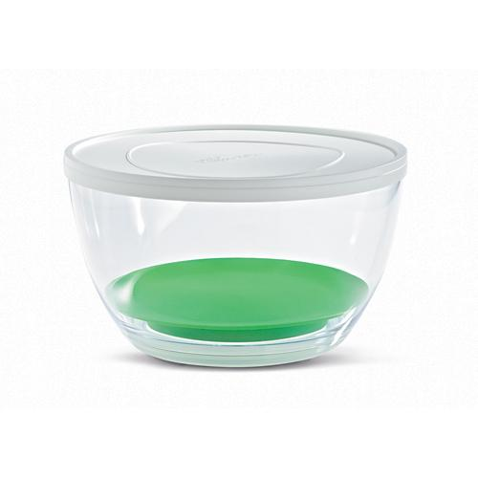  $13.00 |  | #1788 Herb Infuser  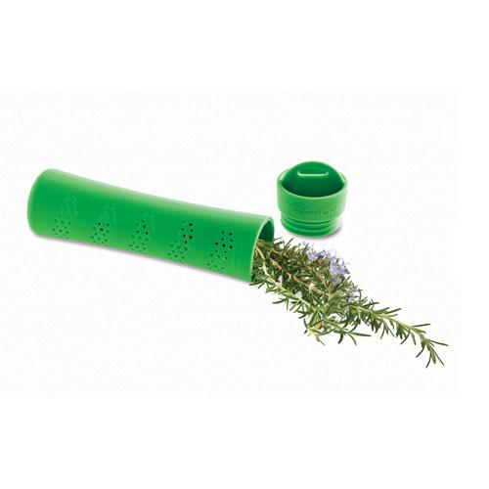  $9.50
#1789 Herb Keeper  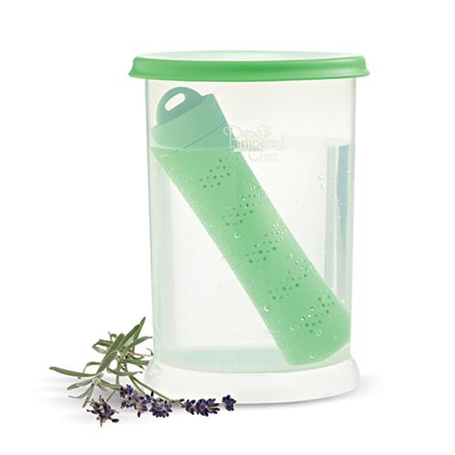  $16.00 |  | #1790 Large Scoop  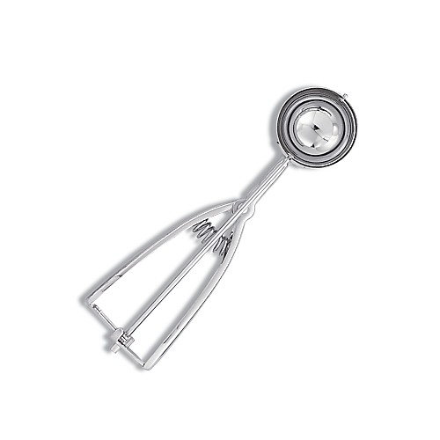  $17.50

