#1703 Master Scraper  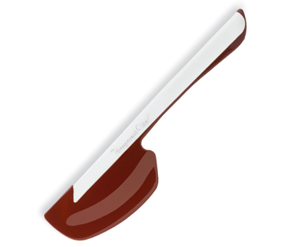  $16.00 | #1706 Torte Pan Set  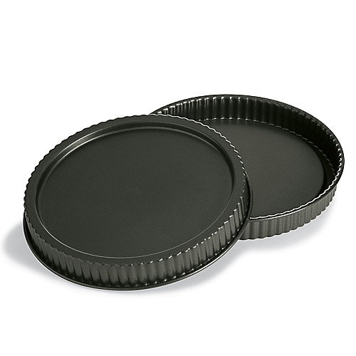  $29.00
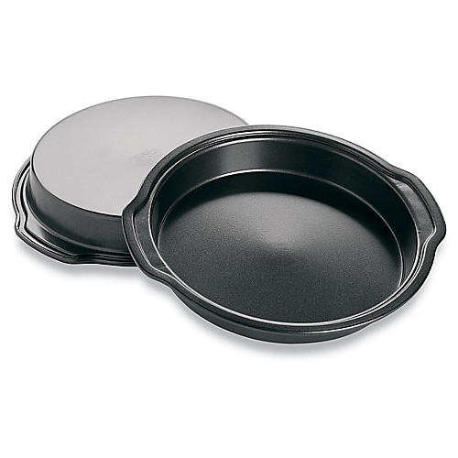  #1707 Cake Pan Set  (set of 2)  $20.00 | #1713 Bamboo Note Holder  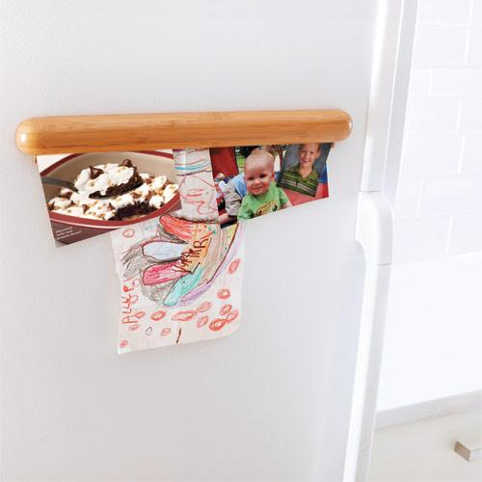  $20.00
#1714 Bamboo Dry Erase Board  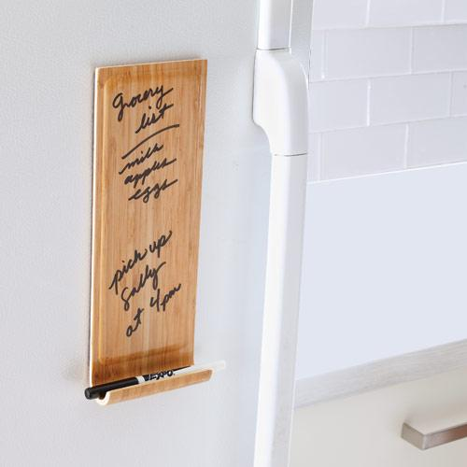  $20.00 | #1715 Pie Crust Shield  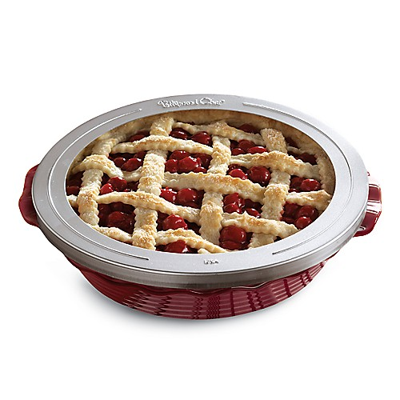  $8.00
#1716 Bamboo Sink Caddy  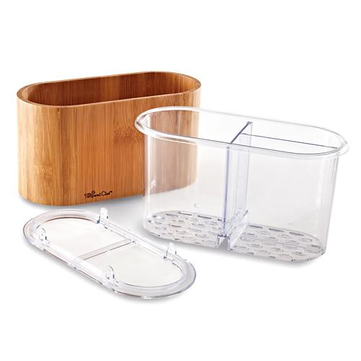  $21.50 | #1718 Pastry Mat  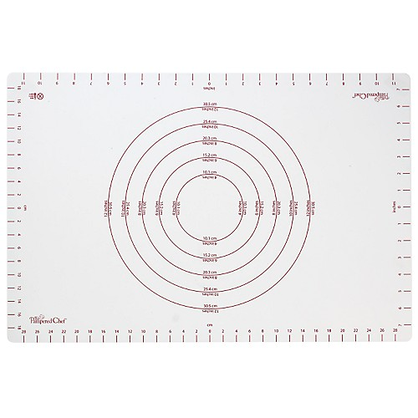  $30.50
#1719 Pie Gate  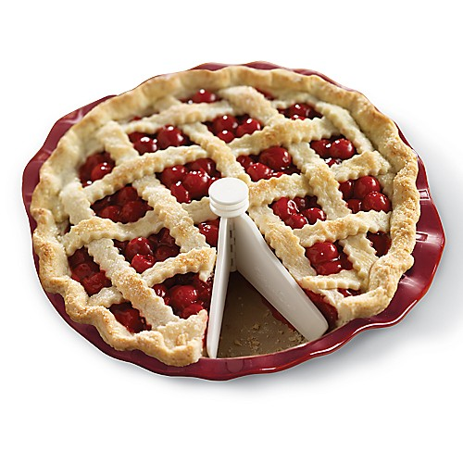  $6.50 | #1721 Medium Sheet Pan  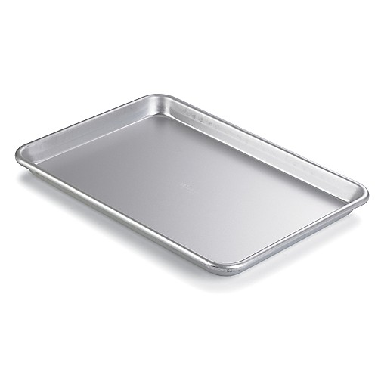  $14.50

