#1719 Pie Gate  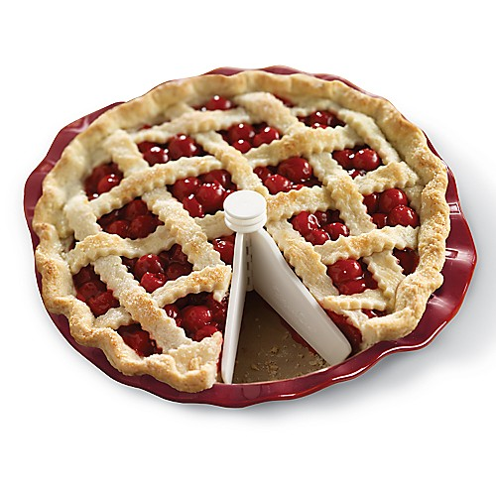  $6.50 |  | #1721 Medium Sheet Pan  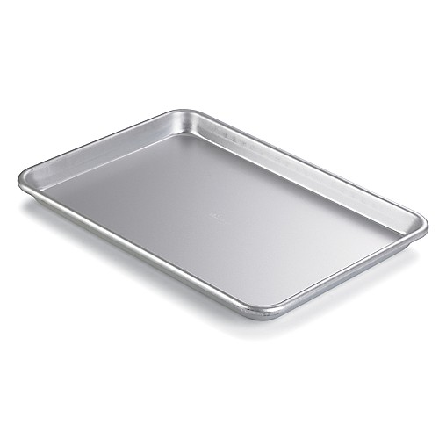  $14.50
#1722 Large Sheet Pan  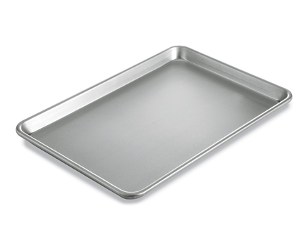  $18.00 |  | #1724 Small Sheet Pan  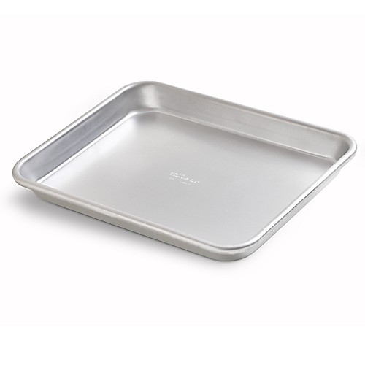  $11.50
#1727 Square Baking Pan  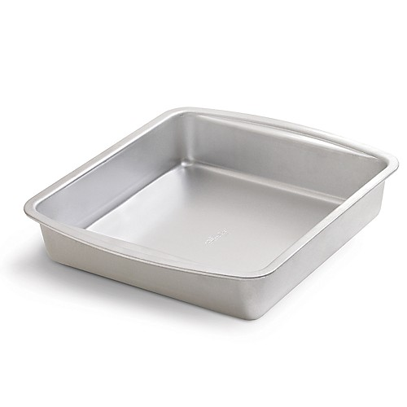  $13.00 |  | #1728 Loaf Pan  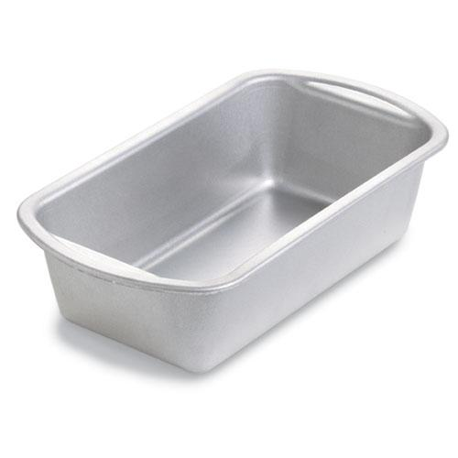  $12.00
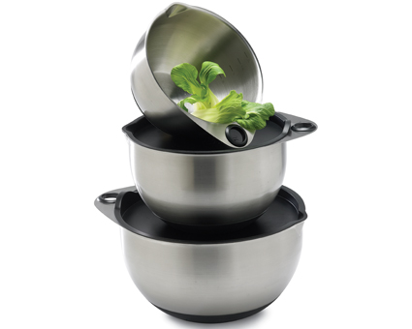  #1735 Stainless Mixing Bowl Set  $84.50 |  | #1741 Pinch Bowl Set  (set of 4)  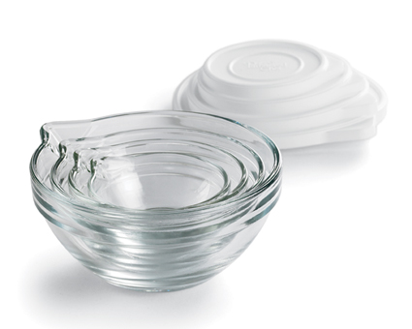  $16.00
#1742 2-cup Prep Bowl Set  (set of 2)  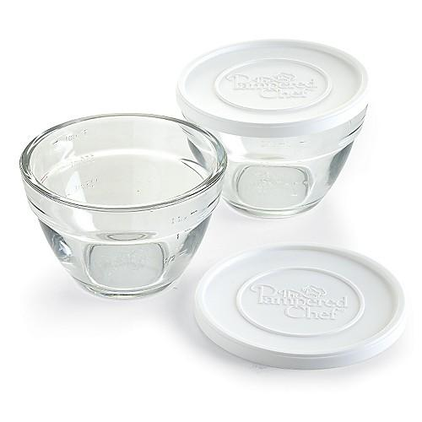  $16.00 |  | #1743 3-cup Prep Bowl Set  (set of 2)  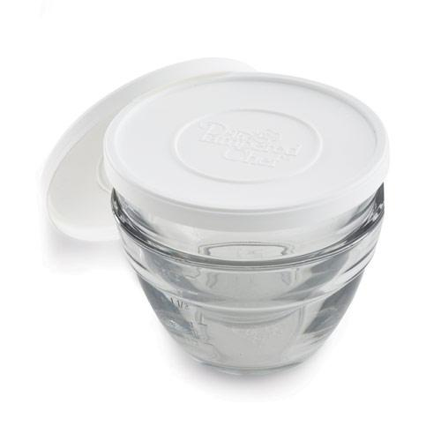  $20.00

