#1681 Corn & Veggie Brush  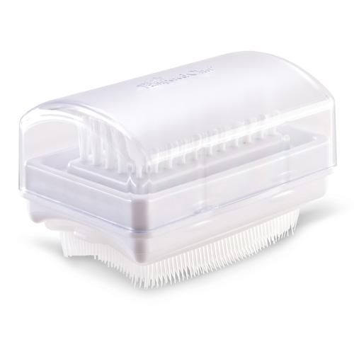  $10.50 | #1682 Scoop & Spear  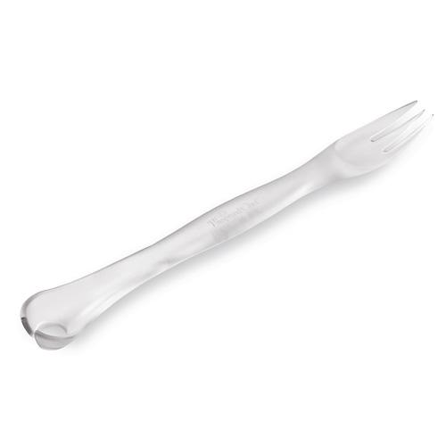  $8.50
#1684 Pastry Cutter  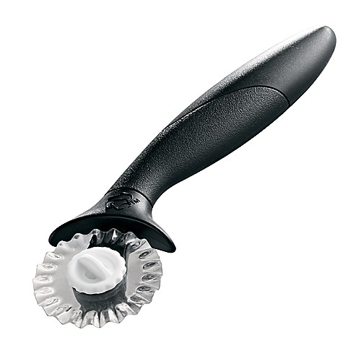  $12.00 | #1686 Pastry Blender  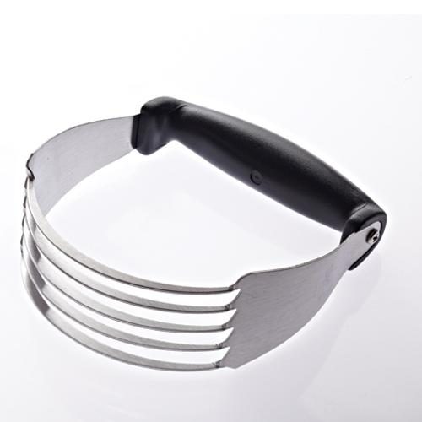  $8.50
#1687 Tea Infusion Pitcher  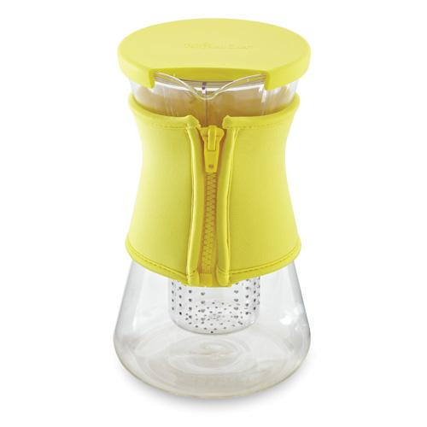  $55.00 | 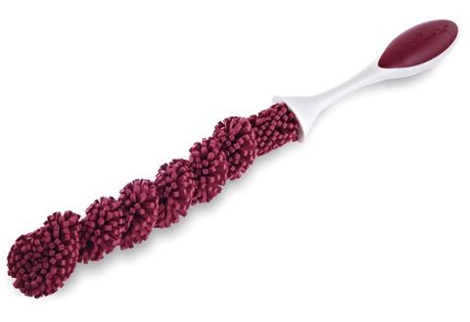  #1688 Decanter/Bottle Cleaning Brush  $9.00
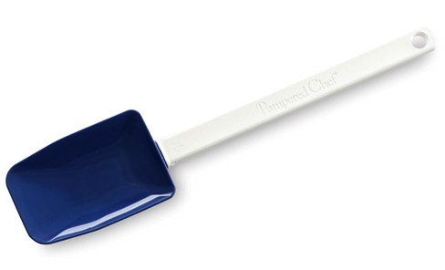  #1691 Mini Mix ‘N Scraper –  Cobalt Blue  $10.00 | #1695 Flour/Sugar Shaker  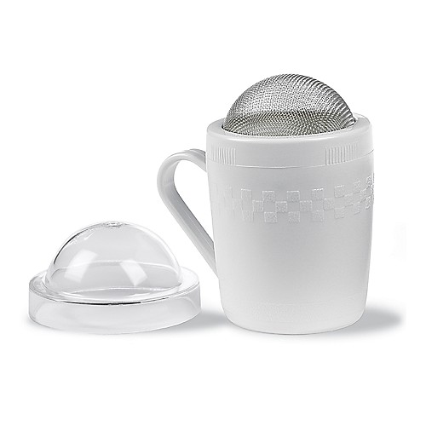  $6.50
#1701 Mega Scraper  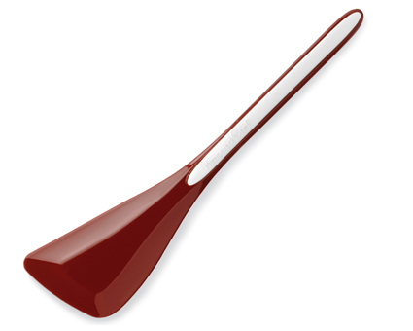  $20.00 | #1702 Micro Scraper  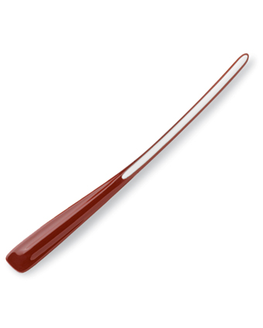  $13.00

