#1701 Mega Scraper  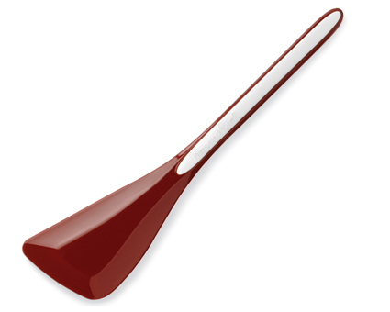  $20.00 |  | #1702 Micro Scraper  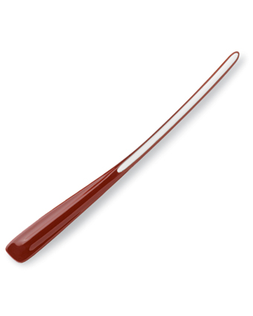  $13.00
#1703 Master Scraper  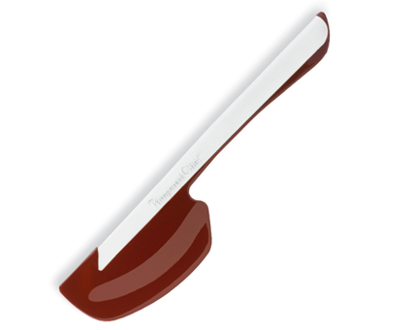  $16.00 |  | #1706 Torte Pan Set  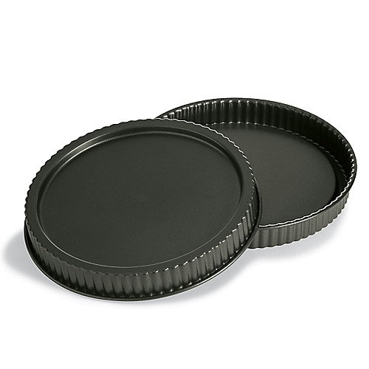  $29.00
#1707 Cake Pan Set (set of 2)  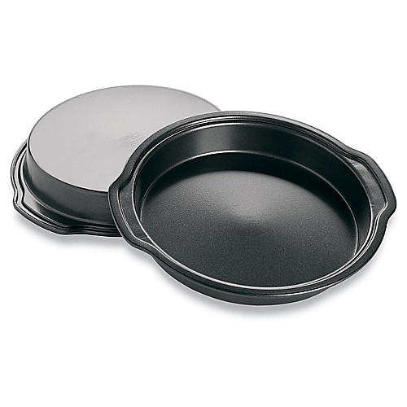  $20.00 |  | #1713 Bamboo Note Holder  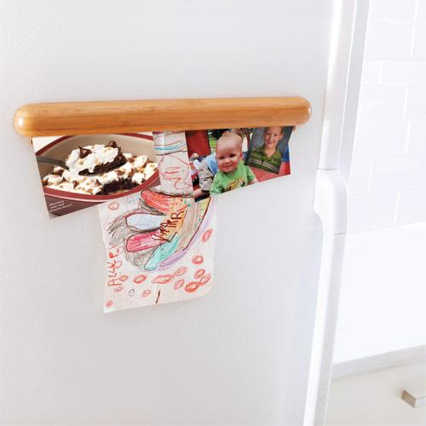  $20.00
#1714 Bamboo Dry Erase Board  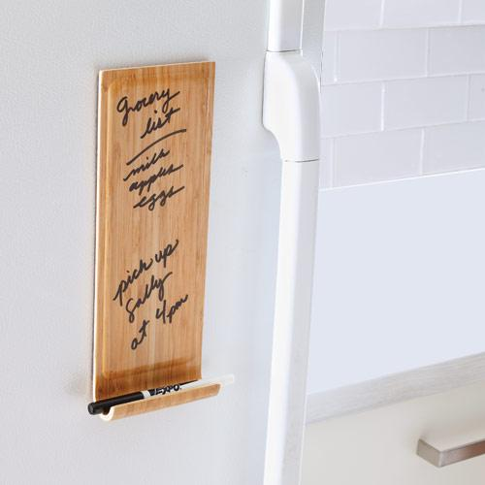  $20.00 |  | #1715 Pie Crust Shield  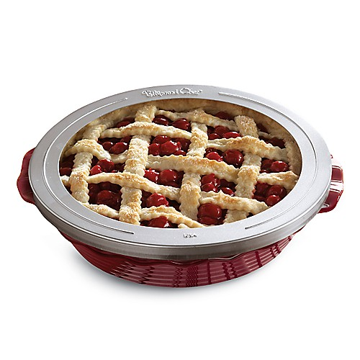  $8.00
#1716 Bamboo Sink Caddy  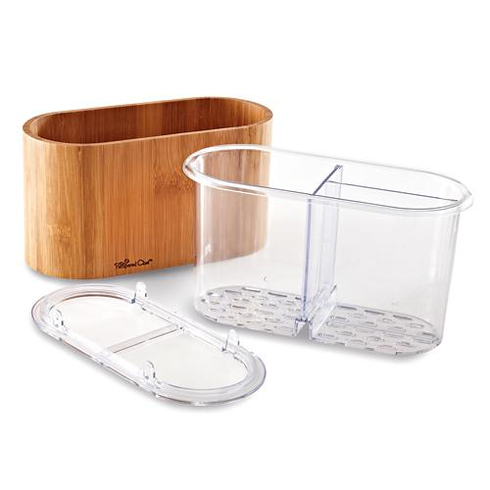  $21.50 |  | #1718 Pastry Mat  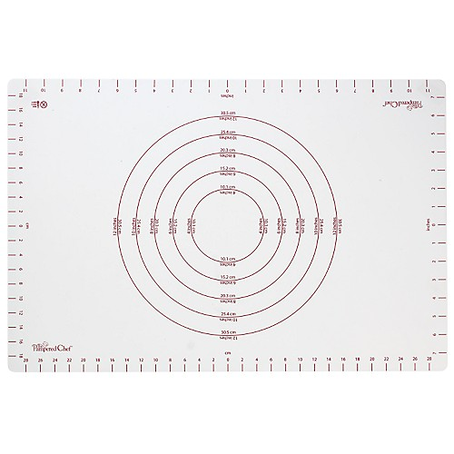  $30.50

