#1650 Classic Scraper  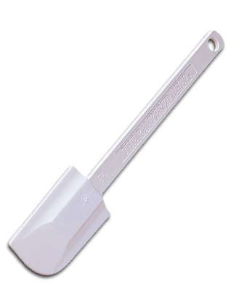  $12.00 | #1655 Skinny Scraper  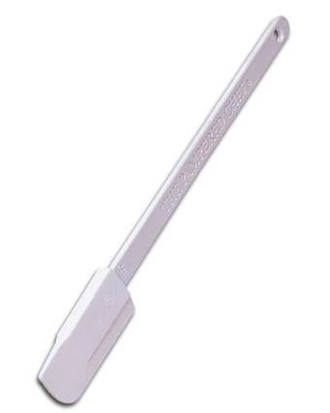  $9.00
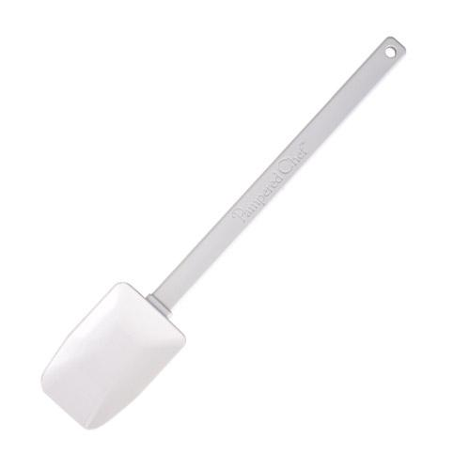  #1656 Mini Mix ‘N Scraper®  $10.00 | #1657 Mix ‘N Scraper®  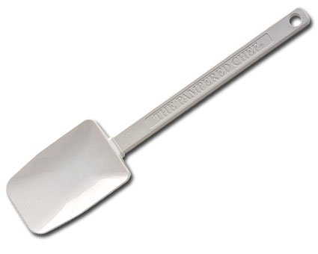  $15.00
#1659 Small Mix ‘N Scraper®  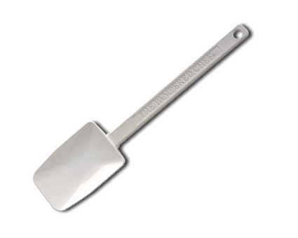  $13.00 | #1665 Baster & Cleaning Brush  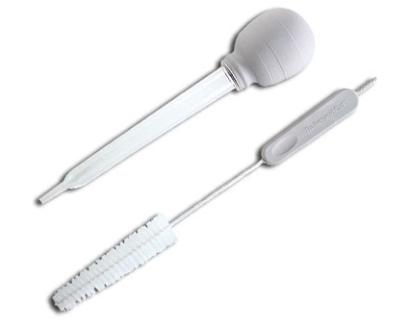  $13.00
#1671 Multi Scraper  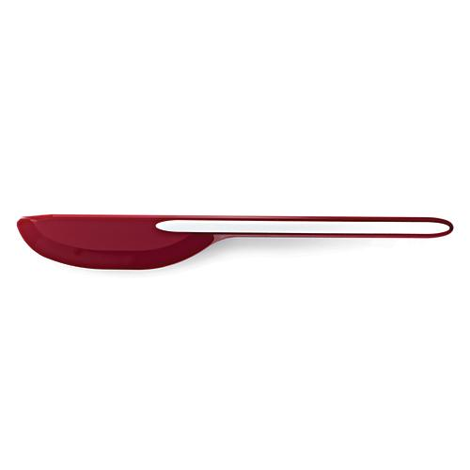  $15.00 | 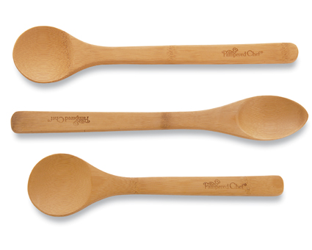  #1674 Bamboo Spoon Set  $10.50
#1678 Spoon Rest  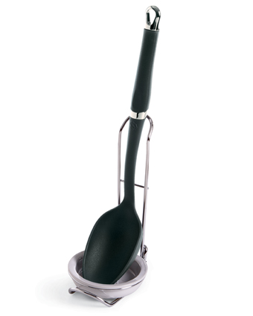  $11.50 | #1679 Scoop & Spread  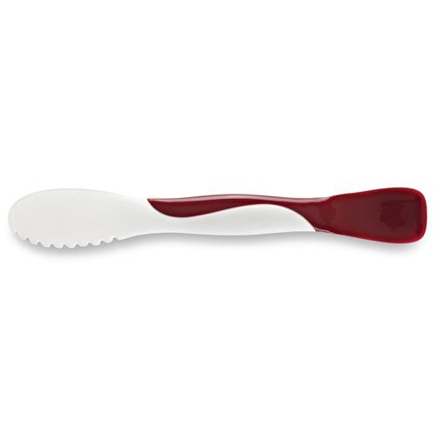  $8.50

