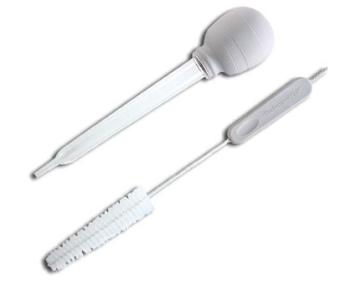  #1665 Baster & Cleaning Brush  $13.00 |  | #1671 Multi Scraper  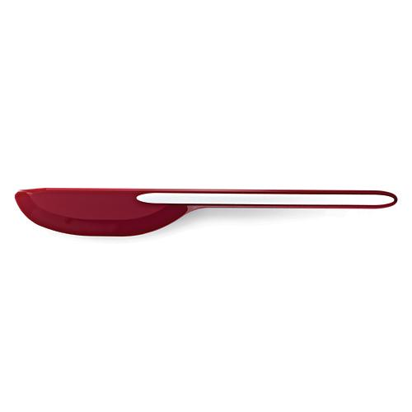  $15.00
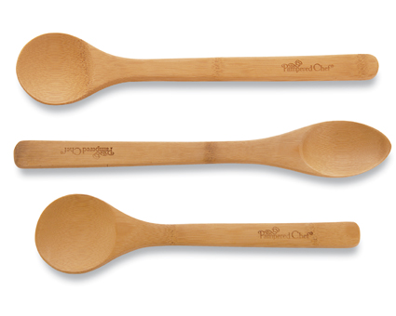  #1674 Bamboo Spoon Set  $10.50 |  | 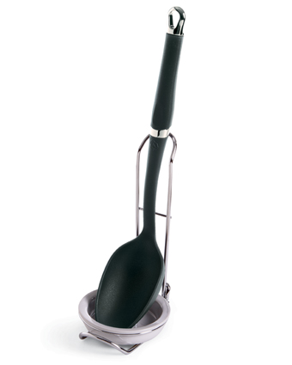  #1678 Spoon Rest  $11.50
#1679 Scoop & Spread  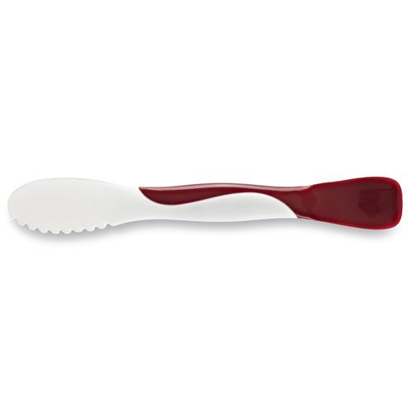  $8.50 |  | #1681 Corn & Veggie Brush  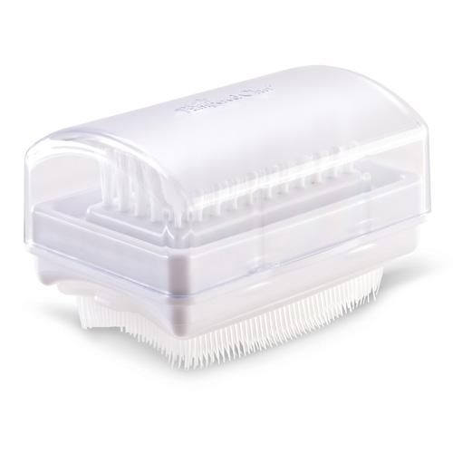  $10.50
#1684 Pastry Cutter  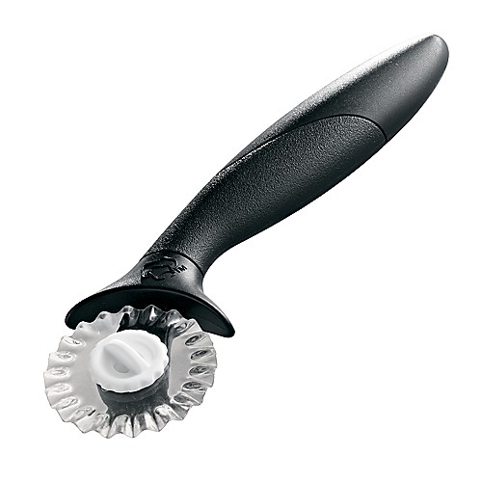  $12.00 |  | #1686 Pastry Blender  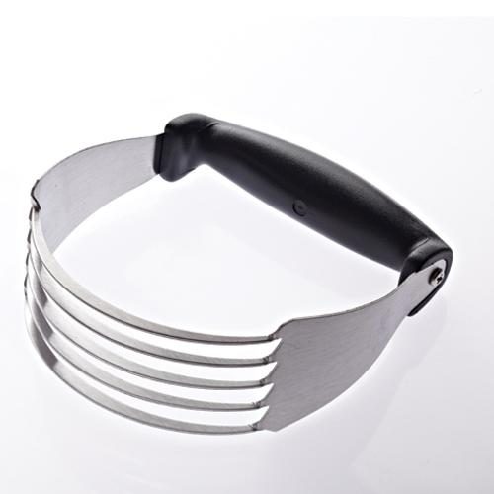  $8.50
#1687 Tea Infusion Pitcher  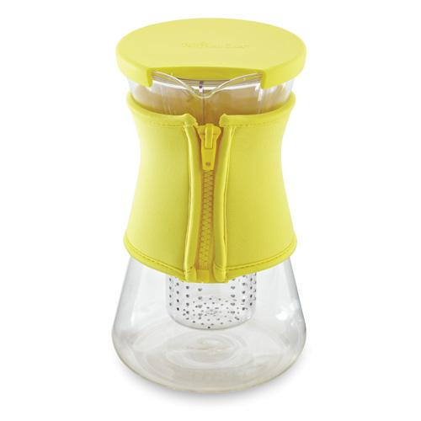  $55.00 |  | #1695 Flour/Sugar Shaker  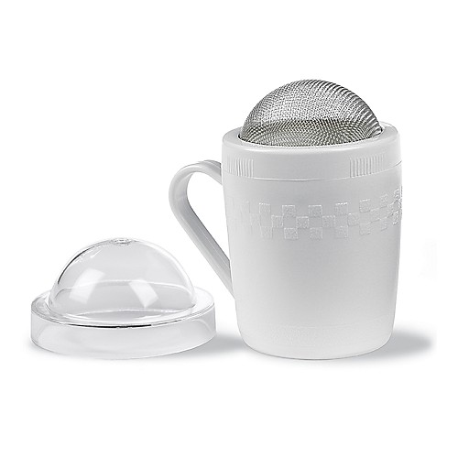  $6.50

