#1624 Soft-Tip Cleaning Brushes  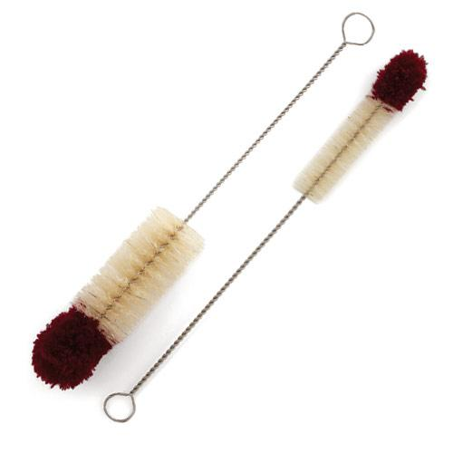  $7.00 | #1625 Easy Clean® Kitchen Brush  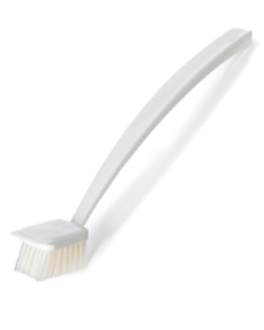  $9.00
#1632 Spice Turn-About  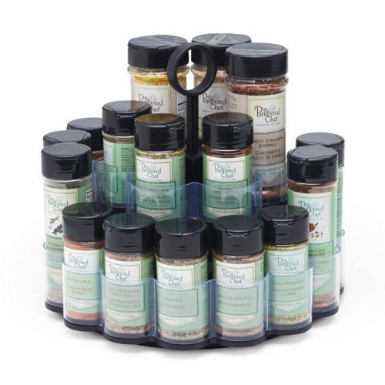  $19.50 | #1633 Kitchen Fork  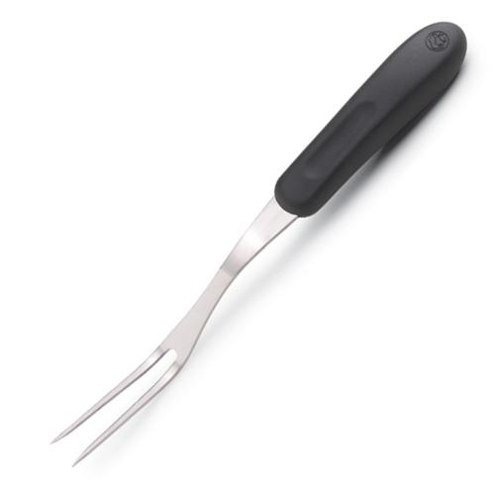  $10.00
#1634 Glass Cleaning Brush  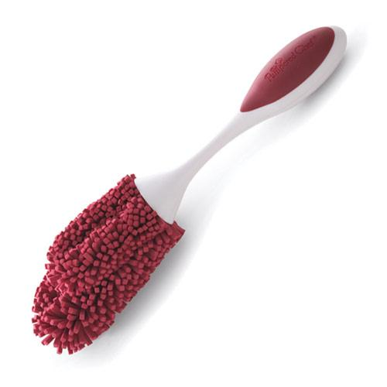  $9.00 | #1636 Dripless Oil Bottle  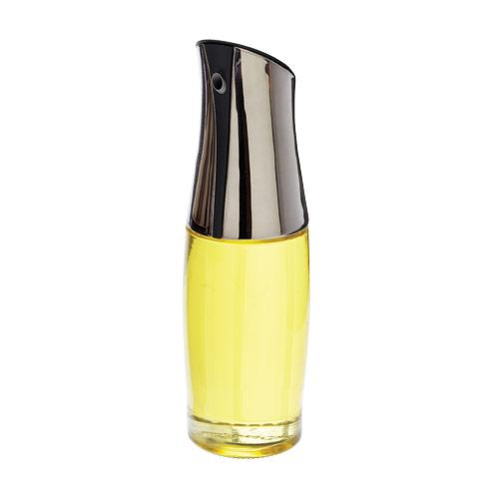  $25.00
#1637 Dripless Vinegar Bottle  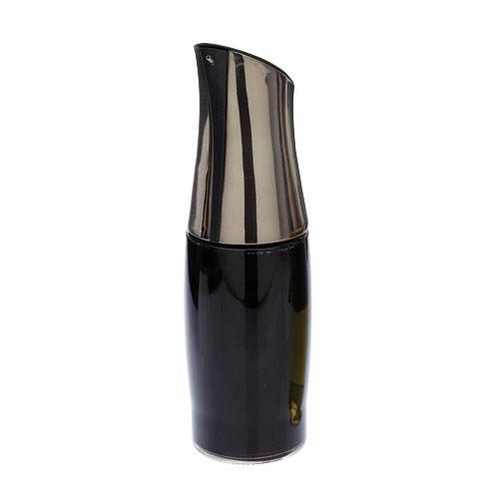  $25.00 | #1642 All-Purpose Spreader  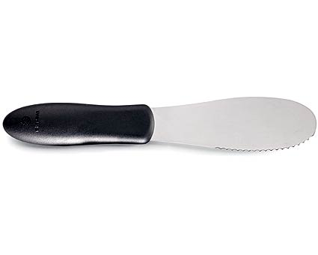  $5.50
#1646 Large Spreader  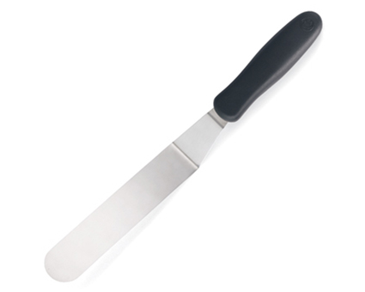  $10.00 | 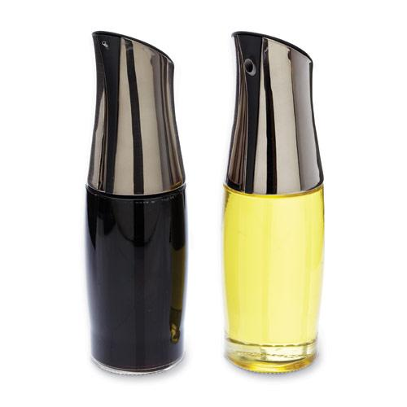  #1647 Dripless Oil & Vinegar Bottle Set  $48.00

