#1636 Dripless Oil Bottle  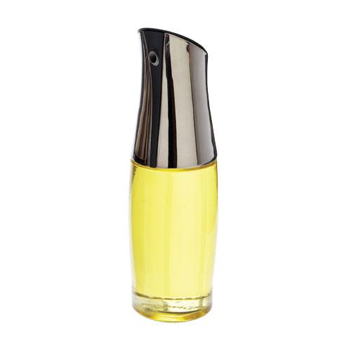  $25.00 |  | #1637 Dripless Vinegar Bottle  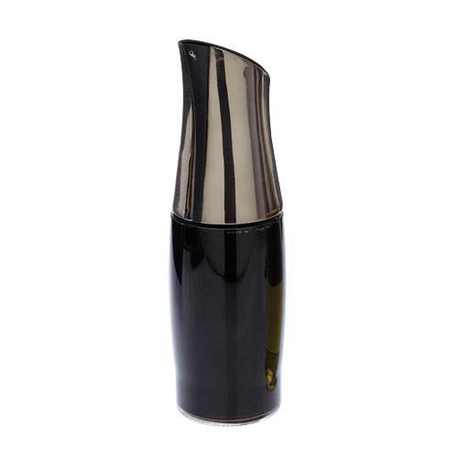  $25.00
#1642 All-Purpose Spreader  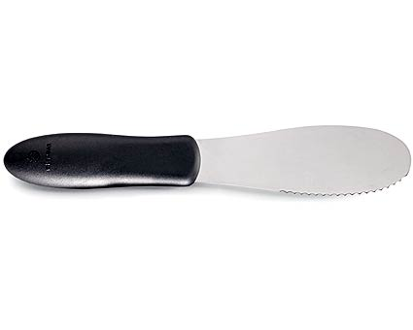  $5.50 |  | #1646 Large Spreader  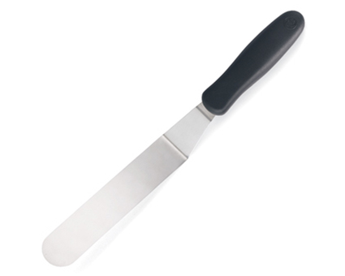  $10.00
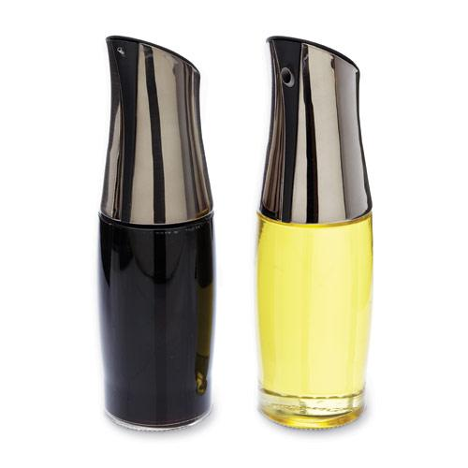  #1647 Dripless Oil & Vinegar Bottle Set  $48.00 |  | 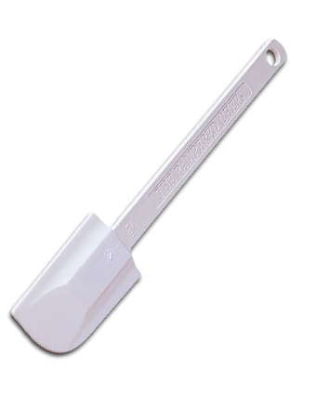  #1650 Classic Scraper  $12.00
#1655 Skinny Scraper  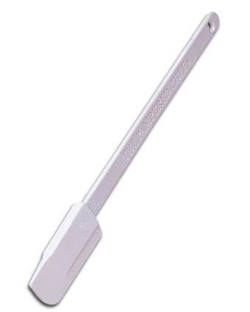  $9.00 |  | #1656 Mini Mix ‘N Scraper®  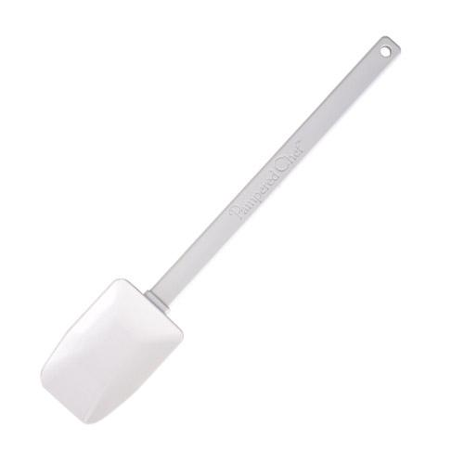  $10.00
#1657 Mix ‘N Scraper®  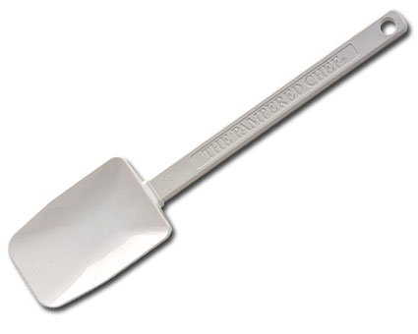  $15.00 |  | #1659 Small Mix ‘N Scraper®  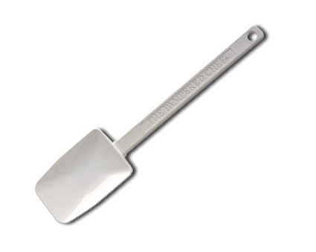  $13.00

