#1585 Decorator Bottle Set  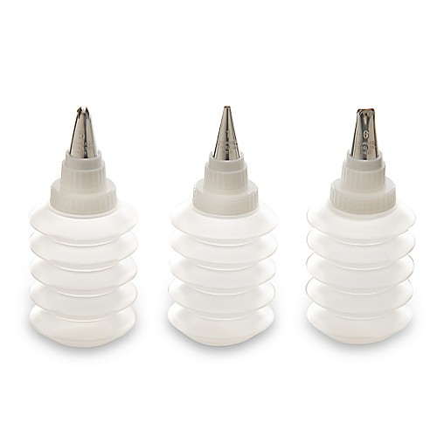  $13.50 | 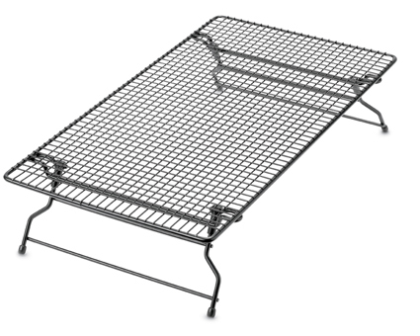  #1587 Stackable Cooling Rack  $15.50
#1590 Mini-Tart Shaper  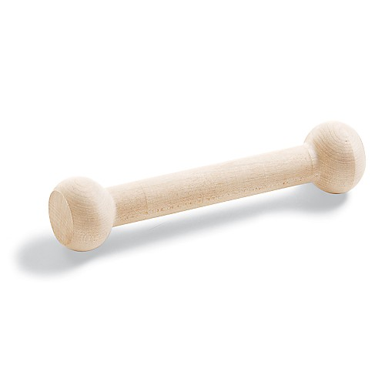  $6.00 | 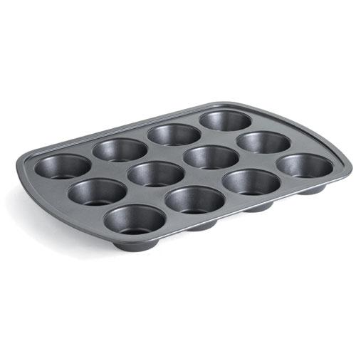  #1601 Muffin Pan  $18.50
#1606 Deluxe Mini-Muffin Pan  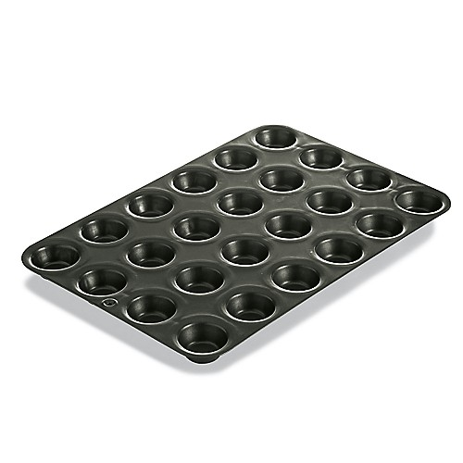  $17.00 | #1613 Silicone Floral Cupcake Pan  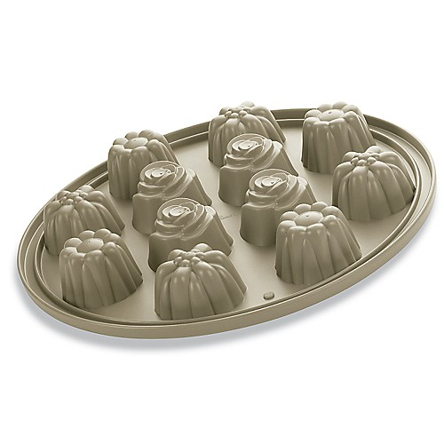  $39.00
#1614 Silicone Crown Cake Pan  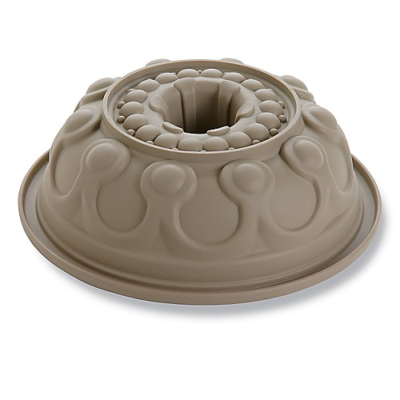  $39.00 | #1615 Handy Scraper  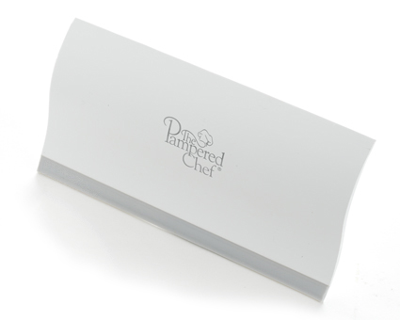  $7.00
#1621 Grill Pan & Press Scraper  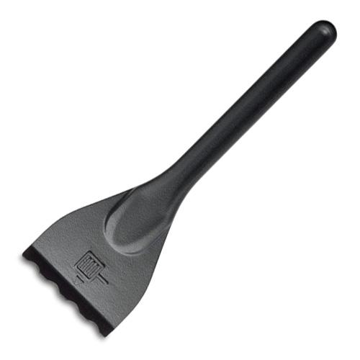  $4.00 | #1622 Scoop ‘N Drain  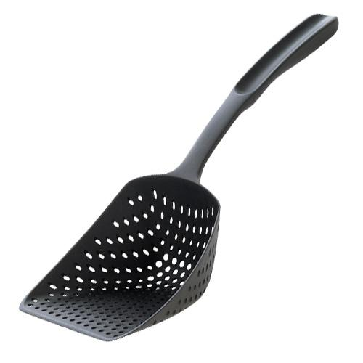  $11.00

