#1613 Silicone Floral Cupcake Pan  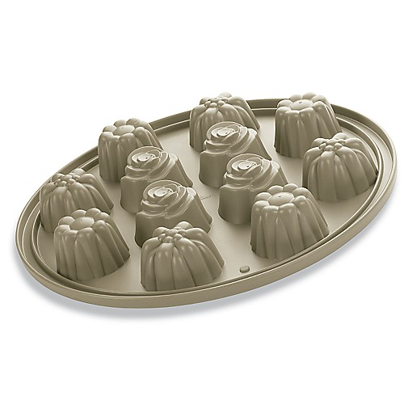  $39.00 |  | #1614 Silicone Crown Cake Pan  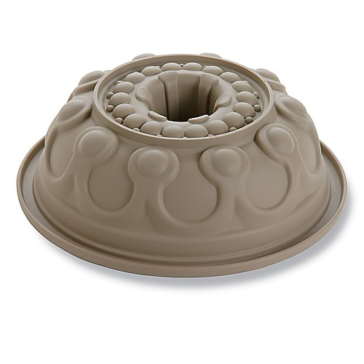  $39.00
#1615 Handy Scraper  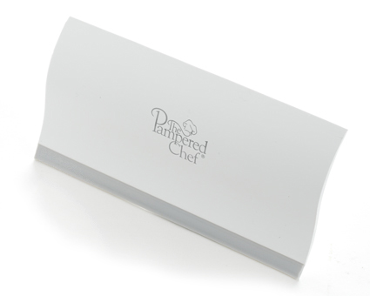  $7.00 |  | #1621 Grill Pan & Press Scraper  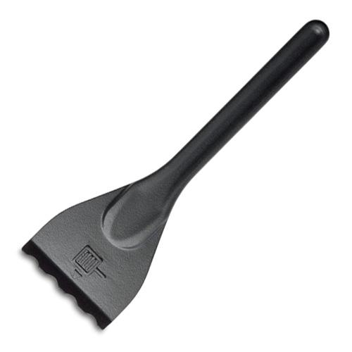  $4.00
#1622 Scoop ‘N Drain  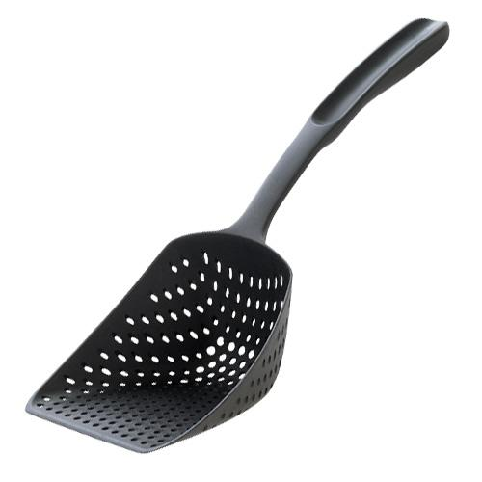  $11.00 |  | #1624 Soft-Tip Cleaning Brushes  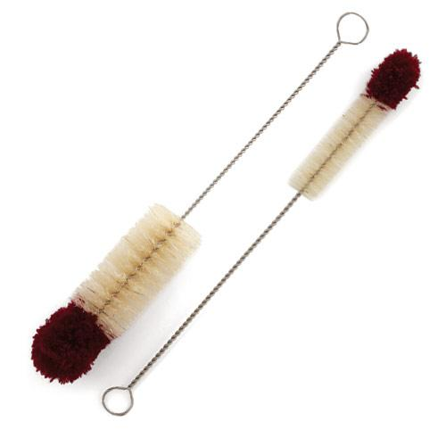  $7.00
#1625 Easy Clean® Kitchen Brush  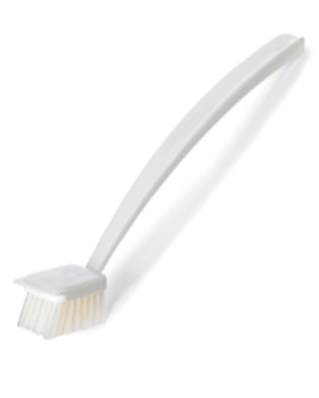  $9.00 |  | #1632 Spice Turn-About  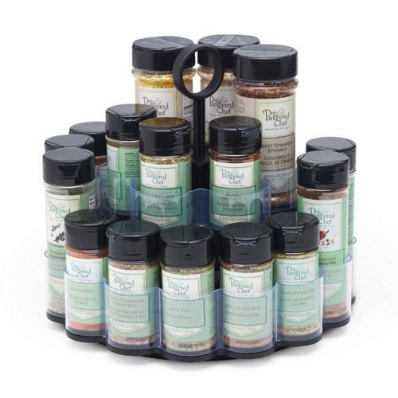  $19.50
#1633 Kitchen Fork  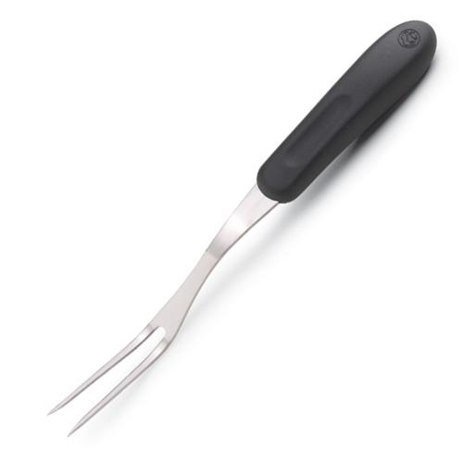  $10.00 |  | #1634 Glass Cleaning Brush  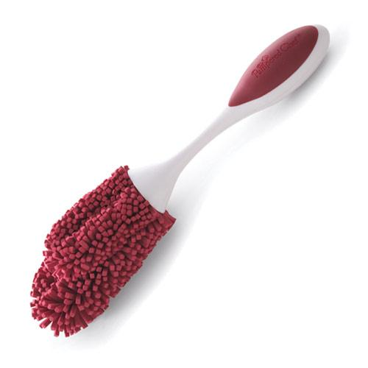  $9.00

