#1465 12-Cup Muffin Pan  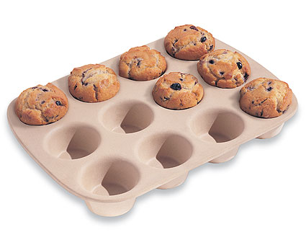  $37.00 | #1485 Baker’s Roller  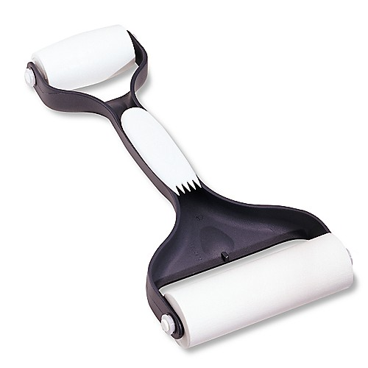  $18.50
#1511 9” Pie Plate  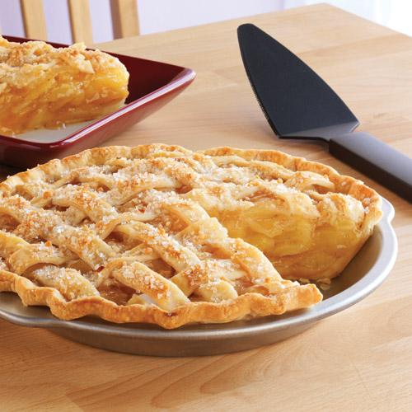  $9.50 | #1512 Rectangle Baking Pan  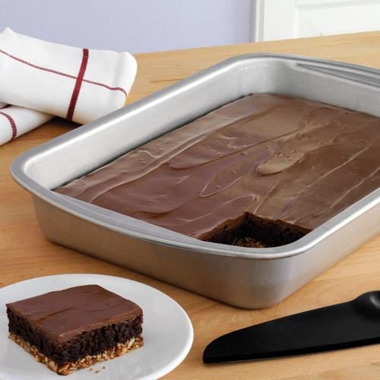  $19.50
#1521 Cookie Sheet  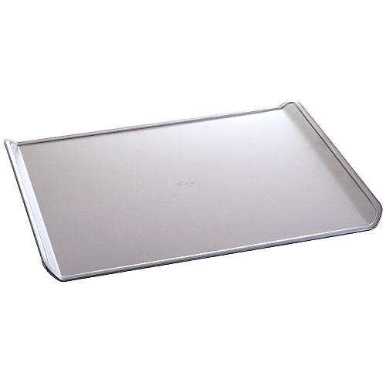  $18.00 | #1526 Cookie Press  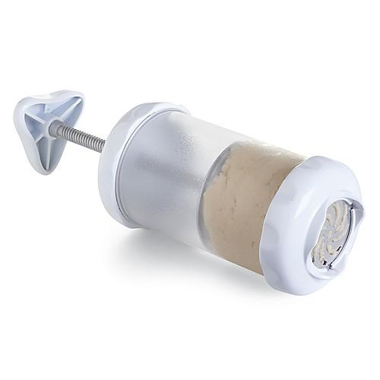  $32.50
#1542 Springform Pan  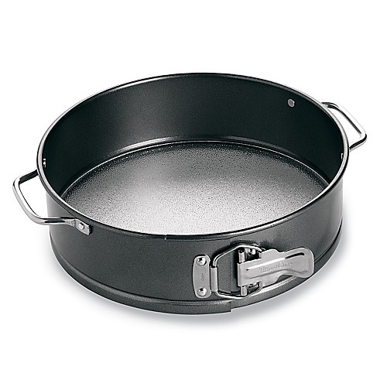  $26.00 | #1544 Brownie Pan  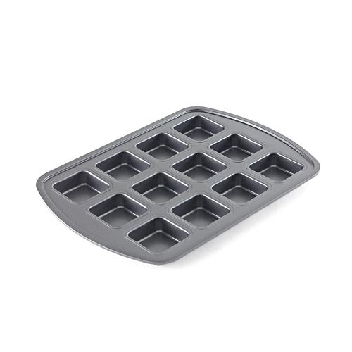  $19.00
#1546 Mini Pie Pans  (set of 6)  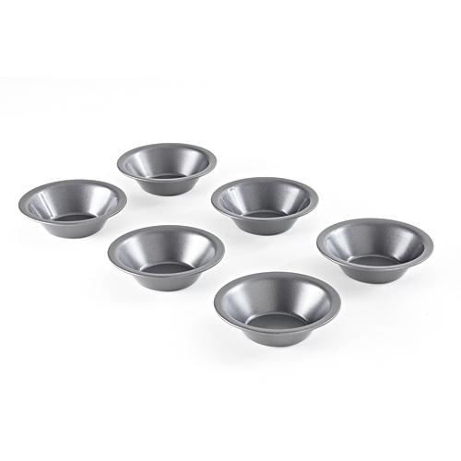  $25.00 | #1548 Mini Tart Pans  (set of 6)  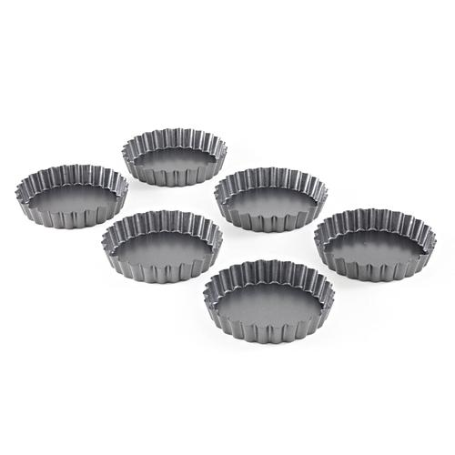  $25.00

