#1526 Cookie Press  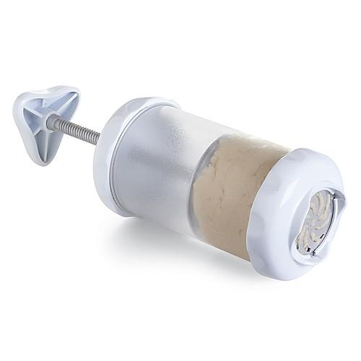  $32.50 |  | #1542 Springform Pan  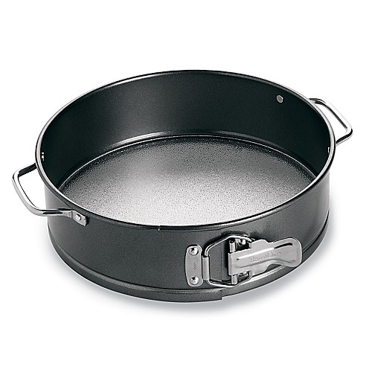  $26.00
#1544 Brownie Pan  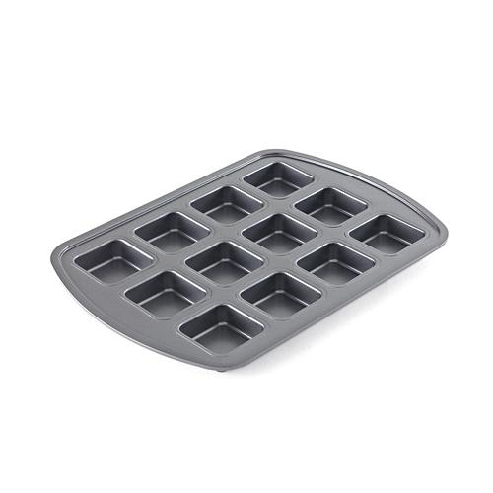  $19.00 |  | #1546 Mini Pie Pans  (set of 6)  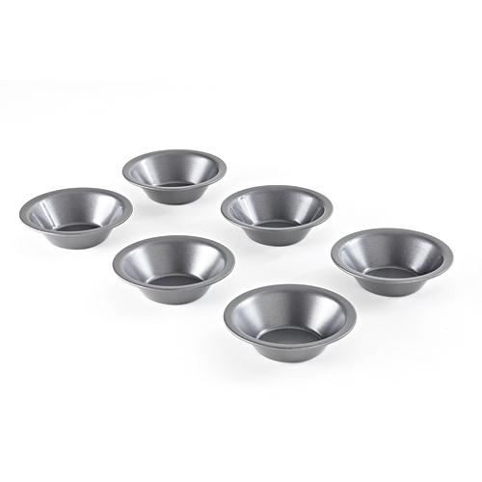  $25.00
#1548 Mini Tart Pans  (set of 6)  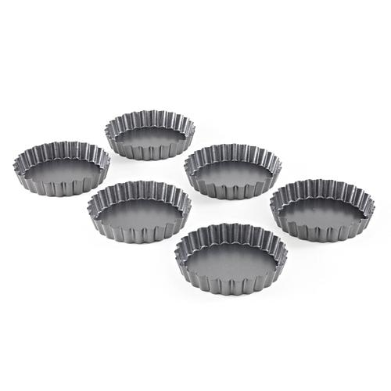  $25.00 |  | #1585 Decorator Bottle Set  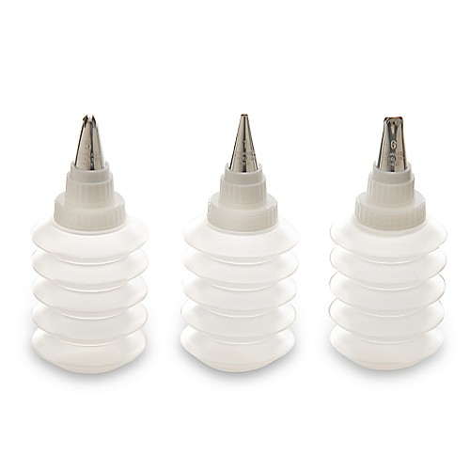  $13.50
#1587 Stackable Cooling Rack  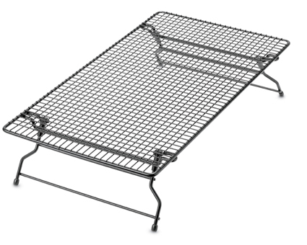  $15.50 |  | #1590 Mini-Tart Shaper  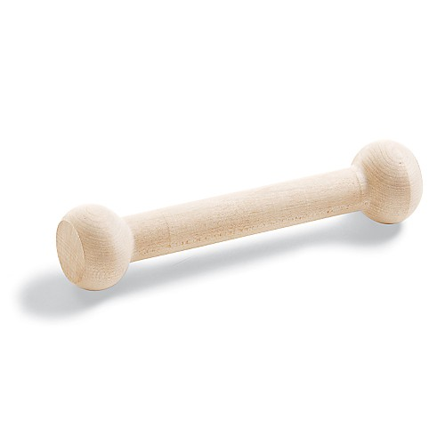  $6.00
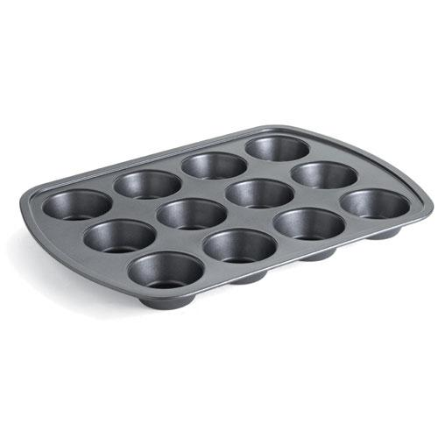  #1601 Muffin Pan  $18.50 |  | #1606 Deluxe Mini-Muffin Pan  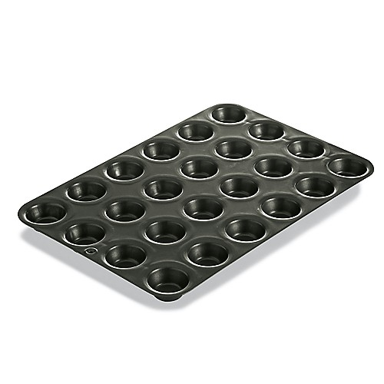  $17.00

