#1371 Large Round Stone with Handles  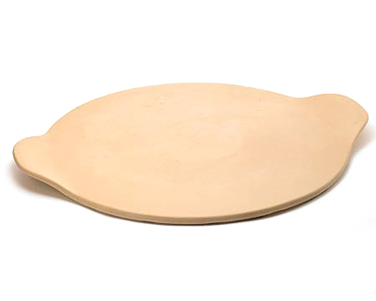  $33.00 | #1372 Microwave Egg Cooker  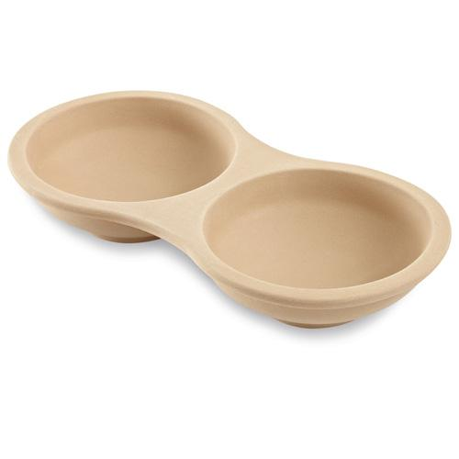  $19.50
#1373 Single Servings Pan  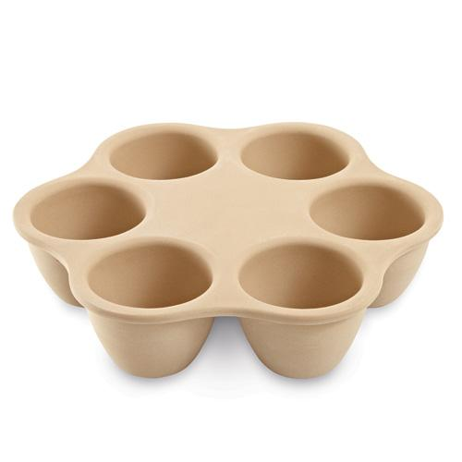  $29.50 | #1417 Stoneware Loaf Pan  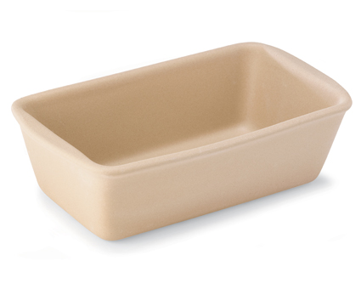  $24.00
#1418 Mini Loaf Pan  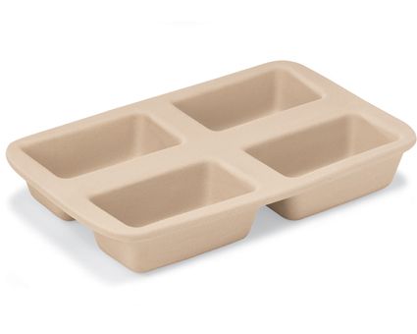  $35.00 | #1430 Rectangular Baker  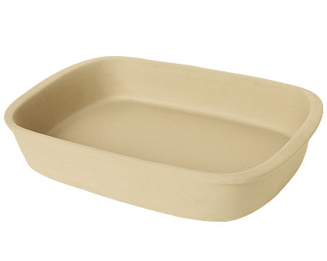  $40.00
#1440 Stoneware Fluted Pan  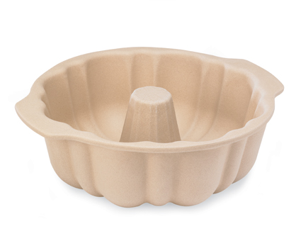  $34.00 | #1445 Large Bar Pan  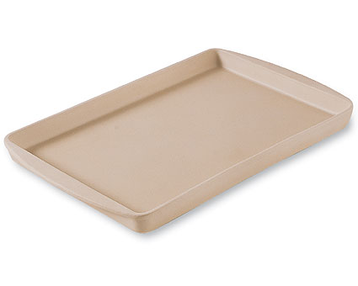  $35.00
#1448 Small Bar Pan  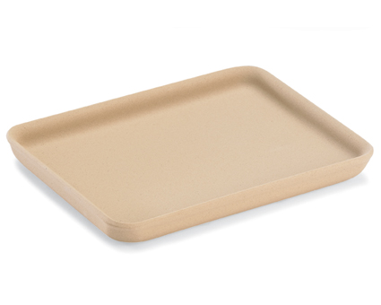  $18.00 | #1449 Medium Bar Pan  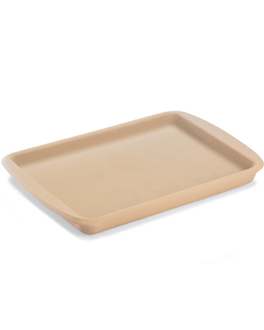  $25.00

