#1440 Stoneware Fluted Pan  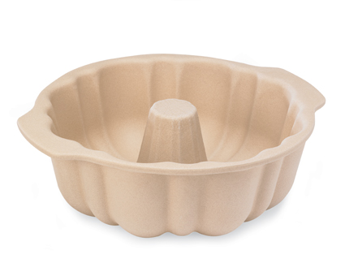  $34.00 |  | #1445 Large Bar Pan  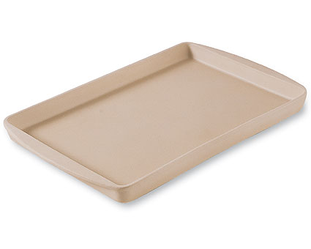  $35.00
#1448 Small Bar Pan  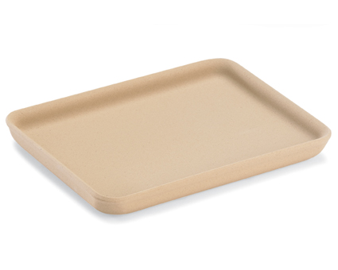  $18.00 |  | #1449 Medium Bar Pan  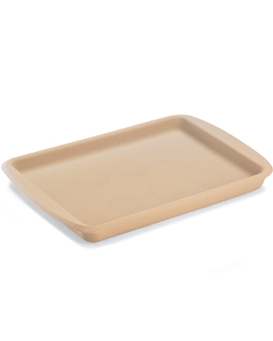  $25.00
#1465 12-Cup Muffin Pan  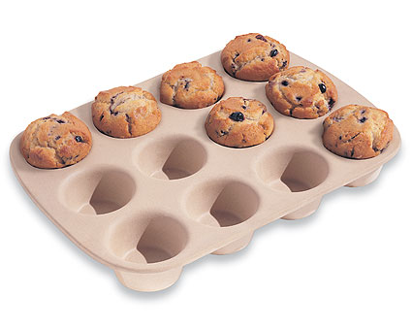  $37.00 |  | #1485 Baker’s Roller  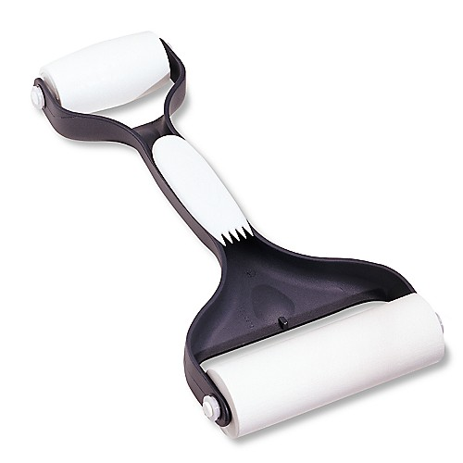  $18.50
#1506 Parchment Paper  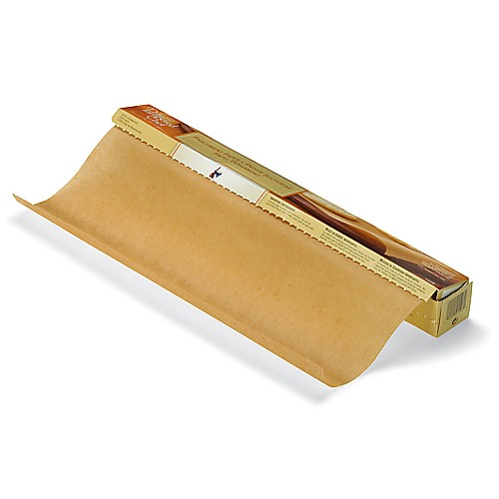  $8.00 |  | #1511 9” Pie Plate  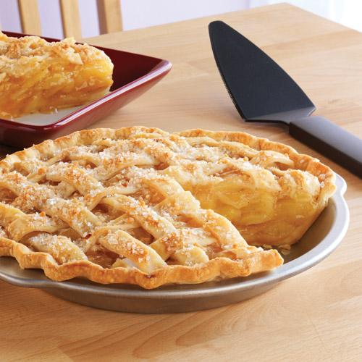  $9.50
#1512 Rectangle Baking Pan  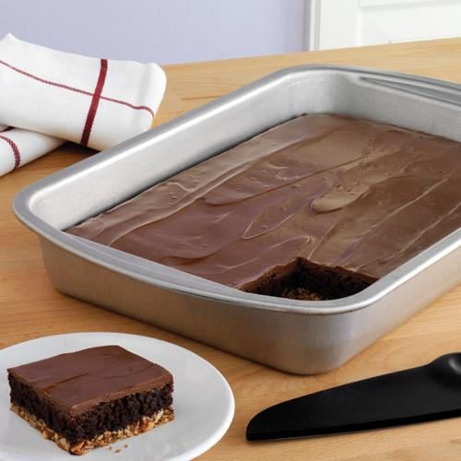  $19.50 |  | #1521 Cookie Sheet  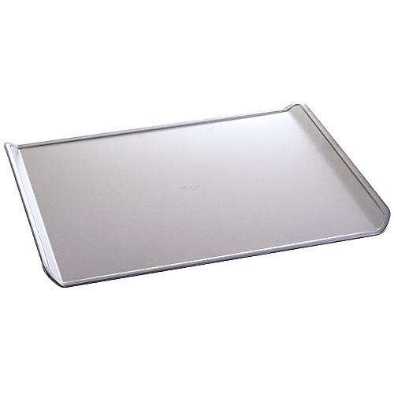  $18.00

