#1342 Small Ridged Baker  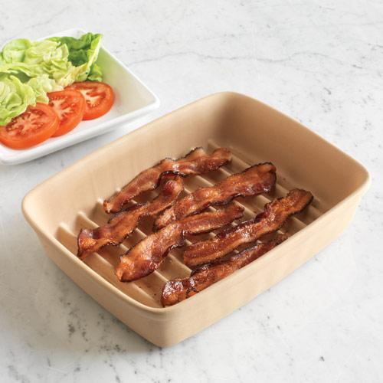  $30.00 | #1343 Stoneware Cookie Sheet  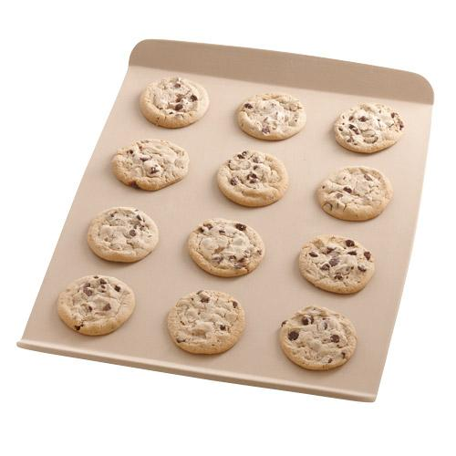  $35.00
#1344 Silicone Oven Mitt  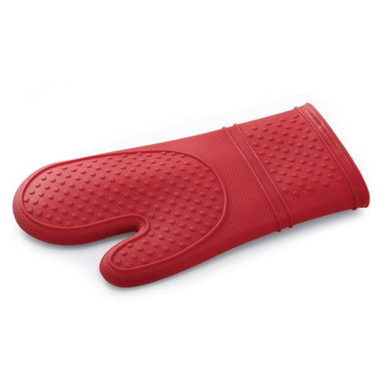  $17.00 | #1346 Oven Pad  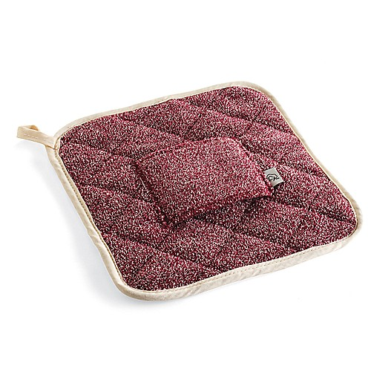  $13.50
#1347 Silicone Handle Protector  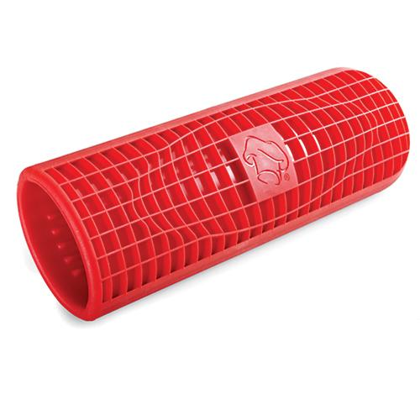  $10.00 | 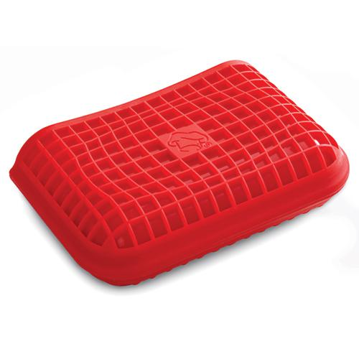  #1348 Silicone Helper Handle Protector  $6.50
#1350 Rectangle Stone  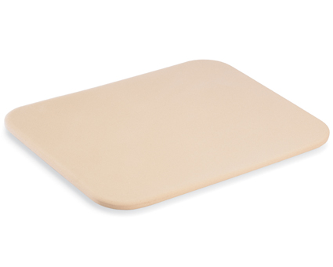  $29.00 | #1364 Round Covered Baker  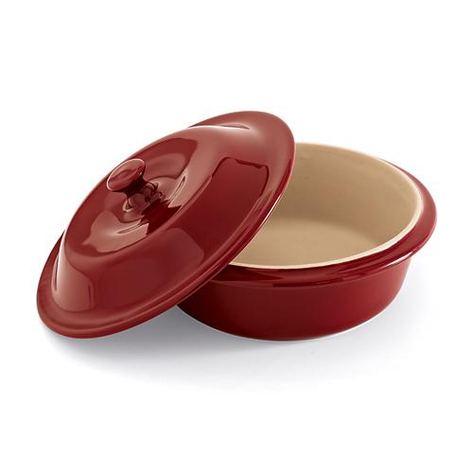  $49.00
#1368 Microwave Grips  (set of 2)  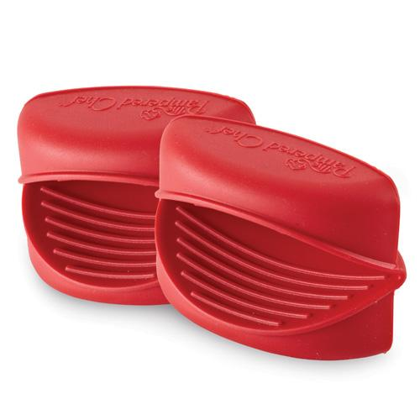  $7.50 | #1369 Garlic & Brie Baker  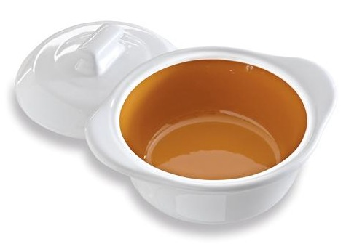  $29.50

