#1350 Rectangle Stone  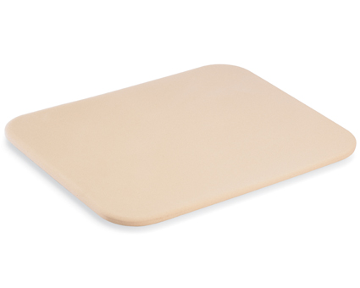  $29.00 |  | #1364 Round Covered Baker  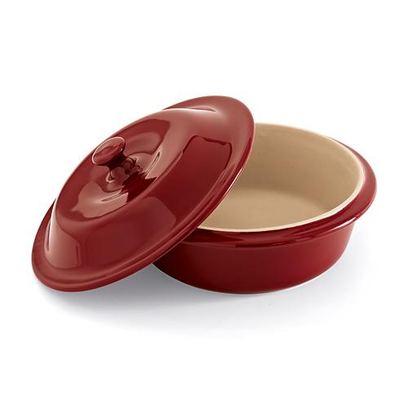  $49.00
#1368 Microwave Grips  (set of 2)  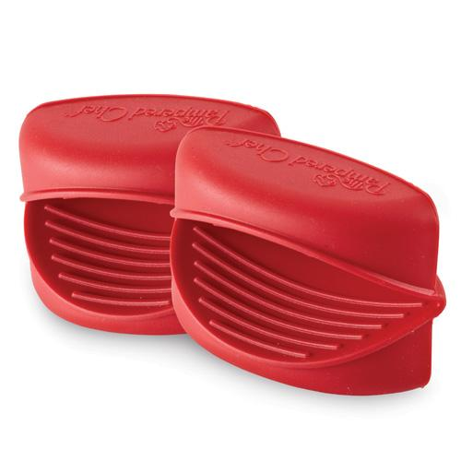  $7.50 |  | #1369 Garlic & Brie Baker  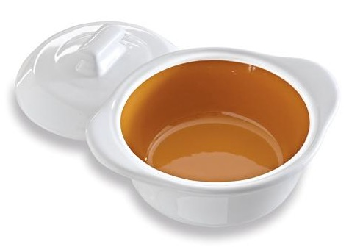  $29.50
#1371 Large Round Stone with Handles  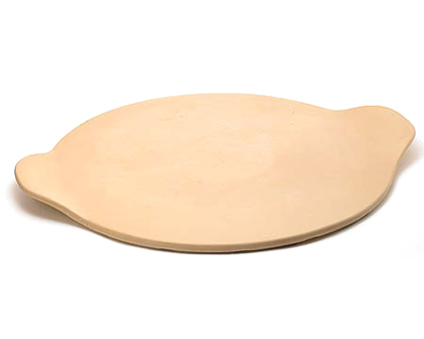  $33.00 |  | #1372 Microwave Egg Cooker  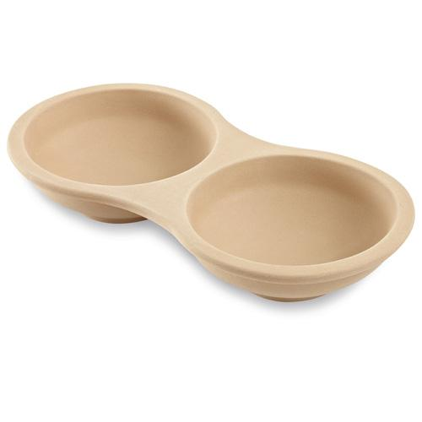  $19.50
#1373 Single Servings Pan  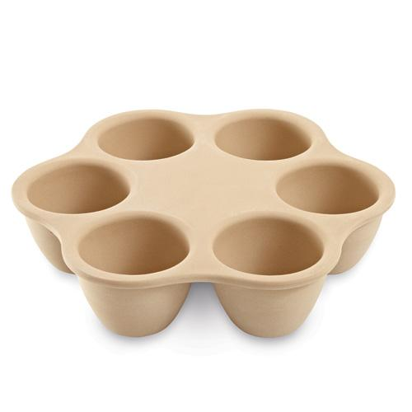  $29.50 |  | #1417 Stoneware Loaf Pan  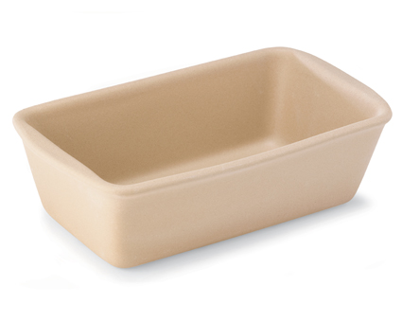  $24.00
#1418 Mini Loaf Pan  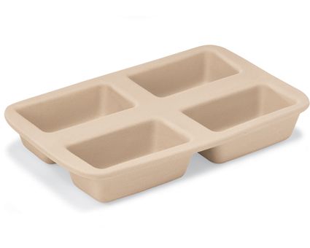  $35.00 |  | #1430 Rectangular Baker  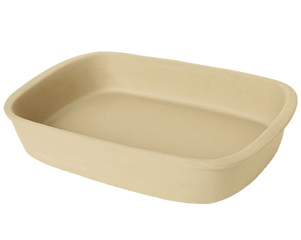  $40.00

