#1260 Citrus Peeler  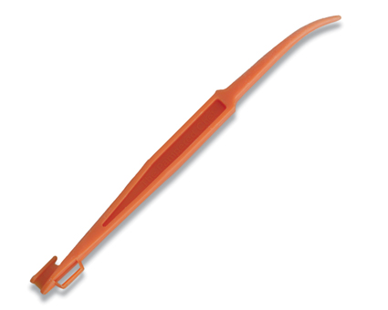  $1.00 | #1277 Rotary Grater  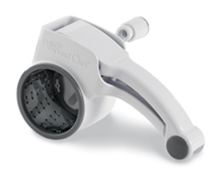  $20.00
#1302 Pizza Cutter  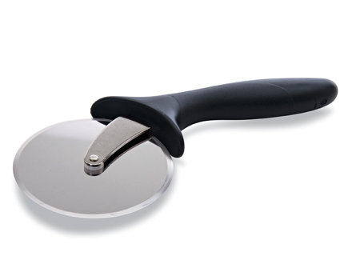  $10.50 | #1321 Deep Covered Baker – Cranberry  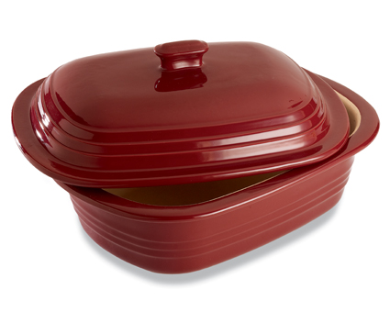  $85.00
#1329 Oven Mitt  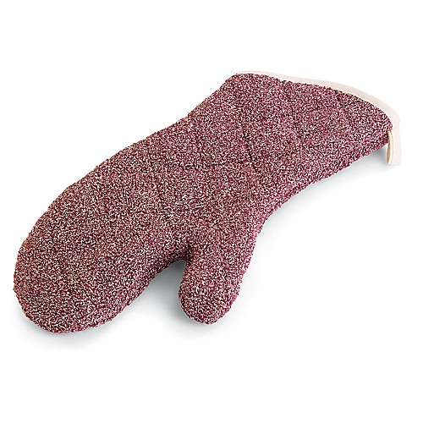  $17.50 | #1332 Deep Dish Pie Plate – Cranberry  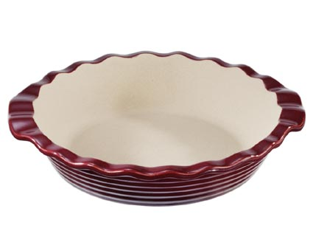  $35.00
#1337 Mini-Baker – Cranberry  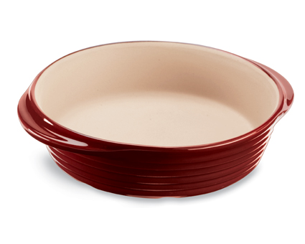  $27.00 | 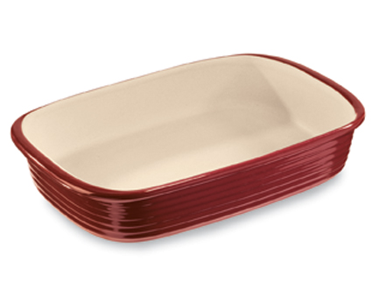  #1338 Rectangular Baker – Cranberry  $49.00
#1339 Square Baker – Cranberry  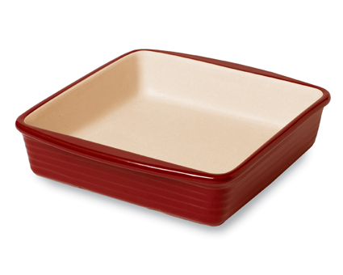  $38.00 | 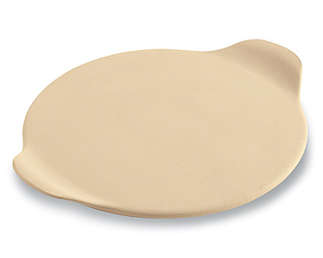  #1341 Medium Round Stone with Handles  $25.00

