#1337 Mini-Baker – Cranberry  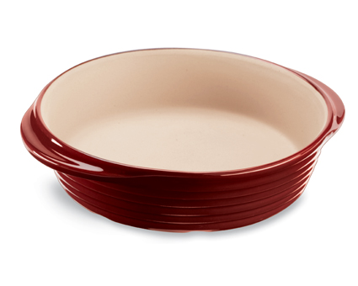  $27.00 |  | 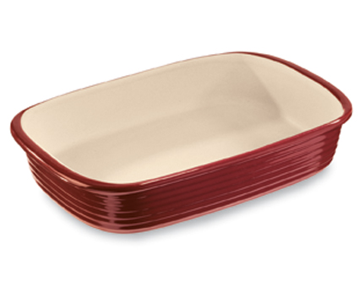  #1338 Rectangular Baker – Cranberry  $49.00
#1339 Square Baker – Cranberry  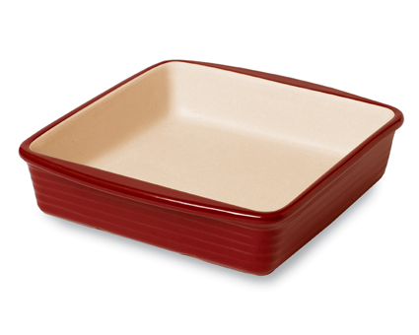  $38.00 |  | 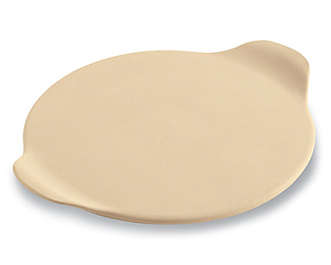  #1341 Medium Round Stone with Handles  $25.00
#1342 Small Ridged Baker  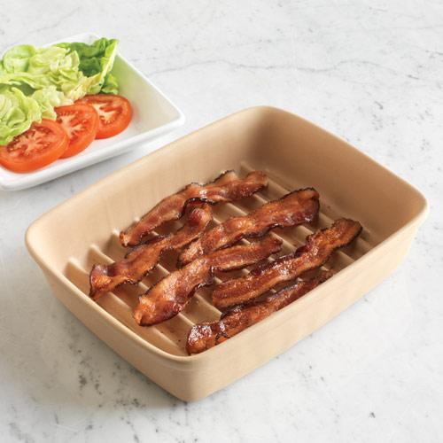  $30.00 |  | #1343 Stoneware Cookie Sheet  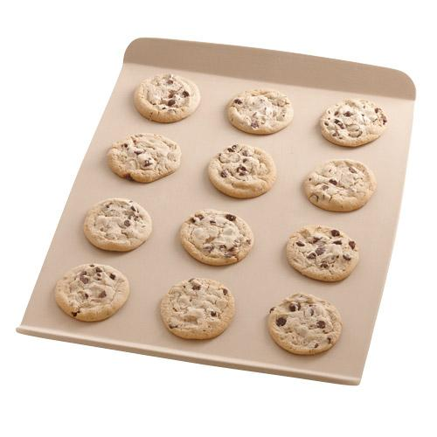  $35.00
#1344 Silicone Oven Mitt  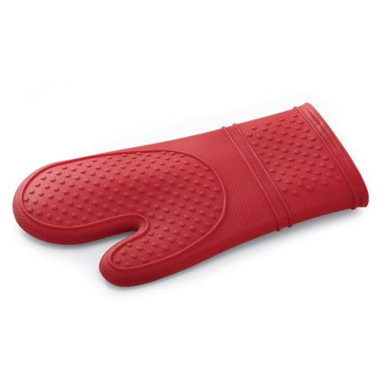  $17.00 |  | 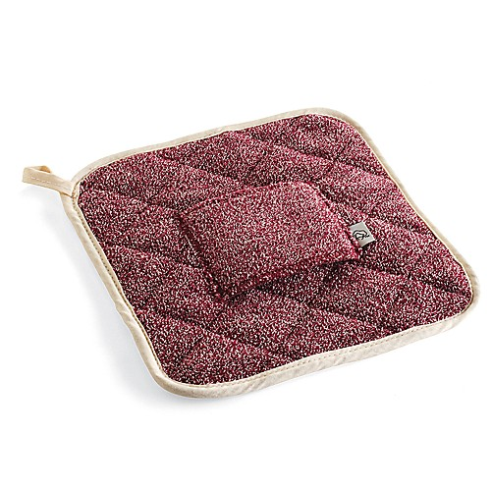  #1346 Oven Pad  $13.50
#1347 Silicone Handle Protector  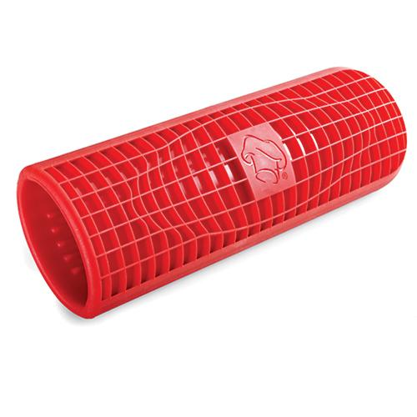  $10.00 |  | #1348 Silicone Helper Handle Protector  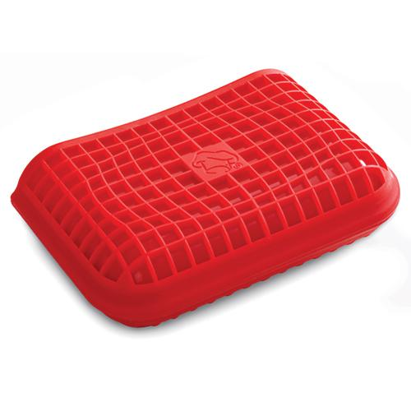  $6.50

