#1001 Bar Board  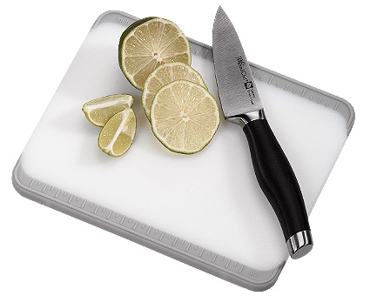  $10.00 | 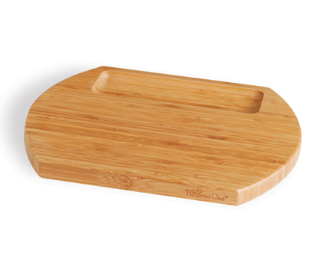  #1003 Reversible Bamboo Cheese Board  $27.50
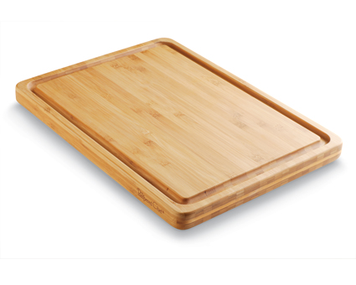  #1005 Reversible Bamboo Carving Board  $73.50 | 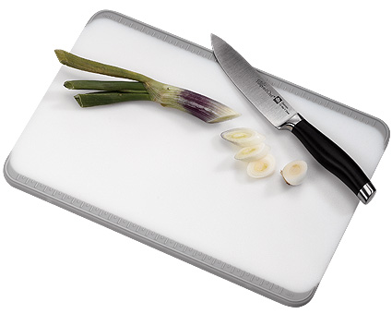  #1012 Cutting Board  $17.50
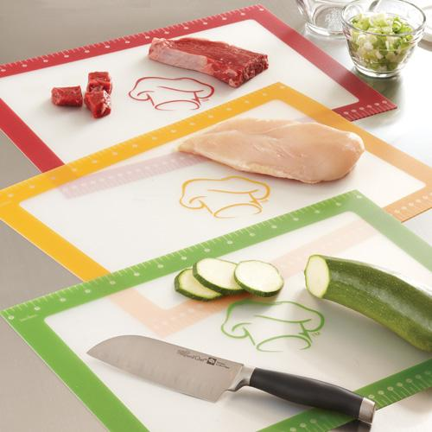  #1013 Flexible Cutting Mats  (set of 3)  $16.50 | #1014 Cutting Board – Large with J uice Wells  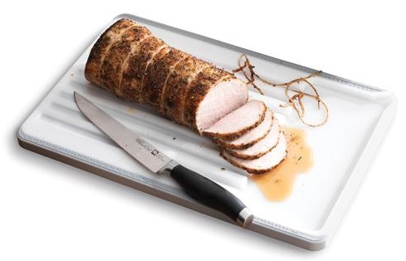  $34.50
#1015 Small Flexible Cutting Mats  (set of 3)  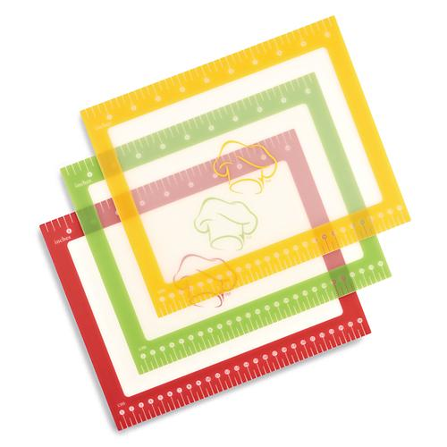  $10.00 | 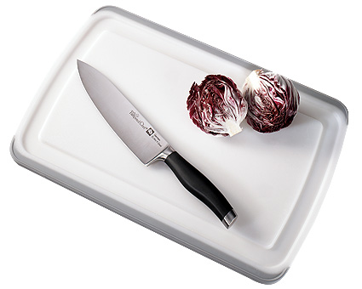  #1023 Large Grooved Cutting Board  $32.00
  #1051 Forged Cutlery –  3.5” Paring Knife  $32.00 | #1052 Forged Cutlery –  5” Utility Knife  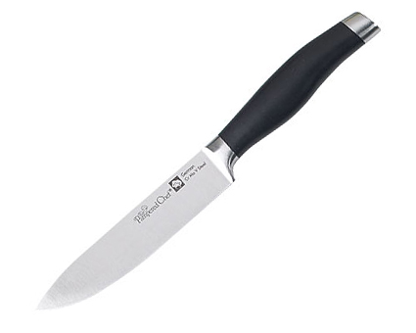  $40.00

