BROWNIE PAN RECIPE BOOKLET



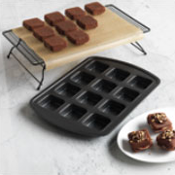

Your Brownie Pan is for much more than brownies. This versatile piece of bakeware handles everything from breakfast recipes to main dishes, and (of course!) lots of fun holiday dessert recipes. Just when you thought you couldn’t love the Brownie Pan more,
here are 12 unique recipes you can make in it.

Your Name Here
The Pampered Chef
xxx-xxx-xxxx
youremail@provider.com
www.pamperedchef.biz/your_website

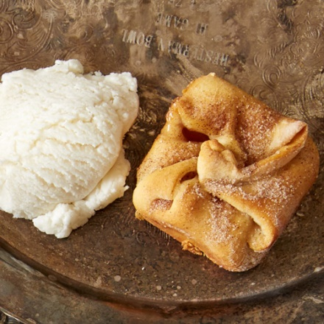
Mini Apple Pies

1 pkg (8 oz/235 g) seamless crescent dough
1 can (20 oz or 540 mL) apple pie filling
2 tbsp (30 mL) granulated sugar
1/2 tsp (2 mL) cinnamon
Vanilla ice cream (optional)

Preheat oven to 350°F (180°C). Roll out dough and use the Bakers Roller® to flatten and enlarge dough.
Use Pizza & Crust Cutter to cut into squares. Place dough in the Brownie Pan, allowing corners to drape over. Using Medium Scoop, top with one scoop of apple pie filling.
In a separate bowl, mix sugar and cinnamon together. Add to the top of each square. Pull corners to the middle and add another dash of the cinnamon/sugar.

Bake 15 -17 minutes or until golden brown. Remove from pan immediately. Serve with ice cream, if desired.

Yield: 12 servings

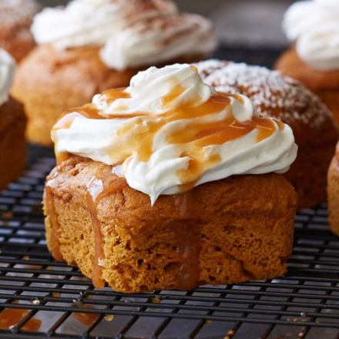

2-Ingredient Pumpkin Cakes

Nonstick cooking spray
1 package (16.5 oz or 432 g) spiced cake mix
1 can (15 oz) solid pack pumpkin
Optional toppings: cream cheese frosting, powdered sugar, ground cinnamon or caramel sauce

Preheat oven to 325°F (160°C). Spray Brownie Pan with nonstick cooking spray.
Combine cake mix and pumpkin in Classic Batter Bowl (mixture will be thick). Using Large Scoop, divide batter evenly into wells of pan. Bake 20-22 minutes or until wooden pick inserted in center comes out clean.
Remove pan from oven and let stand for 5 minutes. Remove cakes from pan and serve. If using, allow cakes to cool before topping.

Yield: 12 servings

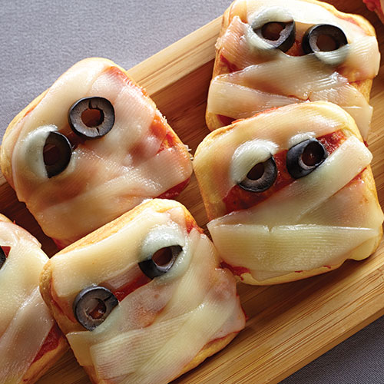
Mini Mummy Pizzas

1 pkg (8 oz or 250 g) refrigerated seamless crescent dough
1/4 cup (50 mL) pizza sauce
4 oz (125 g) block mozzarella cheese
12 black olives

Preheat oven to 400°F. Spray wells of Brownie Pan with nonstick cooking spray. Remove dough from package (do not unroll). Cut dough into 12 even discs. Press discs evenly into the wells of Brownie Pan. Bake 8-10 minutes or until golden brown. Spoon about one tsp of sauce over each crust. Shave thin ribbons from the side of the cheese using the Serrated Peeler. Layer cheese at angles over the sauce to form the “wraps” of the mummy face. Slice olives into rounds using Egg Slicer Plus® and place on each pizza to make the eyes. Remove from pan and serve.
Yield: 12 servings

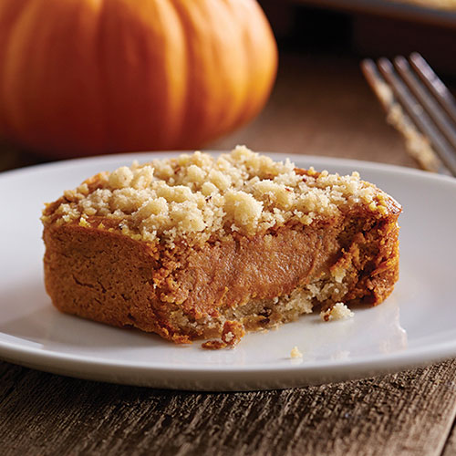
Pumpkin Streusel Cheesecake Squares

18 pecan shortbread cookies, divided
1 pkg (8 oz/250 g) cream cheese
1/2 cup (125 mL) sugar
1 can (15 oz) solid pack pumpkin (1¾ cups/425 mL) (not pumpkin pie filling)
2 eggs
1 tbsp (15 mL) flour
1 tbsp (15 mL) Cinnamon Plus® Spice Blend* or pumpkin pie spice
Thawed frozen whipped topping (optional)

Preheat oven to 350°F (180°C). Spray wells of Brownie Pan with nonstick cooking spray. Place one cookie into each well. Set remaining 6 cookies aside.
In Classic Batter Bowl, microwave cream cheese 10-15 seconds or until softened. Add sugar; whisk with Stainless Whisk. Add pumpkin, eggs, flour and spice blend; whisk until blended.
Using Medium Scoop, divide pumpkin filling evenly into wells of pan. Repeat until all of the filling is used. (Wells will be very full.)
Using Manual Food Processor, finely chop remaining 6 cookies. Carefully remove blade from processor bowl and sprinkle cookie crumbs evenly over pumpkin filling (about 1 tbsp/15 mL over each).
Bake 18-20 minutes or until edges are done and pull away from sides of pan. Remove pan from oven to Stackable Cooling Rack; cool 5 minutes. Loosen squares from sides of pan and serve with Mini Nylon Serving Spatula. Serve with whipped topping.

Yield: 12 servings

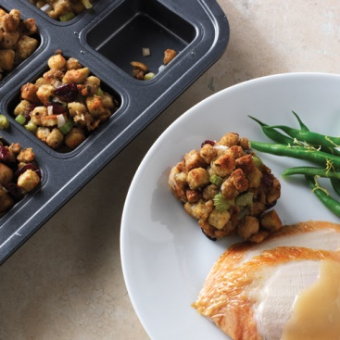
Sausage and Apple Stuffing Portions

Prepare your favorite stuffing recipe and bake it in a Brownie Pan. This way, everyone gets a proper portion (or two!). Plus it cooks faster in the pan, and each serving ends up with a delicious crispy edge. One of our favorite stuffing recipes is Sausage and Apple Herbed Stuffing…maybe it will become your favorite, too!

1/2 lb bulk pork sausage
1/2 cup (1 stick) butter or margarine
1 1/2 cups sliced celery
1 1/2 cups chopped onion
1 package (14 ounces) herb-seasoned cubed stuffing
1/2 cup sweetened dried cranberries
1/2 cup coarsely chopped apples
1 tbsp Lemon Rosemary Rub
2 cans (14.5 oz each) chicken broth

Preheat oven to 350ºF. Place sausage into (10-in.) Skillet; cook over medium heat 3-5 minutes or until no longer pink, breaking into crumbles. Remove Skillet from heat and transfer sausage to paper towel-lined plate. (Do not drain Skillet.)
Add butter to Skillet; heat over medium heat 1-3 minutes or until foamy. Add celery and onion; cook and stir 4-5 minutes or until vegetables are crisp-tender.
In Stainless (6-qt.) Mixing Bowl, combine stuffing, cranberries, apples, seasoning mix and sausage. Add vegetable mixture and broth; toss until moistened.
Spoon stuffing into Deep Covered Baker. Cover and bake 30 minutes. Carefully remove lid using Oven Mitts, lifting away from you; bake an additional 30 minutes or until stuffing is golden brown and heated through.

Yield: 16 servings

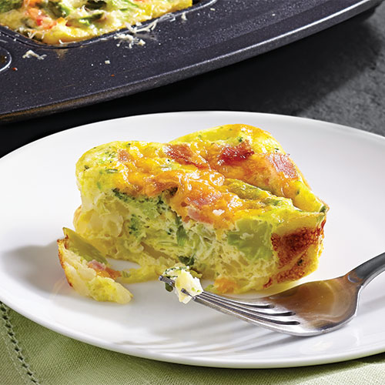
Frittatas

Having a quick and easy breakfast recipe in your back pocket ensures you’re always prepared for company, especially around the holidays. This frittata recipe is great to have prepped and ready to bake when visitors come to town. Or make a batch at the beginning of the week and take a portion to work each day. Try one (or all) of our three easy frittata recipes.
FLAVOR | COARSELY PROCESS IN  MANUAL FOOD PROCESSOR | MIX IN  CLASSIC BATTER BOWL | TOPPING
Vegetable Primavera | ½ lb fresh asparagus, trimmed and cut into 1" lengths  ½ medium red bell pepper,  cut into chunks  ¼ medium red onion,  cut into chunks | 8 eggs  ½ cup milk  ½ tsp salt  1 oz Parmesan cheese (¼ cup grated)  Processed vegetables | Cooked crumbled  bacon
Ham and Broccoli | 2 green onions, cut into  2" lengths  ¾ cup frozen broccoli, thawed | 8 eggs  ½ cup milk  ½ tsp salt  ½ cup grated cheddar cheese  Processed vegetables | Cooked  chorizo
Bacon and Bell Pepper | ½ medium green bell pepper,  cut into chunks  ¼ medium onion,  cut into chunks | 8 eggs  ½ cup milk  ½ tsp salt  ½ cup grated Swiss cheese  Processed vegetables | Cooked crumbled  bacon

Preheat oven to 350 degrees. Spray a Brownie Pan with nonstick cooking spray and divide 2 cups of refrigerated shredded hash brown potatoes evenly into the wells. Prepare a frittata flavor of your choice, pour the mixture evenly into wells and sprinkle with the topping. Bake 17 – 20 minutes or until set. Cool 5 minutes in pan, remove with Mini Nylon Serving Spatula and serve.
Yield: 12 servings

Mini Spinach Lasagna Squares
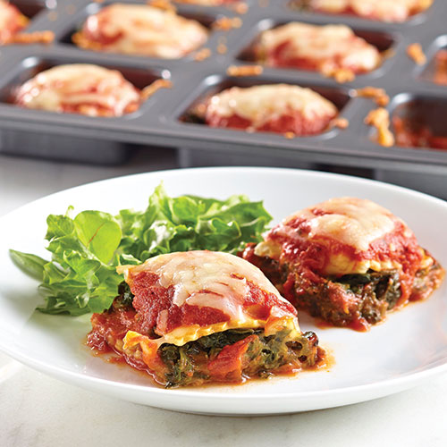
4 oz (125 g) part-skim mozzarella cheese (1 cup/250 mL grated), divided
1 oz (30 g) fresh Parmesan cheese (1/4 cup/50 mL grated)
1 pkg (10 oz or 300 g) frozen chopped spinach, thawed and well drained (see Cook’s Tip)
2 garlic cloves
1 3/4 cups (425 mL) marinara sauce, divided
24 small (approx 1½-2-in./4-5-cm squares) frozen cheese ravioli (12 oz/350 g)

Preheat oven to 350°F (180°C). Using Microplane® Adjustable Coarse Grater, grate cheeses; place in two separate (1-cup/250-mL) Prep Bowls.
In Classic Batter Bowl, combine ½ cup (125 mL) of the mozzarella, Parmesan, spinach and garlic pressed with Garlic Press. Mix well with Small Mix ‘N Scraper®.
Place marinara sauce in (2-cup/500-mL) Easy Read Measuring Cup. Using the Measuring Spoon Set, spoon 1 tbsp (15 mL) marinara sauce into each well of Brownie Pan; top with one ravioli.
Using Medium Scoop, place one rounded scoop of spinach mixture on top of each ravioli. Top with another ravioli. Spoon remaining marinara sauce over each ravioli and sprinkle with remaining mozzarella.
Bake 20-22 minutes or until cheese is melted and sauce is bubbly. Remove pan from oven to Stackable Cooling Rack. Serve with Mini Nylon Serving Spatula.

Yield: 6 servings of 2 "lasagna" squares
Cook's Tips: Blot excess moisture from spinach with several layers of paper towels on lid of Classic Batter Bowl.
The frozen ravioli fit just right in the Brownie Pan. Place them directly in the wells…no thawing necessary!

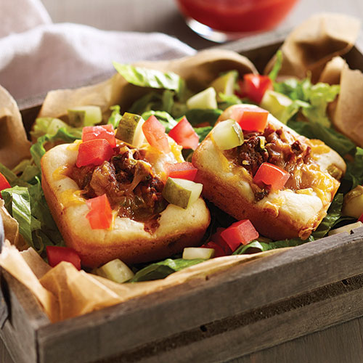
Mini Cheeseburger Pies
Base
Nonstick cooking spray
1 1/4 cups (300 mL) original pancake and baking mix
2 tbsp (30 mL) butter
1/3 cup (75 mL) milk
1 egg

Filling & Topping
12 oz (350 g) 95% lean ground beef or 93% lean ground turkey
2 green onions
3 oz (90 g) sharp cheddar cheese (3/4 cup/175 mL grated), divided
1/2 cup (125 mL) ketchup
1 tbsp (15 mL) yellow mustard
1-2 large firm plum tomatoes
1-2 whole dill pickles
3 cups (750 mL) shredded romaine lettuce

Preheat oven to 375°F (190°C). Spray wells of Brownie Pan with nonstick cooking spray.
Measure baking mix using dry measuring side of Mini Measure-All Cup®; add to Manual Food Processor. Microwave butter in 1-cup (250-mL) Prep Bowl, uncovered, on HIGH 20–30 seconds or until melted. Add melted butter, milk and egg to processor bowl; process until well blended.
Carefully remove blade from processor bowl. Using a scant Medium Scoop, divide batter evenly into wells. (Batter will be thick and not cover surface of the wells.)
Place beef in Classic Batter Bowl. Microwave, uncovered on HIGH 4–5 minutes or until no longer pink, breaking into crumbles with Small Mix ‘N Scraper® halfway through cooking. Drain, if necessary.
Thinly slice green onions. Grate cheese with Microplane® Adjustable Coarse Grater. Add half of the cheese, onions, ketchup and mustard to batter bowl; mix well.
Using a clean Medium Scoop, place one heaping scoop of meat mixture into center of batter, pressing evenly to let dough slightly spread to corners (see cook’s tip). Sprinkle evenly with remaining cheese.
Bake 14–16 minutes or until edges are golden brown.
Remove pan from oven to Stackable Cooling Rack; cool 5 minutes. Seed and dice tomato. Dice pickle. Using Mini Nylon Serving Spatula, loosen pies from pan. Serve with tomato, pickle and lettuce on the side.

Yield: 6 servings of 2 pies
Cook's Tips: Press the meat mixture gently into the batter. The batter will spread out into the wells of the Brownie Pan as it bakes. See step 6.

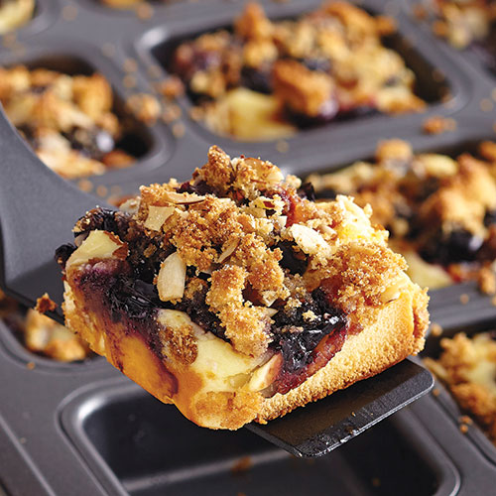
Fresh Blueberries & Cream Cakes

1 pkg (10.75 oz/304 g) frozen pound cake, thawed
1/4 cup (50 mL) sliced almonds
2 tbsp (30 mL) brown sugar
1 pkg (8 oz/250 g) cream cheese, softened
1/4 cup (50 mL) powdered sugar
1 egg
1/3 cup (75 mL) orange marmalade
1 container (6 oz) fresh blueberries (1 cup/250 mL)

Preheat oven to 375°F (190°C). Spray wells of Brownie Pan with nonstick cooking spray. Using Utility Knife, remove a very thin layer off crown of cake and place in Manual Food Processor. Add almonds and brown sugar; process until coarsely chopped. Carefully remove blade from processor bowl; set aside.
Remove ½ in. (1 cm) off one long side of cake; set aside for another use. On Cutting Board, cut cake crosswise into twelve ½ in./1 cm thick slices (each slice will measure about 2x2½ in./5x6 cm). Place one cake slice into each well of pan (see Cook’s Tip).
In Classic Batter Bowl, combine cream cheese, powdered sugar and egg; whisk until smooth with Stainless Whisk. Using a level Medium Scoop, evenly divide cream cheese mixture into wells.
In (2-cup/500-mL) Easy Read Measuring Cup, microwave marmalade, uncovered, on HIGH 30 seconds. Add blueberries; lightly toss to coat with Small Mix ’N Scraper®. With a clean Medium Scoop, evenly divide berry mixture into wells. Sprinkle processed cake crumbs evenly over filling.
Bake 13-15 minutes or until edges of cakes are firm.
Remove pan from oven to Stackable Cooling Rack; cool 10 minutes. Using Mini Nylon Serving Spatula, loosen cakes from sides of pan and serve.

Yield: 12 servings
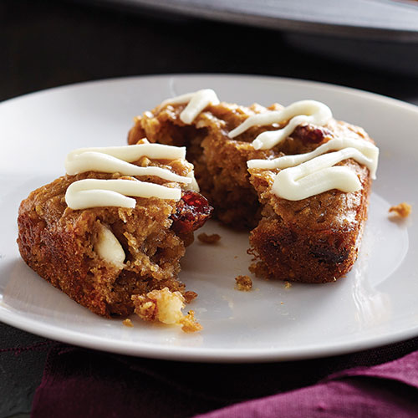
Flourless Oatmeal Bars

Nonstick cooking spray
1 can (15-16 oz or 398 mL) chickpeas, drained and rinsed
2 eggs
1/2 cup (125 mL) reduced-fat creamy peanut butter
1 tsp (5 mL) vanilla extract
2/3 cup (150 mL) white chocolate morsels, divided
1/2 cup (125 mL) quick cooking oats
1/3 cup (75 mL) dried cranberries
1/3 cup (75 mL) packed brown sugar
1/2 tsp (2 mL) baking soda
1/4 tsp (1 mL) salt

Preheat oven to 350°F (180°C). Lightly spray wells of Brownie Pan with nonstick cooking spray.
Place chickpeas and eggs in Manual Food Processor; process until well blended (mixture will not be smooth, see cook’s tips).
Carefully remove blade from processor bowl. Transfer chickpea mixture to Classic Batter Bowl. Add peanut butter and vanilla; mix well with Small Mix ‘N Scraper®. Add 1/3 cup (75 mL) of the morsels, oats, cranberries, brown sugar, baking soda and salt. Mix until combined.
Using Medium Scoop, divide mixture evenly into wells of pan. Gently spread mixture with back of Scoop. Bake 16–18 minutes or until wooden pick inserted in centers comes out clean.
Place remaining 1/3 cup (75 mL) morsels in 1-cup (250-mL) Prep Bowl; microwave on HIGH 1 minute, stirring every 15 seconds or until melted. Transfer to a small resealable plastic bag (see cook’s tips).
Remove pan from oven to Stackable Cooling Rack; let cool 5 minutes. Trim a small corner off the bag; drizzle chocolate evenly over top of bars. Serve with Mini Nylon Serving Spatula.
Yield: 12 servings
Cook's Tips:
The Manual Food Processor will get the chickpea and egg mixture thoroughly combined, but it will not be totally smooth. See step 2.
The chickpeas take the place of flour! They're low in fat, high in fiber and rich in antioxidants... and they make the bars more moist and mouthwatering!
To fill plastic bag with melted chocolate, place a small resealable plastic bag over rim of Mini Measure-All® Cup with one corner pointing into the cup. Pour melted chocolate into bag. Remove bag and twist top.

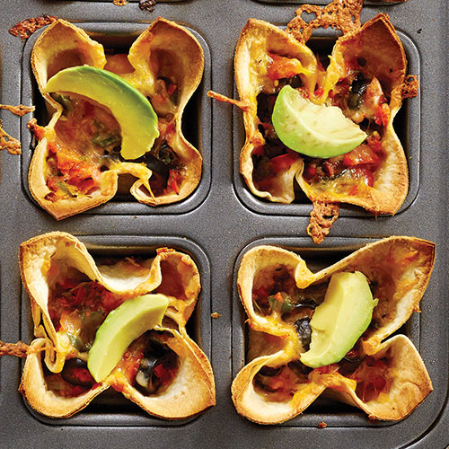
Veggie Quesadilla Cups

3 burrito-size flour tortillas (8½ - 9½-in./22-24-cm)
1 medium red bell pepper
1 small jalapeño, seeded
2 green onions
4 oz (125 g) Colby & Monterey Jack cheese blend (1 cup/250 mL grated), divided
1 can (2.25 oz) sliced pitted ripe olives, drained (½ cup/125 mL)
2 tsp (10 mL) Chipotle Rub
1/2 medium ripe avocado, skin on and seed removed

Preheat oven to 400°F (200°C). Spray wells of Brownie Pan with nonstick cooking spray.
Stack tortillas on Cutting Board. Using Pizza Cutter, cut off the rounded corners to create a large square (about 7x7 in./18x18 cm). Cut into quarters to create twelve squares total. Press one square into corners of each well of pan.
Using Utility Knife, cut off top of bell pepper; cut lengthwise and remove seeds and veins. Cut bell pepper, jalapeño and green onions into small pieces. Add to Manual Food Processor and process until chopped; transfer to Classic Batter Bowl.
Using Microplane® Adjustable Coarse Grater, grate cheese. Add half of the cheese, olives and rub to batter bowl. Mix well with Small Mix ‘N Scraper®.
Using a heaping Medium Scoop, fill cups with vegetable mixture. Top with remaining cheese.
Bake 10-12 minutes or until cheese is melted and corners of tortillas are golden brown. Remove pan from oven to Stackable Cooling Rack.
Using Medium Scoop, scrape along the avocado half to create shavings over each tortilla cup (See Cook’s Tip). Using Mini Nylon Serving Spatula, loosen cups from sides of pan and serve.
Yield:
12 servings of 1 appetizer
Cook's Tips: Hold the avocado half while gently scraping with the Medium Scoop; release directly over warm cups. See step 7.

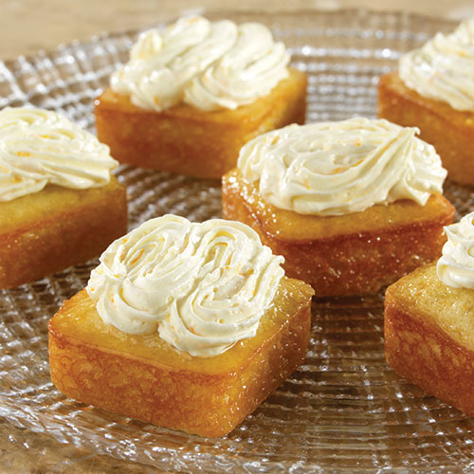
Orange Blossom Cakes

Cakes & Glaze
2 oranges
1 1/2 cups (375 mL) sugar, divided
2 tbsp (30 mL) canola oil
1/2 cup (125 mL) reduced-fat sour cream
1/3 cup (75 mL) milk
2 egg whites, room temperature, lightly beaten
1 1/4 cups (300 mL) flour
3/4 tsp (4 mL) baking soda
1/4 tsp (1 mL) salt

Topping
6 oz (175 mL) reduced-fat cream cheese (Neufchâtel), softened
1/2 cup (125 mL) powdered sugar
1 1/2 tbsp (22 mL) orange zest (from oranges used for glaze)
1 1/2 cups (375 mL) thawed frozen whipped topping

Preheat oven to 350°F (180°C). Spray wells of Brownie Pan with nonstick cooking spray.
Zest oranges using Microplane® Adjustable Fine Grater. (You should get about 3 tbsp/45 mL of zest.) Juice oranges to get 1/3 cup (75 mL).
Mix half of the zest, 3/4 cup (175 mL) of the sugar, oil, sour cream, milk and egg whites in large Bamboo Fiber Bowl until well blended.
Mix flour, baking soda and salt in medium Bamboo Fiber Bowl. Mix flour mixture into wet ingredients until blended.
Divide batter evenly into pan using a heaping Medium Scoop. Bake 12-14 minutes or until wooden pick inserted into centers comes out clean.
To make the glaze, microwave remaining 3/4 cup (175 mL) sugar and orange juice in uncovered Small Micro-Cooker® on HIGH 1-2 minutes or until hot. Stir until sugar is dissolved.
To make the topping, mix cream cheese, powdered sugar and remaining zest in Classic Batter Bowl until smooth. Stir in whipped topping until blended.
Remove pan from oven and immediately spoon about 1 tbsp (15 mL) glaze over each cake. Cool in pan 5 minutes. Remove cakes from pan to Stackable Cooling Rack.
Fit Easy Accent® Decorator with open star tip. Scoop topping into decorator using Medium Scoop and pipe onto cakes.
Yield: 12 mini-cakes
Cook's Tips:
Room temperature egg whites blend more easily into batters and doughs. To quickly bring eggs to room temperature before separating the whites from the yolks, place them in a bowl of warm water for 5-10 minutes before making the batter.
Place a piece of Parchment Paper under the Stackable Cooling Rack to catch any dripping glaze as you pipe the topping onto the cakes.

