
MAY HOST SPECIAL
Leslie Rogakis
Independent Consultant #755153
928-530-0459
www.pamperedchef.biz/leslierogakis
GUEST SPECIAL: Choose
GUEST SPECIAL:
GUEST SPECIAL:
MAY HOST SPECIAL
Leslie Rogakis
Independent Consultant #755153
928-530-0459
www.pamperedchef.biz/leslierogakis

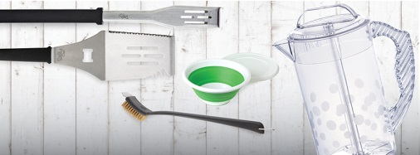
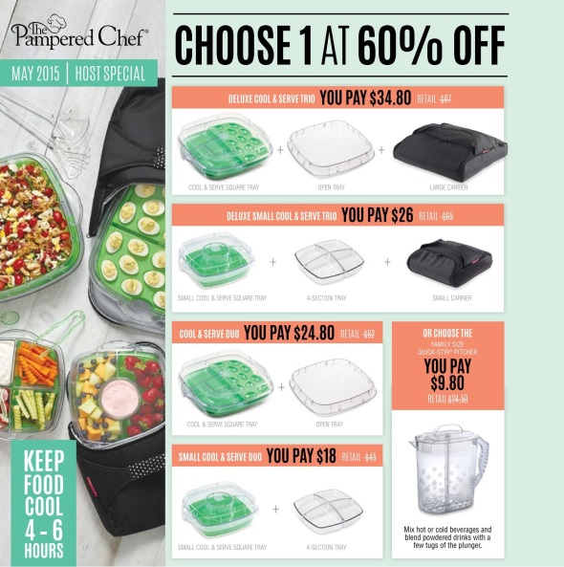

BBQ Tongs, BBQ Turner, BBQ Cleaning Brush, 2-qt Collapsible Serving Bowl, or Quick-Stir® Pitcher free with a $70 purchase!

GUEST SPECIAL:

BBQ Tongs, BBQ Turner, BBQ Cleaning Brush, 2-qt Collapsible Serving Bowl, or Quick-Stir® Pitcher free with a $70 purchase!

BBQ Tongs, BBQ Turner, BBQ Cleaning Brush, 2-qt Collapsible Serving Bowl, or Quick-Stir® Pitcher free with a $70 purchase!

JUNE HOST SPECIAL
JUNE HOST SPECIAL
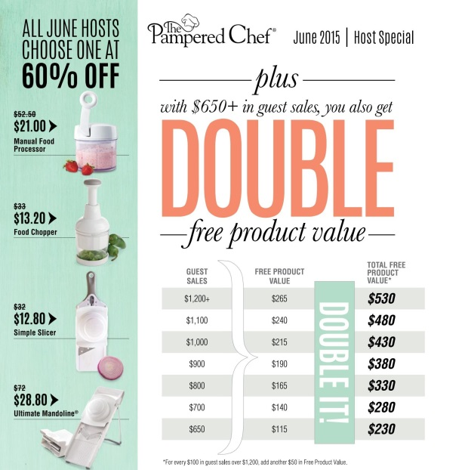
BBQ Tongs, BBQ Turner, BBQ Cleaning Brush, 2-qt Collapsible Serving Bowl, or Quick-Stir® Pitcher free with a $70 purchase!

